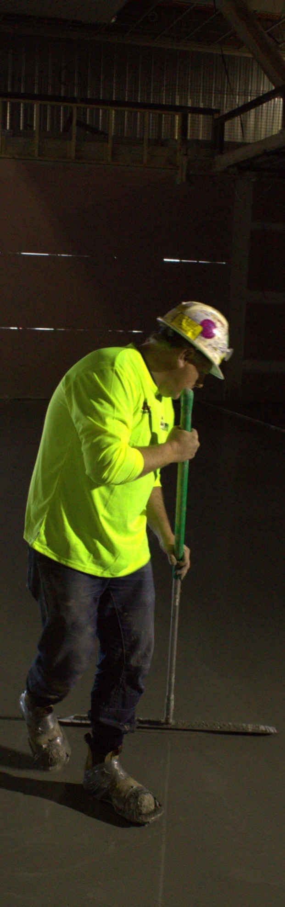
Subfloor coatings and toppings
DRAFT VERSION
October 11

Developed in 2012-2013 for the WELL Program
Learner guide
Supporting:
LMFFL2102A: Prepare, select and apply smoothing and patching compounds
LMFFL2103A: Select and apply appropriate compounds and additives
LMFFL2105A: Select, prepare and apply moisture barriers and damp proof membranes to concrete sub-floors

Subfloor coatings
and toppings
Learner guide

This unit is also available in an e-learning format, which contains additional photos, interactive exercises and a voice-over narration of the text. It can be viewed on CD-ROM, or live on the web at:
www.flooringtech.com.au


Developed by Workspace Training for the 2012-2013
Workplace English Language and Literacy (WELL) Program
Flooring Technology resource development project





Copyright and disclaimer
ISBN: 978-0-9873327-9-0
Funded under the Workplace English Language and Literacy Program by the Australian Government through the Department of Industry, Innovation, Climate Change, Science, Research and Tertiary Education
© Commonwealth of Australia 2013

CC BY-NC-SA
This work is copyright. Except where otherwise indicated, and save for the Commonwealth Coat of Arms, the Department has applied the Creative Commons Attribution-Noncommercial-Share Alike 3.0 Australia Licence to this work.
The Department of Industry, Innovation, Climate Change, Science, Research and Tertiary Education must be attributed as the author of the Department’s copyright material.
As far as practicable, material for which the copyright is owned by a third party has been clearly labelled. The Department has made all reasonable efforts to ensure that this material has been reproduced in the print-based resources and accompanying website with the full consent of the copyright owners.
Requests and enquiries concerning the Department’s copyright material should be addressed to:
The Legal Branch
Department of Industry, Innovation, Climate Change, Science, Research and Tertiary Education
GPO Box 9839 Canberra ACT 2601
Email: legalservices@innovation.gov.au
Questions about the design and content of the resource itself should be addressed to the project manager:
David McElvenny
Workspace Training
PO Box 1954 Strawberry Hills, NSW, 2012
Email: david@workspacetraining.com.au

Disclaimer
The content of this Learner guide is provided for educational purposes only. No claim is made as to the accuracy or authenticity of the content. The views expressed in this publication do not necessarily represent the view of the Minister for Tertiary Education, Skills, Science and Research or the Australian Government. The Australian Government does not give any warranty nor accept any liability in relation to the contents of this work.

About this resource
This Learner guide is part of a suite of resources developed for the Flooring Technology project, funded by the WELL Program. The resources support 19 competencies from the Certificate III in Flooring Technology (LMF31208). The project comprises a website and an accompanying set of Learner guides and work books.
The individual competencies are grouped into ‘Learning units’ as shown below. Each one is given a title describing the main theme of that set of integrated competencies.

Learning unit title Competencies covered
Safety at work MSAPMOHS200A: Work safely
LMFFL3002A: Establish and maintain a safe flooring technology work environment
Inspecting and testing subfloors LMFFL2004A: Moisture test timber and concrete floors
LMFFL3101A: Inspect sub-floors
Planning and costing LMFFL3001A: Plan and cost flooring technology work
Subfloor coatings and toppings LMFFL2102A: Prepare, select and apply smoothing and patching compounds
LMFFL2103A: Select and apply appropriate compounds and additives
LMFFL2105A: Select, prepare and apply moisture barriers and damp proof membranes to concrete sub-floors
Concrete grinding LMFFL2107A: Select, operate and maintain grinding equipment
Preparing floor coverings LMFFL2002A: Receive and prepare floor covering materials for installation
Lay flat vinyl LMFFL2301A: Install lay flat vinyl floor coverings
Resilient tiles LMFFL2302A: Install resilient tiles using standard installation practices
Commercial vinyl LMFFL3302A: Install commercial vinyl floor coverings
LMFFL3303A: Install resilient floor coverings using custom designs and decorative finishes
Linoleum LMFFL3301A: Install linoleum floor coverings
ESD floors LMFFL3308A: Install anti-static resilient floor coverings
LMFFL3309A: Install conductive resilient floor coverings
Making measurements MSAPMOPS101A: Make measurements
Working sustainably MSAENV272B: Participate in environmentally sustainable work practices
The purpose of these resources is to help trainee floor layers acquire the background knowledge needed to satisfy the theoretical components of the competencies covered in this project. However, the resources are not designed to replace the practical training necessary to develop the hands-on skills required. Learners will still need to receive extensive on-the-job training and supervision before they will be ready to be formally assessed in the relevant competencies.

E-learning version
All of the content material contained in this Learner guide is also available in an e-learning format, which has additional photos, interactive exercises and a voice-over narration of the text. The e-learning version can be viewed on the web at: www.flooringtech.com.au
The web version can also be purchased on a CD at a cost-recovery price from the project developer:
Workspace Training
PO Box 1954 Strawberry Hills, NSW, 2012
Email: david@workspacetraining.com.au

Acknowledgements

Project team
Project manager: David McElvenny
Instructional designer: Kath Ware
Technical developer (website): Jim Vaughan
Assistant technical developer (and voice-over artist): Alex Vaughan
Quality assurance consultant: Giselle Mawer
Industry coordinator: Gary Dunshea (MSA Industry Skills Council)

Technical Advisory Group

Lead advisors
William Tree – South West Sydney Institute of TAFE
Mark Willis – Council of Textile and Fashion Industries of Australia
Craig Bennett – Hunter Institute of TAFE

Reviewers
Ian Ciesla – Polytechnic West
Robert Cole – Furnishing Industry Association of Australia
Steven Dalton – Marleston TAFE
Shane Eales – SkillsTech Australia
David Hayward – Australian Timber Flooring Association
Bruce Ottens – Holmesglen TAFE
Chris Shaw – Skills Institute Tasmania
Warren West – Australian Resilient Floor Covering Association

Industry advisors
Peter Brack – Forbo Flooring Systems
Don Considine – IKW Consulting Group
Gary Eggers – Tarkett Flooring
Jim Hilston – Hilston Floors
Lionel Jacobs – Epoxy Solutions
Owen Jordian – Choices Flooring
Steven King – Armstrong Floors
Jarka Kluth – Pro Grind Australia
Haydn Reynolds – Floorex Products
Naomi Archer – All Preparation Equipment

Photographs
Most of the photos in this suite of resource were taken by David McElvenny. Additional photos were provided by:
David Beeforth (ParexDavco)
Don Considine (IKW Consulting Group)
Craig Bennett (Hunter TAFE)
David Hayward (Australian Timber Flooring Association)
Gary Eggers (Tarkett)
Lionel Jacobs (Epoxy Solutions)
Jarka Kluth (Pro Grind Australia)
Haydn Reynolds (Floorex Products)
Naomi Archer (All Preparation Equipment)
We would like to thank the following organisations for allowing us to take on-site photos of their employees at work or students in class.
Choices Flooring – Sandgate, Bulleen, Thomastown and Mornington
Lidcombe College of TAFE
Lomac Commercial Flooring
Tarkett
Epoxy Solutions

Graphics
Graphics were drawn by Kath Ware. Many of these graphics are based on line drawings or photographs from installation manuals published by the following flooring manufacturers:
Armstrong: http://www.armstrong.com/flooring/guaranteed-installation-systems.html
Forbo: http://www.forbo-flooring.com.au/Commercial-flooring/Support-installation-and-maintenance/Installation/Installation-technique/
Tarkett: http://professionals.tarkett.com.au/commdocu?field_docu_type_value=
Installation+guide

Financial contributions
This resource was funded by the Workplace English Language and Literacy Program by the Australian Government through the Department of Industry, Innovation, Climate Change, Science, Research and Tertiary Education. Additional financial assistance was provided by Manufacturing Skills Australia (Industry Skills Council).

Table of contents
Introduction 1
Section 1 Preparations 3
Overview 5
Checking moisture and pH levels 6
Preparing concrete substrates 9
Preparing timber substrates 12
Tools and equipment 13
Health and safety 16
Assignment 1 19
Section 2 Concrete moisture barriers 21
Overview 23
Moisture and pH problems 24
On-site issues 28
Types of moisture barriers 30
Applying moisture barriers 33
Applying moisture suppressants 36
Assignment 2 37
Section 3 Priming, patching and levelling 39
Overview 41
Types of levelling compounds 42
Applying primers 44
Applying patching compounds 46
Applying levelling compounds 48
Estimating quantities 51
Assignment 3 55
Practical demonstrations 57

Introduction
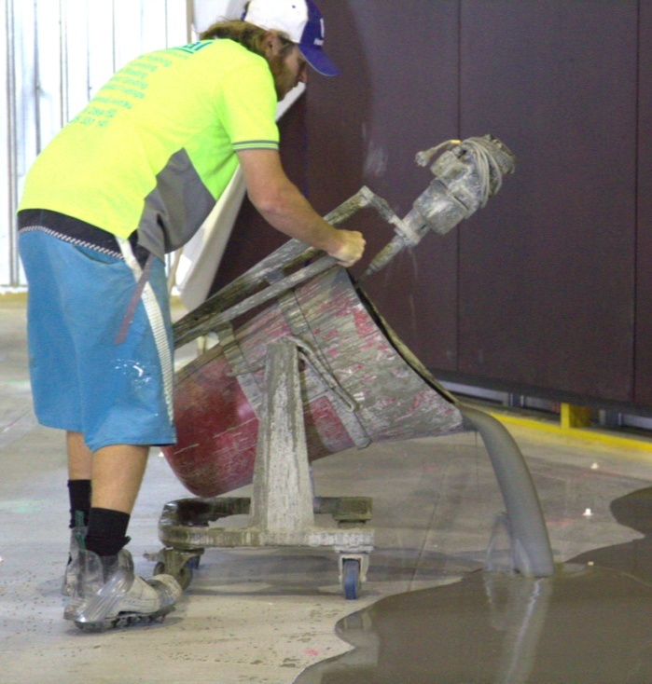
Experienced floor layers know that the long-term quality of a finished project always starts with the subfloor. Even though the client often doesn’t see this stage of the job, it’s the part that most often causes problems in the finish or performance of the floor covering.
In this unit, we’ll cover the processes of preparing the subfloor and applying various coatings and toppings to the surface. We’ll use the term coatings to refer to primers and liquid moisture membranes, and toppings to describe all patching, levelling and smoothing compounds.
We’ll also use the term substrate to refer to the subfloor surface. In the unit Inspecting and testing subfloors we gave ‘substrate’ the precise definition from Australian Standard 1884-2012 (resilient floor coverings) to describe the layer immediately under the floor covering. However, this more general definition includes any layer below another layer that’s placed on top.
Primers, moisture barriers and damp proof membranes will also be discussed in this unit. Note that all of these processes involve ‘building up’ from the surface of the subfloor. The process of ‘going down’ – or removing layers – is covered in detail in the unit: Concrete grinding.

Working through the unit

There are three sections in this unit:
- Preparations
- Concrete moisture barriers
- Priming patching and levelling.
Each section contains an Overview, an Assignment and Lessons which cover the content material.

Assignments
Your trainer may ask you to submit the assignments as part of your assessment evidence for the unit. You will find hard-copy templates for these assignments in the separate workbook.
Electronic ‘Word’ templates of the assignments are available on the website for this resource, at: www.flooringtech.com.au

Learning activities
Each of the lessons has a learning activity at the end. The Workbook for this unit contains all of the learning activities together with spaces for written answers.
Again, you will find the learning activities on the website version, together with some interactive ‘Just for fun’ exercises.

Practical demonstrations
Your final assessment of competency in this unit will include various practical demonstrations. Their purpose is to assess your ability to apply coatings and toppings to subfloor surfaces. To help you get ready for these hands-on assessment activities, see the sample checklist shown in the Practical demonstrations section at the back of this Learner guide.
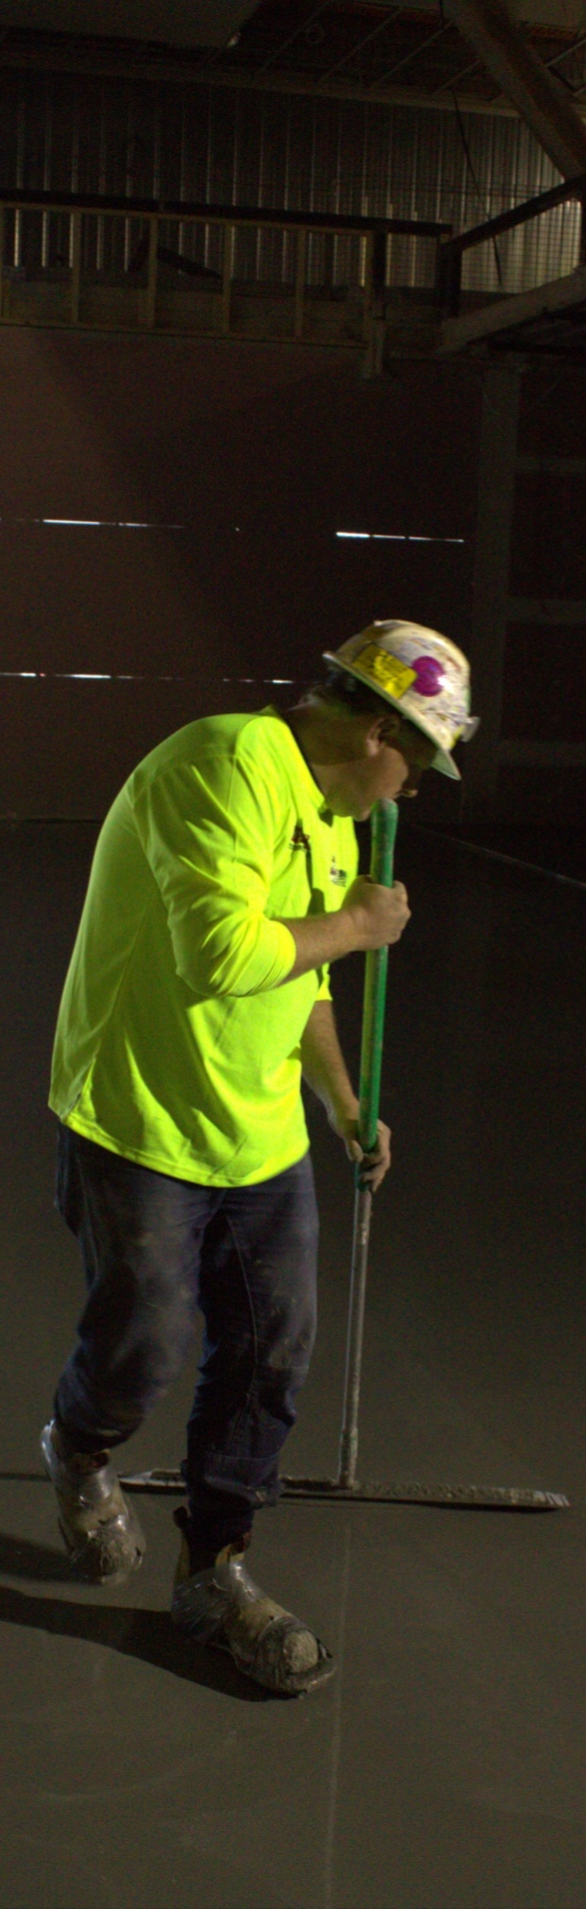

Section 1

Preparations

Overview
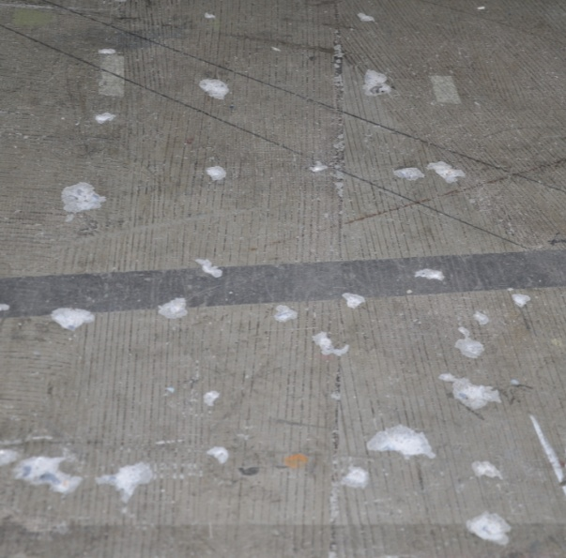
One of the most important points to remember when you’re preparing a subfloor surface for a coating or topping is that the strength of the bond can only ever be as good as the surface you’re bonding to.
This means that anything on the surface that might reduce the bonding strength will need to be removed.
It also means that the moisture content of the subfloor must be at an acceptable level or be controlled with the use of a moisture barrier.
In addition, concrete floors need to have reached a suitable pH level, to avoid the problem of an alkaline reaction with the adhesive and floor covering.
In this section, we’ll discuss the preparations you'll need to carry out before installing a coating or topping. We’ll also look at the health and safety issues involved in the preparing subfloors, applying coatings, mixing compounds and installing the underlayment.

Completing this section

The assignment for this section is designed to test your understanding of the processes involved in preparing subfloors for coatings and toppings.
Have a look at the Assignment on page 19 to see what you’ll need to do to complete it.
There are five lessons in this section:
- Checking moisture and pH levels
- Preparing concrete substrates
- Preparing timber substrates
- Tools and equipment
- Health and safety.
These lessons will provide you with background information relevant to the assignment.

Checking moisture and pH levels
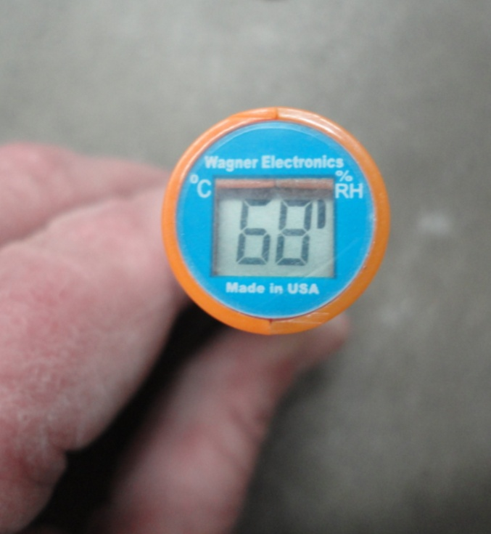
Of all the problems that can occur in a finished floor, the ones that stem from high moisture or pH levels are likely to give you the most trouble.
That’s why you need to be very thorough in your moisture and pH testing before you start any preparation work.

Moisture levels
Set out below are the relative humidity (RH) and moisture content (MC) levels permitted under the Australian Standards for textile floor coverings (AS 2455) and resilient coverings (AS 1884).
Note that these figures are general specifications – manufacturers of flooring products may have different specifications listed in their installation guidelines. There may also be particular regions in Australia where these limits are not appropriate, such as in North Queensland where atmospheric humidity often remains high for long periods of time.
For each subfloor, three tests need to be carried out in the first 100 m², plus one extra test for every additional 100 m². Tests may also need to done in other locations, depending on the structure of the floor.

Concrete subfloors
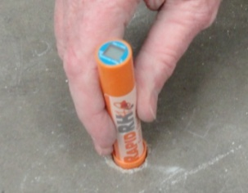
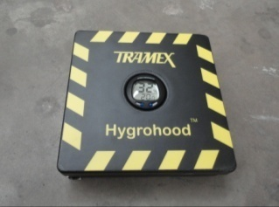
Surface-mounted insulated hood
test – maximum RH: 70%
In-situ probe test –
maximum RH: 75%
If it turns out that the RH level is not acceptable for the coatings or toppings you’re planning to use, you will have to make a choice – either:
- wait until the concrete dries down to an acceptable level, or
- apply a moisture barrier to the surface.
We’ll talk more about moisture barriers in the next section of this unit.

Timber subfloors
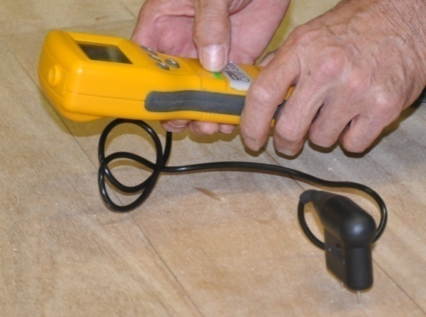
Moisture content (MC) range: 10-14%
If the moisture content is above 14%, it could mean there’s a subfloor ventilation problem or that the floor has been flooded due to a broken water pipe or some other plumbing problem.
In these cases, you’ll need to address those issues first and then wait for the floor to dry.

pH levels
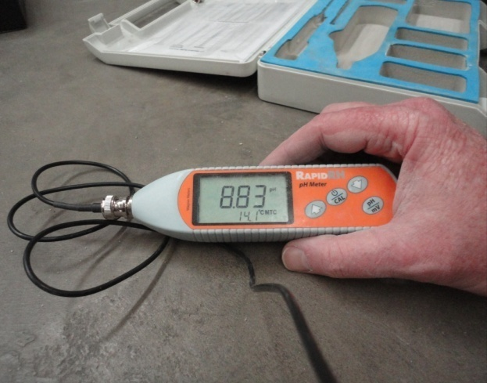
The latest Australian Standard for resilient flooring installation (AS 1884-2012) says that a pH test must be carried out on all concrete subfloors as part of the pre-installation assessment. The level should be as follows:
- pH range: 9-10
Again, three tests need to be carried out in the first 100 m², plus one extra test for every additional 100 m².
Note that freshly poured concrete always has high alkalinity (often with a pH of 12-13), because this is a by-product of the chemical reaction occurring between cement and water. So you don’t need to be concerned about high pH levels while the concrete is still drying.
However, if the concrete has reached equilibrium moisture content (EMC) and the pH is still too high, you’ll need to take some action. The most common treatment is an acid wash. We’ll talk more about this in the next lesson.

Learning activity

If you haven’t already completed the unit Inspecting and testing subfloors, you should go to it now and read through Section 4: ‘Measuring moisture and pH’.
Even if you have completed it, you might want to refresh your memory on these topics and have another look at the range of YouTube video clips showing how the various test procedures are carried out.
Below is the link to a video clip produced by Wagner Electronics on how to use the Rapid RH probe (pictured at the beginning of this lesson).
http://www.wagnermeters.com/video-install.php

Preparing concrete substrates
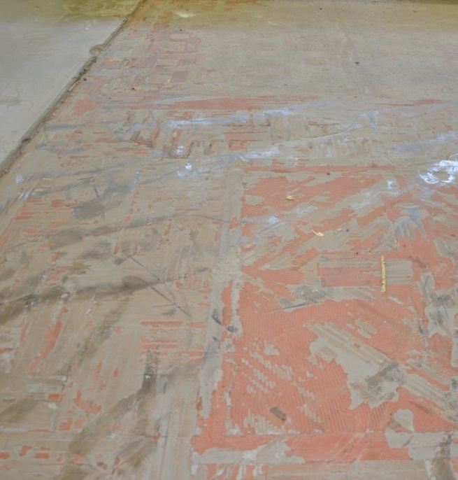
Once you’re satisfied that the moisture and pH levels are within the allowable range, it’s time to prepare the concrete surface.
This involves removing anything from the surface that might reduce the bonding strength or performance of the layers you’re going to put on top.
The sorts of things that have to be removed include oil, grease, asphalt, curing compounds, gypsum, dust and any other contaminants that could affect the new coatings or toppings.
In addition to these substances on top of the surface, concrete subfloors sometimes have a weak or powdery surface layer due to spalling or laitance. See Inspecting and testing subfloors for more details on these conditions.
There are various ways of removing contaminants and weak surface material. The method you use will depend on how serious the problem is and what the substances are. Set out below are the main methods.

Abrasion

The best way to achieve a clean bare concrete substrate is through some form of physical abrasion. The simplest method of abrasion is to simply scrape off surface blobs by hand with a floor scraper.
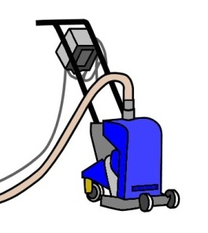
More serious contaminants are removed by grinding away the affected layers of concrete with a machine. Depending on the amount of material that needs to be removed, you might use a grinder, shot blaster or scarifier.
See the learning activity below for a link to several video clips that demonstrate these techniques. They are also explained in more detail in the unit: Concrete grinding.

Acid washing
For certain surface contaminants, some people like to wash the concrete with acid. However, this should only ever be used as a last resort, because most levelling compound manufacturers will not warrant their products unless the concrete surface has been mechanically ground.
If you do decide to acid wash the surface, be careful to keep the solution within the confines of the slab and to completely remove any residue when you finish. Muriatic acid is generally used, which is a commercial grade of hydrochloric acid.

To prepare the solution, mix 1 part muriatic acid to 10 parts water. Apply the solution with a watering can and use a stiff-bristled broom to spread it around the floor.
Once the reaction has taken place, wash it off and make sure that it is completely neutralised before leaving the floor to dry.
Note that acid washes are not effective in removing grease and oil. The same applies to solvent washes, which have a tendency to drive the contaminants further into the concrete pores.

Degreaser and detergent

Grease and oil can often be removed by scrubbing with a degreaser or detergent if the contaminants haven’t penetrated too far below the concrete surface.
Once you’ve finished, wash the concrete clean with water. Then allow the surface to dry and mechanically grind it down to clean concrete before starting the topping process.

Dealing with ‘cutback adhesive’
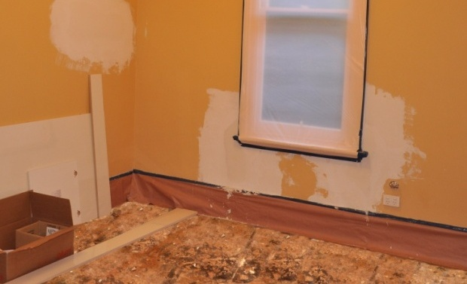
Cutback is a black asphalt-based adhesive that was once used to install vinyl tiles. It often contains asbestos fibres.
If the cutback is still firmly bonded to the floor, it’s often easiest to leave it in place and only remove the thick accumulations and brittle or loose material.
This is done by wet scraping and mopping the floor to avoid the creation of dust.
Always remember that you need to be very careful to minimise the amount of dust that’s produced, and to wear protective clothing that’s suitable for the job. You must also follow proper disposal methods for asbestos based products.
For more information on this topic, see the Queensland Government publication: Asbestos – A guide for minor renovation. You’ll find a downloadable version of this document on the Flooring Technology website under the ‘Supporting resources’ link for this unit.
There is also more information on how to identify and remove old asbestos-based vinyl and lino flooring in the unit: Resilient floor coverings.

Learning activity
The link below will take you to some video clips produced by ConcreteNetwork.com on how to use:
- Concrete scarifiers
- Concrete shot blasters
- Concrete floor scrapers
- Squeegee vacuums.
http://www.concretenetwork.com/videos/surface-preparation/
There is also a video clip on moisture testing that includes a demonstration on how to carry out a calcium chloride test. You’ll remember that we discussed the problems with this test in Inspecting and testing subfloors.
What is wrong with the calcium chloride test, and why is it no longer acceptable under AS 1884-2012?

Preparing timber substrates
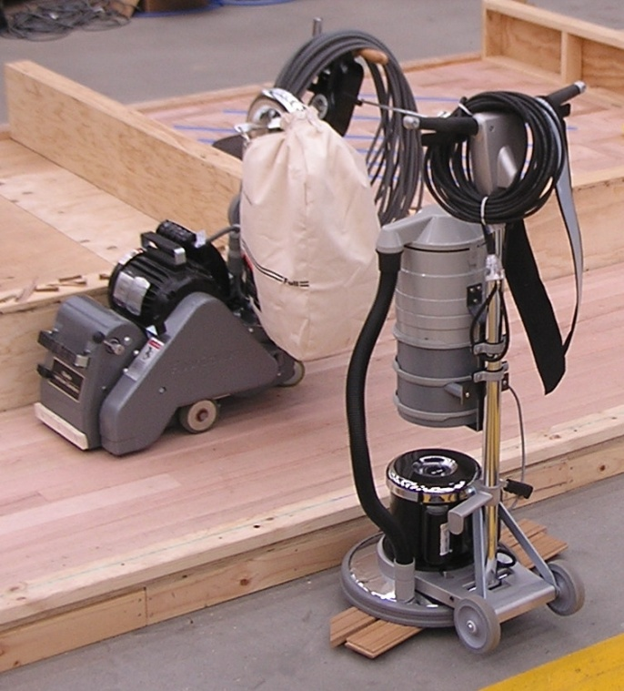
Timber surfaces include plywood and particleboard sheeting and solid tongue-and-groove boards.
Solvents and strippers don’t work well on timber floors, so you’ll need to remove contaminants by sanding down to bare wood.
Drum sanders are best on floors that need a lot of material removed. Belt sanders provide a finer finish, but get clogged up more easily, so they are most effective when the surface only needs to be lightly sanded. Orbital ‘edgers’ are used around skirting boards and corners.
Once the sanding is completed, vacuum up all dust with an industrial vacuum cleaner. Also check that all boards or sheets are well fixed and there are no squeaks or movement underfoot. Re-nail or screw any loose boards or panels.
Cement-based toppings should not be used on a particleboard substrate unless the manufacturer recommends it. This is because the particleboard is less tolerant of the high levels of moisture in the fresh underlayment than plywood or solid hardwood flooring.
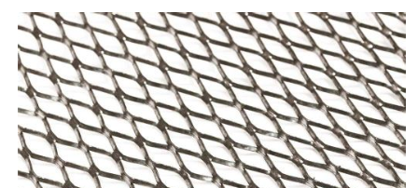
Where cement-based toppings are used on wooden subfloors, a diamond metal mesh should be put down first. Installers often use 12 mm ‘tilers lath’, which provides a strong support structure for the underlayment to bond to.

Learning activity
The link below will take you to a YouTube tutorial produced by ‘Allaboutflooring’ on how to prepare and sand a timber subfloor.
http://www.youtube.com/watch?v=LnCg2GHRBn8
Have you been involved in sanding a timber subfloor? Did you do anything differently from the way it's shown in this clip? If so, describe the differences.

Tools and equipment
The tools and equipment needed to prepare the subfloor and install an underlayment include ordinary hand tools as well as some more specialised tools. Let’s go through the main tools used, grouped according to the stage they are generally used in during the overall installation process.
Note that some tools are specific to certain subfloors and particular compounds, so they won’t always be used in every job.

Preparing subfloors

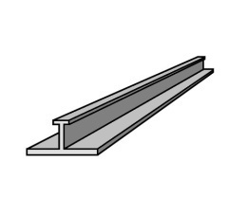
Broom and handbroom – for sweeping
up particles and rubbish.
Straight edge – for checking
planeness and smoothness.
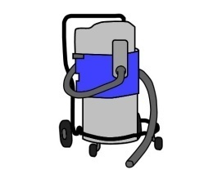

Tape measure – for measuring dimensions
and deviations in the floor.

Industrial vacuum cleaner – for
vacuuming up dust and small particles.
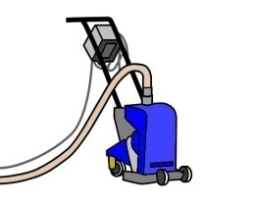
Floor scraper – for removing dags, blobs
of cornice plaster, etc.
Concrete grinder, scarifier, shot blaster, hand-held angle grinder – for removing ridges and contaminants by taking off the subfloor surface.
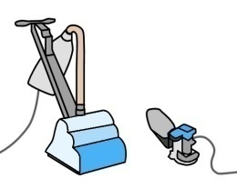
Drum sander, belt sander, orbital sander – for removing high spots, contaminants and surface coatings in a timber floor by sanding down to bare timber.

Installing a liquid moisture membrane
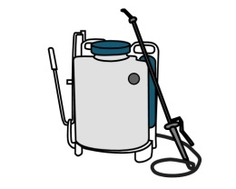

Paint brush and roller – for applying the liquid moisture membrane.
Backpack sprayer – alternative
method of applying the membrane.

Applying a patching compound


Trowel and putty knife – for applying
cement-based patching compounds.
Bucket – for mixing the patching
compound with water.

Applying a levelling compound

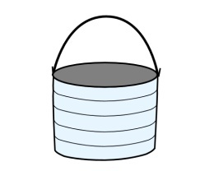
Water gauging bucket – for measuring out
the exact amount of water required per bag
of topping compound.
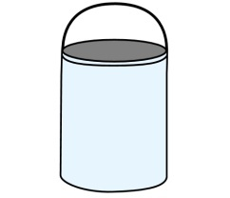
Mixing paddle and heavy-duty drill
– for mechanically mixing the topping.
Mixing and cleaning buckets – for holding the topping
compound and water while they are being
mixed and for cleaning up.
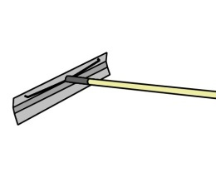

Trowels – for spreading the
underlayment in a kneeling position.
Thickness spreader – for spreading the underlayment in a standing position.


Smoother – for achieving a feather edge
and touching up the underlayment.

Spiked roller – for ‘de-aerating’ (removing
air bubbles) from the underlayment.
Spiked shoes – for wearing while using the spiked roller.

Learning activity
Which of these tools do you use at work when you’re preparing subfloors and installing underlayments? Make up a list and compare it with other learners in your group.
Are there any tools you use that aren’t listed here? Name the tools and provide a brief description of what you use them for.
If you are studying this unit by flexible delivery, you could also take digital photos of the tools. Share your answers with your trainer and other learners in your group via email or a social networking site.

Health and safety
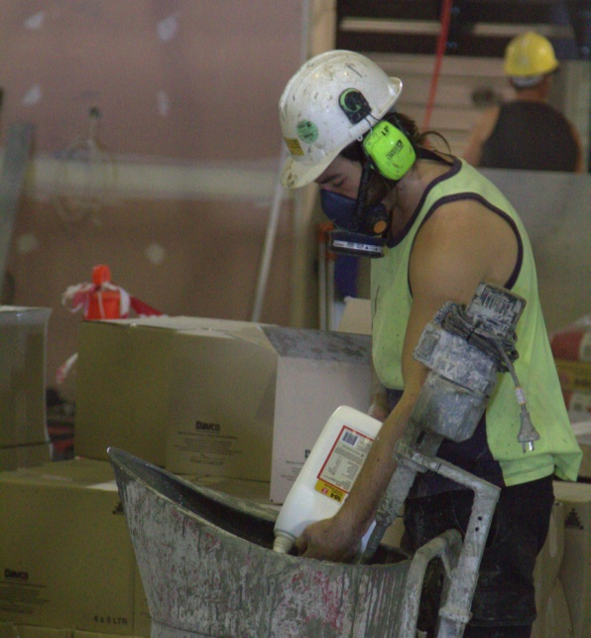
There are a few health and safety issues you’ll need to be mindful of when you’re preparing a subfloor and applying coatings and toppings.
The main ones relate to manual handling, dust, fumes and skin contact.

Manual handling
Grinding and sanding subfloors can be hard work. Walk-behind machines are large and heavy, and often awkward to get on and off a vehicle.
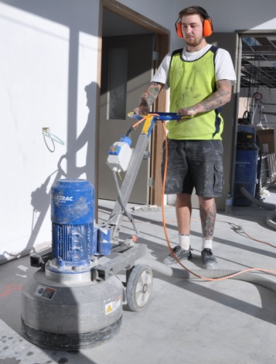
If you don’t have any mechanical lifting aids, you’ll probably need an offsider to help you get the machine from your workshop to the jobsite and into position.
Hand-held sanders and grinders also need to be handled carefully. When you’re working on your knees or in a crouching position, you have to be constantly aware of your posture and balance, the position of your hands and feet, and the location of the power lead. You should also wear knee pads and safety boots.
For more details on the safe work procedures you should follow when using these sorts of power tools, go to the unit: Concrete grinding. For general information on good manual handling practices and personal protective equipment, see: Safety at work.

Dust
Airborne dust is a big problem for flooring installers. Concrete and cement dust contains silica particles which can cause scarring of the lungs if you’re regularly exposed to it. Timber dust can trigger allergic reactions in some people, and over time may cause nasal or lung cancer.
The best way to reduce the amount of dust floating in the air is to collect as much as possible while it’s being generated. Hand-held sanders and grinders should have dust bags fitted. Walk-behind machines generally have vacuum ports that allow you to connect an external industrial vacuum cleaner, or alternatively have fitted bags.
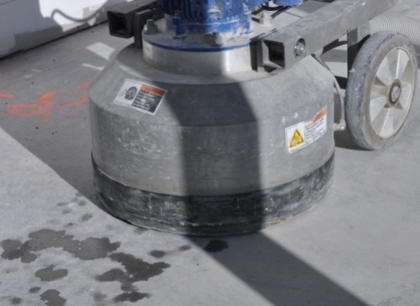
Another method of reducing airborne dust is to wet it down. Walk-behind grinders and scarifiers often have hose attachments that allow water to be sprayed directly onto the concrete while it’s being worked.
If you don’t have a mist sprayer, you can sprinkle wet sand on the floor before you start grinding.
Sweeping the floor surface also causes dust to cloud up and float in the air. One solution is to use an industrial vacuum cleaner wherever possible. If you must use a broom, spray a light mist over the dust first.

Finally, if you’re generating dust or working in a dusty area, make sure you wear a mask. This includes when you’re putting a levelling compound into a mixing bucket.
The mask should be rated P2. Don’t use a domestic ‘nuisance dust’ mask, because it’s not designed for industrial use.

Note that a dust mask alone is not sufficient protection if you come across old flooring products that contain asbestos.
In these instances, you need to notify the person in charge of the site and talk about how to handle it.
There are laws in place that control the removal and disposal of old asbestos-based building products. For more information on dealing with asbestos, see the Code of Practice produced by Safe Work Australia called: How to safely remove asbestos.

Fumes
Some products give off fumes, especially if they’re based on acids, solvents or epoxy resins. These fumes can cause long-term health problems if you regularly breathe them in. Sometimes they can make you feel very sick in a matter of minutes if you’re working in an area with poor ventilation. Signs of being affected include light headedness and breaking out in a cold sweat.
Always read the safety directions that come with hazardous products – you’ll find them printed on the side of the container or packaging they’re supplied in. In particular, pay attention to the ventilation requirements.

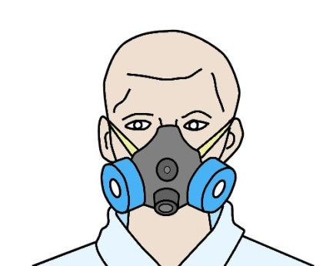
You may have to use a fan to blow the fumes away and wear a cartridge-type respirator while you’re working. It’s also a good idea to take regular breaks, say every 10 to 15 minutes, and go outside to get some fresh air.
The Material Safety Data Sheet (MSDS) for the product will have full details on how to use and store the product safely, and there will be a section on what personal protective equipment you should wear.
Some products come with an MSDS in the box or packaging. Your company should also have MSDSs for all hazardous products on file.

Skin contact
There are lots of products that come with the warning: ‘Avoid contact with skin and eyes’. These include products that contain cement powder, acid, solvents and epoxy resin. Some of them may burn your skin or cause dermatitis; others have toxic chemicals that can be absorbed through your skin.


In these cases, you should wear gloves while you’re mixing and using the products. You may also need to wear safety glasses if there is a chance that the product might splash into your eyes.

Learning activity

Choose a coating or underlayment product that requires the use of personal protective equipment (PPE) when you’re mixing or applying it.
Get a copy of the MSDS for the product and answer the following questions:
- What is the brand name of the product?
- What type of product is it (i.e. what is it used for)?
- What items of PPE are required, and when do you need to wear them?
- What other precautions should you take while you’re preparing, mixing or applying this product?
- How should you dispose of the leftovers once the job is finished?

Assignment 1
Go to the Workbook for this unit to write your answers to the questions shown below. If you prefer to answer the questions electronically, go to the website version and download the Word document template for this assignment.
___________________________________________________________________________
1. What are the maximum relative humidity (RH) levels permitted in a concrete subfloor under AS 1884 and AS 2455 using the following two testing methods?
(a) surface-mounted insulated hood’ test
(b) in-situ probe test.
2. How many RH tests should be carried out to determine whether the floor meets the requirements of the Standards? State the number of tests required and the floor area.
3. What is the acceptable moisture content range for timber subfloors, as specified under AS 1884 and AS 2455? State the upper and lower levels.
4. If the moisture content reading was too high in a raised timber subfloor, what might be causing the problem? List at least three possible causes.
5. The latest Australian Standard for resilient flooring installation (AS 1884-2012) says that a pH test must be carried out on all concrete subfloors. What is the pH range specified in this Standard?
6. How should you remove the following contaminants and substances from a concrete subfloor?
(a) a small amount of oil or grease on the subfloor surface
(b) a large amount of oil or grease that has penetrated the pores of the concrete
(c) blobs of cornice cement and surface dags
(d) spalling or weak surface material
(e) dust from scraping and grinding.
7. What is the best way to remove surface contaminants from a timber subfloor?
8. If you were preparing an old subfloor for a coating or topping and came across asbestos-based products, what should you do?

Section 2

Concrete moisture barriers

Overview
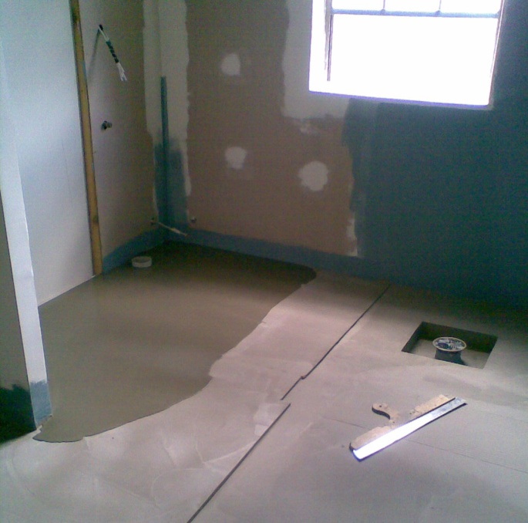
Moisture barriers are normally used in wet areas of buildings. In residential homes these are generally limited to bathrooms and laundries. But in commercial and public buildings they can include industrial kitchens, and particular areas of hospitals and aged care facilities.
In addition to their use in wet areas, moisture barriers can also be applied to concrete subfloors to stop moisture from rising up through the slab and contacting the underside of the floor coverings.
In this section, we’ll discuss the various sources of moisture and the different methods of transmission. We’ll also describe some of the processes used by flooring installers to apply liquid barriers and suppressants.

Completing this section
The assignment for this section will help to prepare you for the practical demonstrations you will need to perform for your assessor.
Have a look at the Assignment on page 37 to see what you’ll need to do to complete it.
There are five lessons in this section:
- Moisture and pH problems
- On-site issues
- Types of moisture barriers
- Applying moisture barriers
- Applying moisture suppressants.
These lessons will provide you with background information relevant to the assignment.

Moisture and pH problems
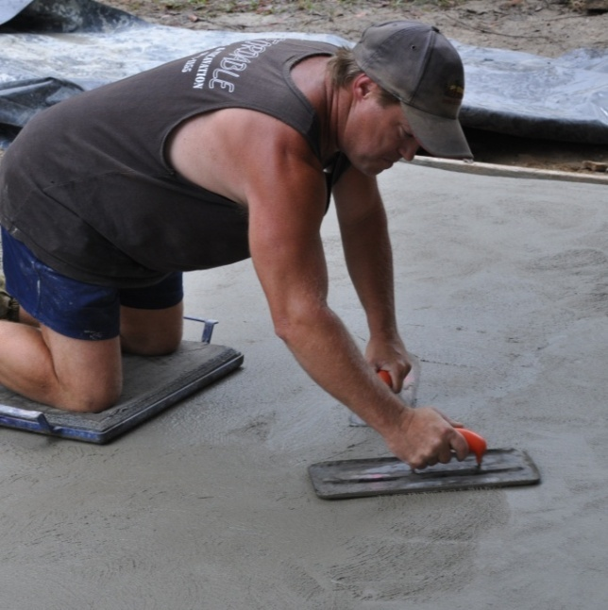
We’ve already talked about the maximum permissible moisture and pH levels in concrete subfloors, as specified under the Australian Standards.
But before you can decide on the best course of action to deal with moisture and pH problems, you need to know where the water is coming from.
The most obvious source of moisture is the excess water that’s put into the concrete mix to make it flow easily into the formwork and finish with a trowel.
However, water can also enter the slab from external sources, such as the surrounding soil or rainwater runoff, particularly if there is no membrane – or vapour barrier, as it’s often called – underneath the slab to protect it.
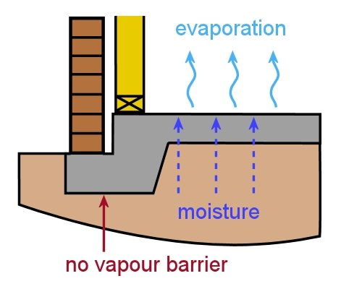
When this happens, the moisture can travel through the cracks and pores in the concrete and make its way up to the underside of the floor covering.
Because it happens out of sight, the moisture can cause a lot of damage to the flooring adhesive and floor covering before it becomes noticeable on the surface.
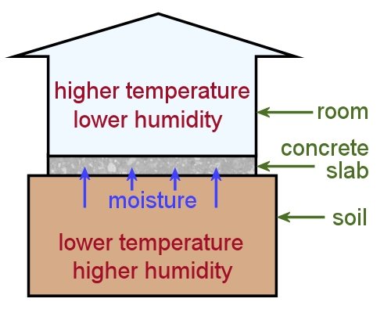
The most important point to remember is that moisture likes to be in ‘equilibrium’, or balance, with its surrounding environment.
So it tends to move from areas of low temperature and high humidity to areas of high temperature and low humidity until that balance is restored.

Below are the main factors that affect the movement of moisture in concrete. Once we’ve looked at these mechanisms, we’ll discuss the effect they can have on pH levels.

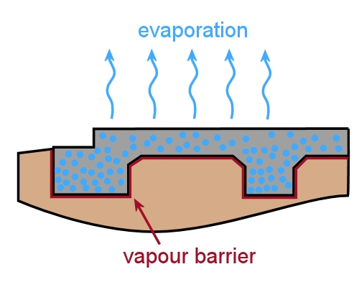
Construction moisture
‘Green’ (or fresh) concrete always starts off with a very high moisture content. In reality, only about one third of the water in wet concrete is needed for the hydration process. The remainder is there to make it more workable.
Before the concrete can reach EMC (equilibrium moisture content) with the surrounding atmosphere inside the building, the excess water has to evaporate from the surface.
Concreters often use the rule of thumb that concrete dries at a rate of about 1 mm per day. This means that a 100 mm thick slab will take about 100 days to dry. But the rule only applies if there is no curing compound on the surface or any other covering that might slow down the drying process – so it can often take much longer.

Capillary action
Capillaries are tiny spaces that allow a liquid to flow through. Capillary action occurs as a result of the ‘attractive force’ between the molecules of a liquid and the ‘adhesive force’ of the very small spaces.
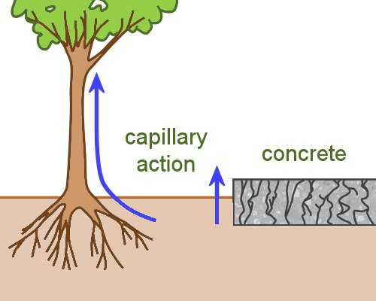
This allows the liquid to flow against the pull of gravity. You can see it happen when blotting paper absorbs ink.
It’s also the force that allows plants to draw moisture up from the roots to the leaves, and a kerosene lamp to draw fuel through the wick.
The pores and cracks in a concrete slab can also provide suitable conditions for capillary action to take place.
If there is no vapour barrier underneath the slab and the soil is wetter than the concrete, moisture will be drawn up through the tiny cavities and evaporate from the surface.
This is a common problem with slabs that are more than 50 years old, because it was not standard building practice in those days to install vapour barriers.
Even if you cover the concrete surface with a floor covering, the moisture will still rise, but because it can’t evaporate into the air it will accumulate under the floor covering.

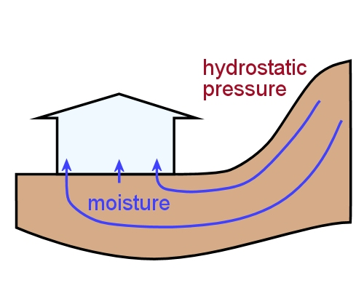
Hydrostatic pressure
‘Hydro’ means water and ‘static’ means stationary. Hydrostatic pressure is the pressure exerted by still water due to the force of gravity, as opposed to flowing water.
It becomes a problem for on-grade or below-grade concrete slabs when the surrounding land is higher on any side.
If there is no membrane separating the slab from the soil, the build-up of hydrostatic pressure can eventually force the moisture up through the slab.
A build-up of hydrostatic pressure can occur in various ways. Heavy rain, broken or leaking pipes, and excess watering by sprinklers can all increase hydrostatic pressure. Raised garden beds next to the house also contribute to the problem.
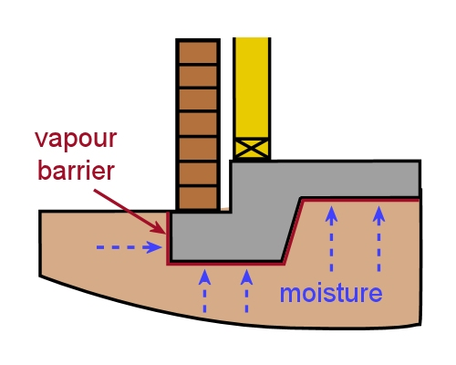
Even if a membrane had been installed before the concrete was poured, it may have deteriorated over the years, or in some cases, have been accidentally punctured by the concreters during construction.
Moisture can also enter through the sides of a slab if the membrane has not been turned up all the way around.

pH levels
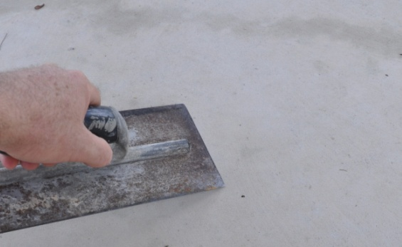
Wet concrete has a very high pH level, or alkalinity. You can often see the whitish deposits of alkaline salts on the surface of drying concrete.
When the pH level is above 10, the alkaline salts can react chemically with the flooring adhesives and gradually cause the bond to fail.
Alkaline salts will also react with the PVC in certain floor coverings and make them go brittle. It can also be responsible for softening rubber-backed coverings and destroying carpet dyes.
Rising moisture in a slab tends to bring alkaline salts to the surface. So in addition to the moisture itself causing damage to adhesives and floor coverings, the high alkalinity brings its own set of problems.
Remember, though, that a freshly poured slab will naturally have high pH levels due to the chemical reaction taking place. So you only need to deal with this problem as a separate issue if the moisture has already been brought under control and the pH is still high.

Learning activity
We’ve mentioned the rule of thumb that concrete dries at a rate of about 1 mm per day. But there are lots of reasons why concrete could take much longer to dry down to a moisture content that’s in equilibrium with the surrounding atmosphere. One of these reasons is the presence of a curing compound on the surface.
How many other reasons can you think of? Make up a list and share it with other learners in your group or with your trainer.

On-site issues
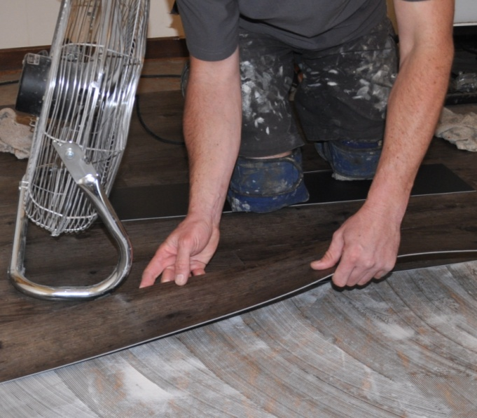
It’s sometimes the case that there is no single big problem responsible for high moisture or pH levels. Instead, there may have been several contributory factors that all played a role.
Here’s an example of what can happen on a jobsite where the builder or client is pushing the installer to get the job done quickly:
- the installer starts work before the concrete has reached 70% RH in all test areas (using an insulated hood)
- the levelling compound is mixed with a bit too much water
- the flooring adhesive is applied before the levelling compound has fully cured.
Now let’s say that the client moves into their new house and then installs an air conditioning system. As the air progressively dries out inside the building, the difference in humidity levels between the slab and the room atmosphere will increase.
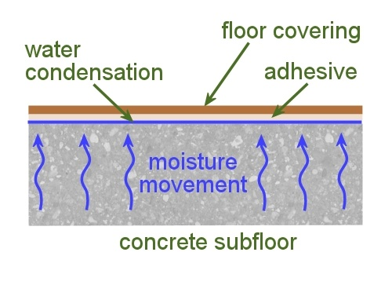
However, the moisture can no longer escape through the surface because the floor covering is restricting its free evaporation. So it condenses into liquid water and begins to degrade the adhesive and flooring materials.
Sheet vinyl and solid timber flooring tend to fare the worst when there’s a difference in humidity levels between the subfloor and the air inside the room.
But all floor coverings can be affected if the humidity differences are large enough or remain a problem for long enough.

Air conditioners
Australian Standard 1884-2012 says that when air conditioning units are being installed in a new building, no underlay or floor covering should be laid on the subfloor until the unit has been operating at the expected temperature and humidity levels for at least seven days. The unit should be kept running continuously during the laying process and for a further 48 hours.
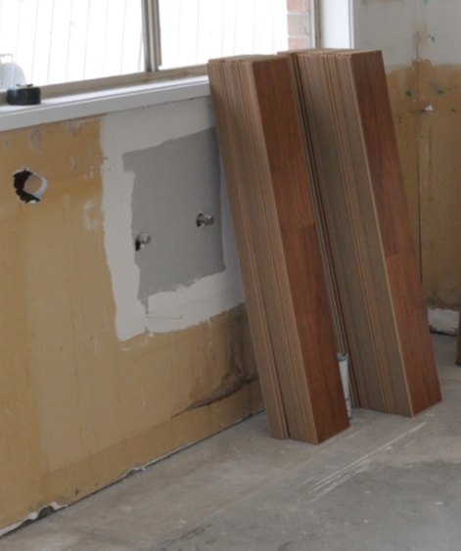
In the case of solid timber flooring, manufacturers often state in their warranty conditions that the boards must be allowed to ‘acclimatise’ to the room humidity levels for at least two weeks prior to laying. Again, when an air conditioner has been installed, it must be running continuously during the acclimatisation period.
Note that these requirements assume that the subfloor humidity has already dropped to an acceptable level, or the surface has been properly coated with a moisture barrier.
If you’re still waiting for the concrete to dry or there are other problems causing high moisture levels, you’ll need to deal with those issues first before you start acclimatising the flooring materials.

Learning activity
Why do you think that air conditioning systems get a special mention in AS 1884? What does an air conditioner do to the humidity level inside the room?
How would this affect the difference in RH levels between the concrete subfloor and the room atmosphere?

Types of moisture barriers
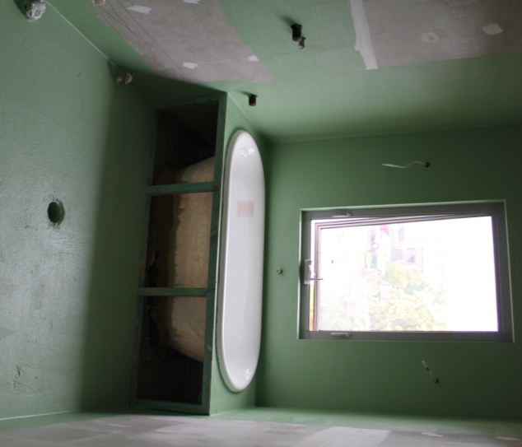
Moisture barriers, damp proof membranes (DPMs) and waterproofing membranes are terms that are often used interchangeably.
Strictly speaking, however, the only true barriers that completely stop the transmission of moisture are metal (generally aluminium or copper) and glass.
Nonetheless, AS 4858-2004 (Wet area membranes) defines a membrane as ‘waterproof’ if it achieves a specific performance level under test conditions.
This level is called the ‘moisture vapour transmission rate’.
The types of moisture barriers that meet this definition include:
- Pre-formed sheet membranes that are either laid on top of the subfloor surface or bonded to the surface.
- Fibre reinforced liquid-applied membranes, which either contain chopped strands of fibre in the liquid, or have a separate sheet of mesh that’s embedded into the liquid while it’s being applied to the floor.
- Liquid-applied membranes that contain no reinforcement.
Pre-formed sheet membranes are commonly found in the modular fibreglass units installed in bathrooms, such as shower trays and other fixtures.
Liquid-applied membranes are used by floor tilers and vinyl floor layers working in wet areas. These areas include bathrooms, laundries, commercial kitchens and hospital rooms where water may be splashed around.
They can also be used when there is a moisture problem coming from an external source. In these cases, their purpose is to resist any moisture that travels through the slab from getting to the surface and affecting the floor coverings or walls.
In addition to these ‘waterproofing’ membranes, flooring installers sometimes use moisture suppressants if they want to begin an installation before green (freshly poured) concrete has dried to an acceptable level, or if there is low-level capillary movement of moisture through the slab.

Types of liquid-applied membranes
There are three main categories of liquid-applied membranes:
- Acrylic membranes are water-based and can be one or two part. One-part products are premixed, so they are applied direct from the container. Two-part systems normally contain a liquid polymer and a cement-based powder.
- Polyurethane membranes are ‘reaction polymers’ – that is, the molecules react with other chemicals to form strong cross-linked membranes.
- Epoxy membranes are all two-part systems that contain an epoxy resin and a reactive hardener. Some are designed to be flexible when cured, others are non-flexible.
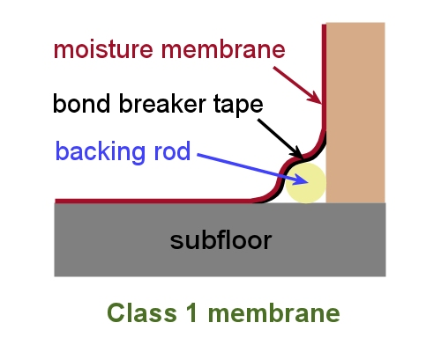
The flexibility of a membrane is a major factor in its performance and the way it is installed. AS 4858 defines three classes of membranes, based on their ‘extensibility’, or ability to stretch when there is movement in a crack or join.
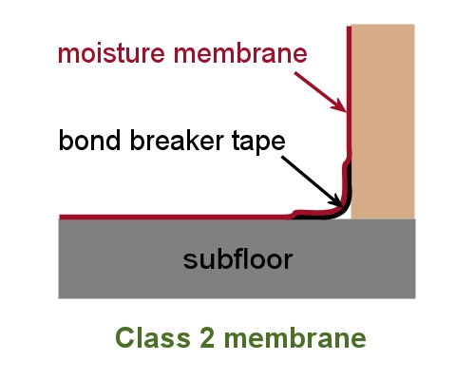
Class 1 membranes have low extensibility, so they don’t ‘extend’ very well when there is movement in a crack or join in the floor, or between the floor and a wall.
This means that if there is regular movement the membrane might fatigue over time and eventually rupture.
Class 2 membranes have medium extensibility and Class 3 have high extensibility.

Joints and bond breakers
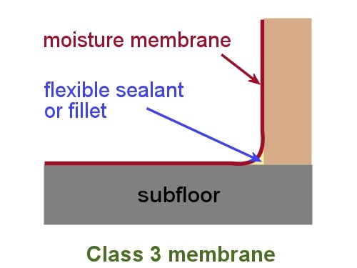
A bond breaker is piece of tape or other material that goes between the moisture barrier and the substrate where movement is likely occur, such as over joints in the floor or joints between the floor and walls.
Its purpose is to ‘break the bond’ and give the membrane more room to stretch and return to normal.
The different types of bond breakers used in residential construction are described in AS 3740-2010 (Waterproofing of domestic wet areas). Their design is directly related to the class of membrane being used.
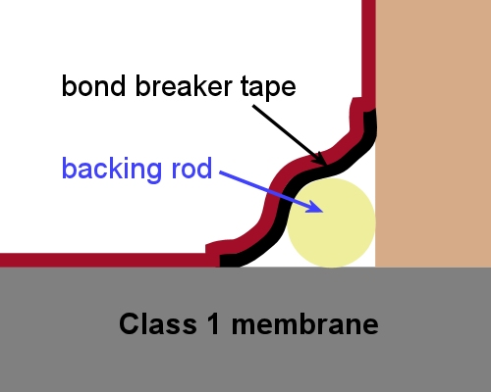
For example, Class 1 membranes have low extensibility, so the bond breakers are designed to let the membrane flex rather than stretch.
Note that the backing rod shown in the diagram at right is best used to fill an expansion cavity between the wall and floor junction. It should not protrude beyond a 90 degree angle if you’re carrying out a resilient installation.
Class 2 membranes are more flexible, so the width of the tape can be proportionately less. And Class 3 are very flexible, so the bond breaker can be as little as a 12 mm bead of silicone.
Expansion joints are a different matter. These openings must be carried right through to the finished floor and fitted with an approved jointing system. We’ll discuss this further in the next lesson.

Learning activity
Choose one liquid-applied moisture membrane and answer the questions below.
- What is the brand name of the product?
- Who is the manufacturer?
- What membrane class does it belong to?
- What is its chemical base (e.g. acrylic, polyurethane, epoxy resin)?
- When should the product be used? (Give some examples of the types of applications specified by the manufacturer for this product.)
If you’re not familiar with any particular brands, follow the links below to two manufacturers’ websites – Ardex and Davco – and choose one of their products.
http://www.davco.com.au/productCategory.php?id_category=15
http://www.ardexaustralia.com/products/waterproofing
Alternatively, you could select a product being stored on the shelf at your workplace, or simply go to your local hardware store.

Applying moisture barriers
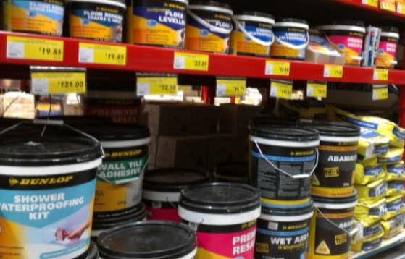
There’s a wide range of moisture barrier products on the market and various installation techniques.
Because moisture control is so crucial to the success of the overall floor covering project, you should always follow the manufacturer’s instructions closely.
This includes using any other products specified by the manufacturer if it forms part of an overall ‘moisture barrier system’, to ensure that all the products you’re using are compatible and that you’ve satisfied their warranty conditions.
Remember, incompatible solvent-based adhesives can react with some moisture barrier products and cause costly failures. Even if you’ve put a cement-based compound in between the adhesive and the moisture barrier, you may still not stop the solvent from penetrating.
Below are the general principles involved in installing a two-part epoxy resin moisture barrier.

Preparation and installation procedure
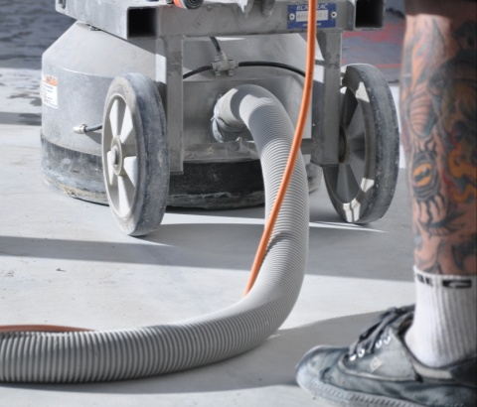
1. Remove all surface contaminants and weak or powdery material from the concrete substrate. This can be done by shot blasting, scarifying or diamond grinding. The final surface must be clean, porous, bare concrete.
2. Remove all dust and debris and allow the floor to stand for at least 30 hours to let any moisture from the shot blasting or grinding process to dry out.
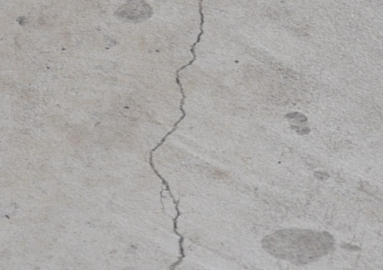
3. Note any cracks in the substrate for future reference. Check all expansion joints and construction joints and repair them as required.
If there are any structural cracks or problems with expansion joints, discuss them with your supervisor.

4. Give the floor a final vacuum to remove any remaining dust.
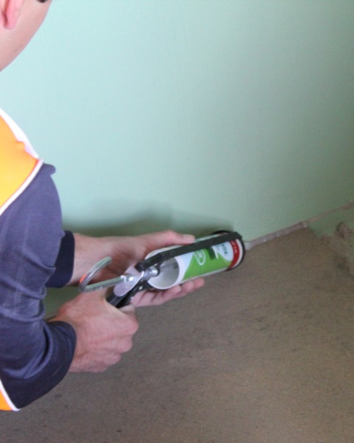
5. Apply a primer to the surfaces. This will improve the bond strength of the moisture membrane, particularly on fibre cement wall sheeting that has been sanded but is still holding a fine dust from the hard-set plaster.
6. Cover all joints, waste junctions and other penetrations with woven fabric tape, or other bond breaker materials, as specified by the manufacturer.
In some cases, a silicone or polyurethane sealant may be recommended by the manufacturer.
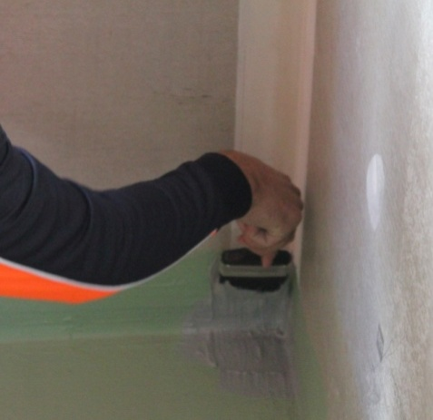
7. Mix the epoxy and hardener components together. Apply the mixture to the floor with a notched trowel, squeegee or brush.
Make sure that the correct thickness is maintained by using the specified amount for the area to be covered.
Continue the barrier up the base of the walls to at least 150 mm above floor height.
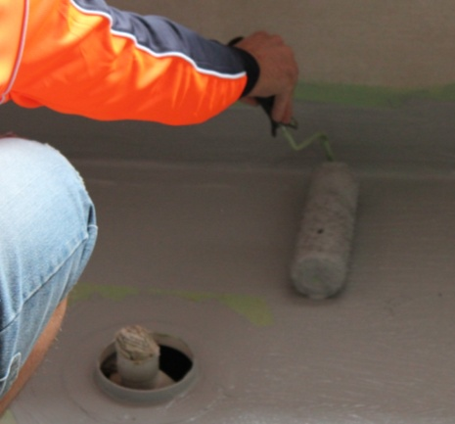
8. Use a nap roller to roll out the product, making sure there are no pinholes or bubbles in the coating.
9. Wait for the specified amount of time, and then apply a second coat at 90 degrees to the first coat. Again, check that the correct thickness is maintained by using the quantity specified for the second coat.

Cracks and expansion joints
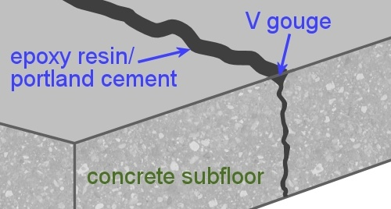
Non-active cracks should be filled using the method recommended by the product manufacturer.
One method is to ‘V’ gouge the crack, prime it with epoxy resin and then fill it with a slurry of epoxy resin and Portland cement.
Active cracks – that is, cracks that could move over time and either open or close – should be noted and discussed with your supervisor to find out whether a structural engineer’s advice is needed. These sorts of cracks can result in later moisture problems and show through a finished resilient floor, so they may require specialist treatment.
Expansion joints must be continued right through the moisture barrier and underlayment. One method of keeping them open is as follows:
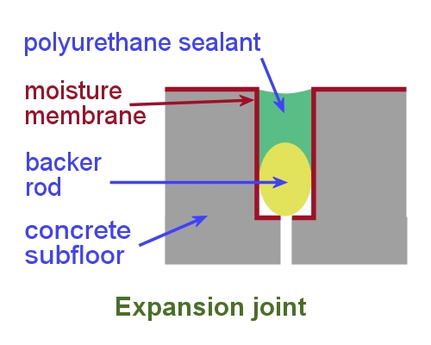
- put a backer rod in the joint and mark its position on the walls or other fixtures at each end
- coat over the top of the joint with the moisture barrier and underlayment
- put two vertical saw cuts through the underlayment to expose the joint
- remove the material and coat the sides of the saw cut with moisture barrier
- install a jointing system recommended by the manufacturer.
The drawing above shows a polyurethane sealant on top of a foam backer rod. Note that the term ‘moisture membrane’ has been used in place of ‘moisture barrier’. Most manufacturers call their products ‘moisture barriers’, while the Australian Standards refer to them as ‘moisture membranes’.

Learning activity
The link below will take you to a YouTube video produced by Altro Flooring on how to install their AltroProof Solo Damp Proof Membrane.
Watch the clip and then answer the following questions.

- What is the chemical base of AltroProof Solo DPM?
- After you add the hardener to the base, how long should you stir the mixture for?
- What tools are used to apply and spread the membrane on the floor?
http://www.youtube.com/watch?v=3aG08Iq7m5s

Applying moisture suppressants
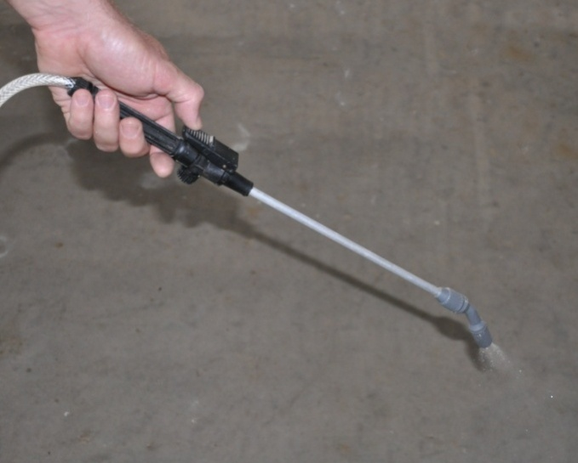
Moisture suppressants are mostly used to ‘fast track’ a floor covering installation when the concrete is still green and has not yet reached an acceptable RH level.
They’re not designed to provide the same level of protection as a full moisture barrier.
Most moisture suppressants are water-based products that can be applied with a roller, brush or sprayer.
When a sprayer is used, several passes are applied until the area is evenly saturated. Then the excess material in the low spots is spread with a broom to the high spots.
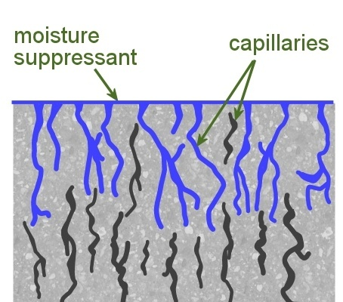
As the concrete pores fill up, any contaminants trapped inside the pores will tend to float to the surface. So the concrete needs to be sanded and vacuumed 24 hours after the suppressant is applied to remove the residual chemicals and substances.
As with moisture barriers, you must carry expansion joints through to the finished floor height. These are typically filled with a jointing system made from polyurethane, silicone or epoxy resin.

Learning activity

Below is a link to a video clip demonstrating the installation of Protect Crete ‘Moisture fix’ concrete moisture barrier. Although this product provides a fully waterproof membrane, it shows a simple application technique which can also be used for moisture suppressants.
Watch the clip and then describe the process used and equipment required to spread the product.
http://www.youtube.com/watch?v=0IkJMveIMWo

Assignment 2
Go to the Workbook for this unit to write your answers to the questions shown below. If you prefer to answer the questions electronically, go to the website version and download the Word document template for this assignment.
___________________________________________________________________________

Assignment questions
1. What is hydrostatic pressure? What types of landscaping or land formations tend to contribute to hydrostatic pressure in the soil under a slab?
2. What are capillaries? How do they allow moisture to travel through a slab?
3. How should an expansion joint be treated when you are applying a moisture barrier?
4. What is the purpose of a bond breaker? Where should you use bond breakers?
5. Select the liquid moisture barrier product that you plan to use for your first practical demonstration in this unit. Obtain the manufacturer’s MSDS and technical data sheet for the product and answer the following questions.
(a) What is the product’s brand name and who is the manufacturer?
(b) What is its chemical basis (water, polyurethane, epoxy, etc)?
(c) What membrane class is it?
(d) What type of bond breaker tape or materials are required at joints?
(e) What items of PPE are required when mixing and using this product?
(f) What other safety precautions apply to the use of this product (such as ventilation and lighting)?
(g) How many coats are required and how long should you wait between coats?
(h) What is the curing time after the final coat has been applied (that is, how long should you wait before moving onto the next stage of the subfloor preparation)?
6. Select the moisture suppressant product that you plan to use for your second practical demonstration in this unit. Obtain the manufacturer’s MSDS and technical data sheet for the product and answer the following questions.
(a) What is the product’s brand name and who is the manufacturer?
(b) What is its chemical basis (water, polyurethane, epoxy, etc)?
(c) What items of PPE are required when mixing and using this product?
(d) What other safety precautions apply to the use of this product (such as ventilation and lighting)?
(e) How many coats are required and how long should you wait between coats?
(f) What is the curing time after the final coat has been applied (that is, how long should you wait before moving onto the next stage of the subfloor preparation)?
___________________________________________________________________________

Practical demonstrations
Before you’re signed off as competent, you will be asked to carry out at least two installations of moisture membranes. See the ‘Practical demonstration’ chapter at the back of this Learner guide for more information on these assessment activities and sample checklists showing the sorts of things you’ll need to demonstrate.

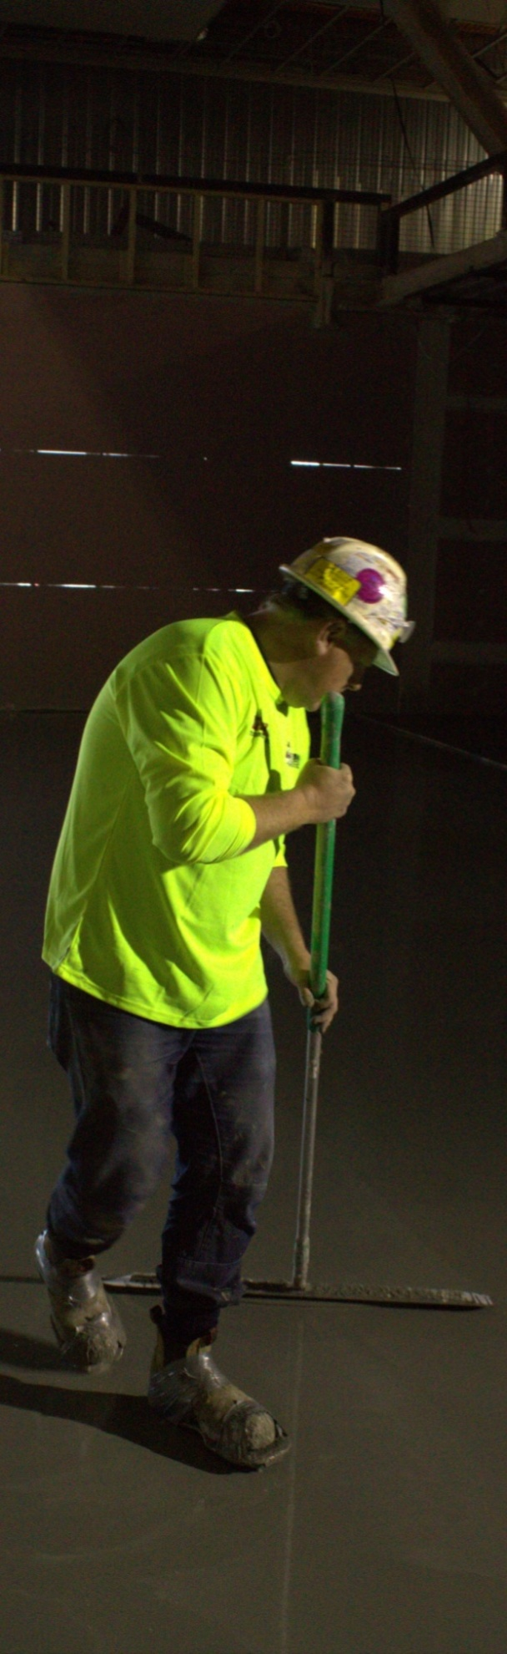

Section 3

Priming, patching and levelling

Overview
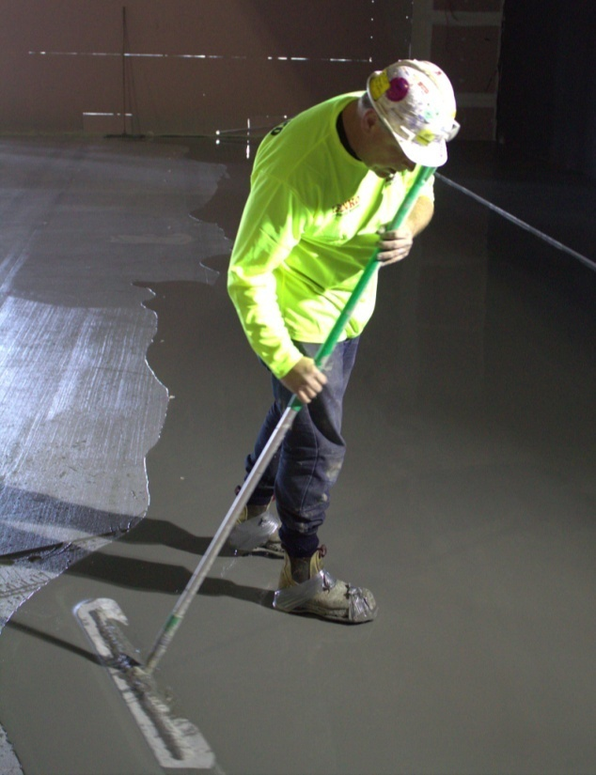
Levelling compounds are used to build up the underlayment that goes between a subfloor and the floor covering.
They’re generally used on concrete subfloors, but can also be applied to sheet flooring products and timber strip flooring.
The process of installing an underlayment begins with priming and patching the subfloor to provide a suitable substrate for the levelling compound. Then the compound is poured onto the surface and smoothed and levelled.
In this section, we’ll look at the main types of products used to build up an underlayment and the general processes involved.

Completing this section
The assignment for this section will help to prepare you for the practical demonstrations you will need to perform for your assessor.
Have a look at the Assignment on page 55 to see what you'll need to do to complete it.
There are five lessons in this section:
- Types of levelling compounds
- Applying primers
- Applying patching compounds
- Applying levelling compounds
- Estimating quantities.
These lessons will provide you with background information relevant to the assignment.

Types of levelling compounds
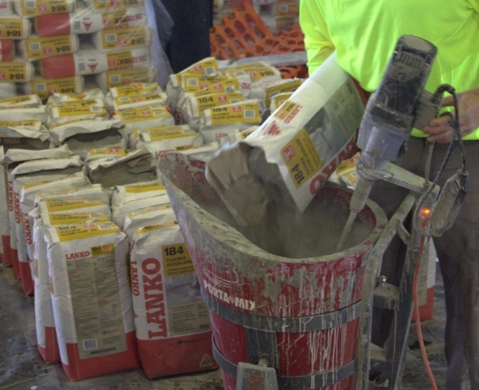
Some people use the term ‘levelling compound’ to refer to the whole range of products used to patch, smooth and level a floor. But this general term can be subdivided into three more specific categories – smoothing, self-levelling and non-slump compounds.
Smoothing compounds are thinly skimmed on the concrete surface as a top coat to take out fine defects in localised areas.
Self levelling compounds are used to smooth and level an entire floor area. They are poured onto the floor and naturally form a level surface once they’ve been spread evenly.
Non-slump compounds have more body, so they tend to stand up higher when placed on the floor. They are used for smoothing, creating ‘falls’ towards a floor waste, creating ramps up to a higher floor level, filling uneven areas of the floor, and repairing holes, cracks and defects.

Finished thickness
The amount of body or slump in the compounds can also be categorised in terms of the product's finished thickness on the floor. For example:
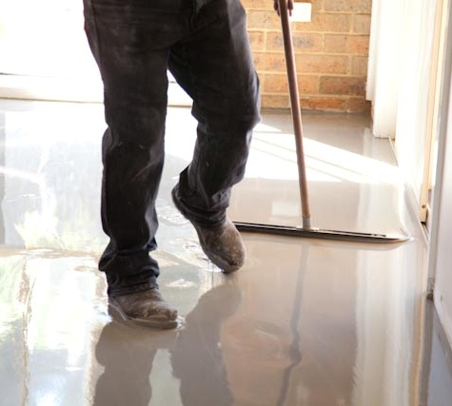
- Smoothing compounds are applied in one pass, in thicknesses ranging from a feather edge up to about 3 mm.
- Levelling compounds are applied in one pass but can often accommodate thicknesses of 10 mm or more.
- Bulk fillers are applied in one pass, typically in a layer that’s at least 5 mm thick and sometimes up to 100 mm.
- Repair compounds are used for patching holes and compensating for large height differences, and can be built up in separate layers.
When a levelling compound includes aggregate and is used as a bulk fill, it is often called a screed. This is the term that floor tilers use for the sand and cement mix that they put under tiles, especially in wet areas where there is a fall in the floor towards the waste pipe.

Binding agents
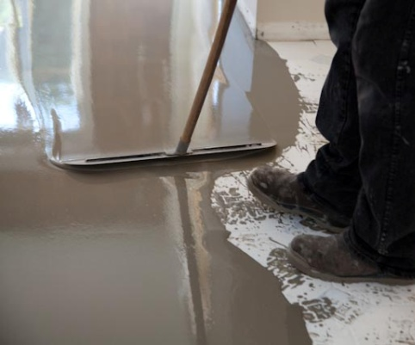
Different binding agents are used to give the levelling compounds particular characteristics, such as speed of curing and suitability for certain substrates and adhesives.
Mineral compounds can be either cement based or calcium sulphate based. They are mixed with cold water to form a paste and then spread over the floor. For thicker layers, sand can be added as a filler.
Dispersion compounds contain water-based synthetic resins, mineral fillers and other components. Most products are ready to use from the container, and don’t need to be mixed with water.
Reaction resin compounds are used for patching and grouting. Most formulations are based on polyurethane or epoxy resin and are supplied as two-part systems which are mixed together immediately before use.

Learning activity

See if you can identify one brand name for each of the compounds listed below.
State the product’s brand name and manufacturer. Share your answers with your trainer and other learners in your group.

- Smoothing compound
- Levelling compound
- Bulk filler
- Repair/patching compound.

Applying primers
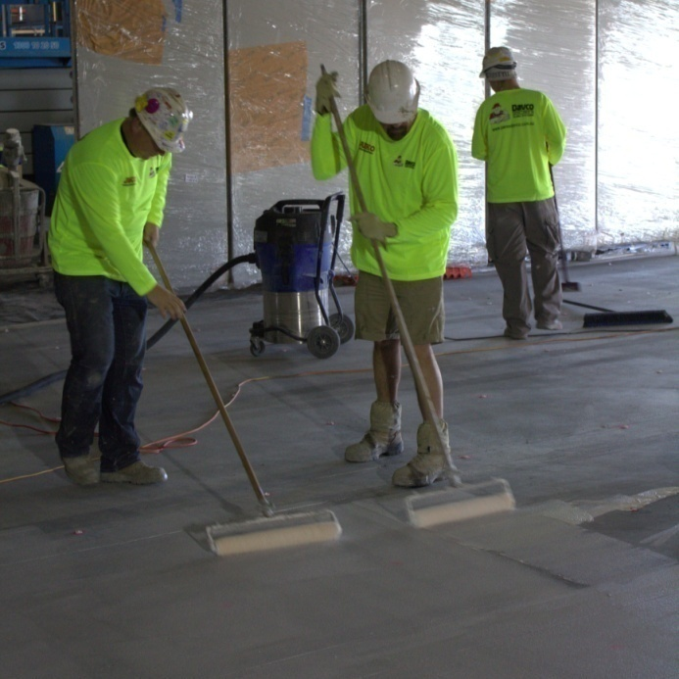
The purpose of a primer is to improve the adhesion of the levelling compound to the substrate.
Sometimes they contain additives designed to address certain conditions in the subfloor – such as a sealant for very porous concrete to prevent air bubbles from rising up through the underlayment.
However, it’s important to note that primers are not designed to be moisture barriers, even if the product is described as a ‘sealant’.
Unless the product has been tested in accordance with AS 4858 and has satisfied the required ‘moisture vapour transmission rate’, you can’t depend on it to stop rising damp or other moisture transmission problems.
Nonetheless, some primers are designed to retard – or slow down – the movement of moisture, so they can help to protect adhesives and floor coverings from a small amount of moisture rising up through the slab.
Underlayment manufacturers normally supply their own primers to go with their range of levelling compounds. They may also recommend other products for specific subfloor issues, such as dense or smooth substrates, or very absorbent surfaces.
Most primers are water-based and can be applied with a roller, brush or spray gun. The general installation procedure for a water-based primer is set out below.

Preparation and installation procedure
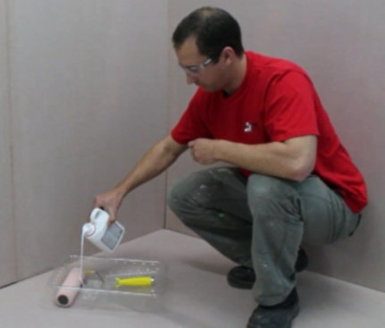
- Make sure that the surface to be primed is free from dust, dirt, oil grease, curing compounds and any other contaminants. Check that the moisture content is appropriate for the primer being used and the underlayment that will be applied over the top.
- Pour the primer into a container, ready for application, if it is designed to be used undiluted.

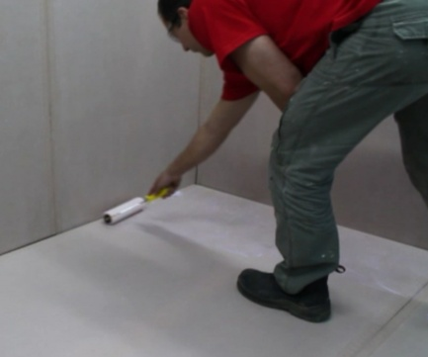
- Apply the primer to the floor using a roller, sponge or brush. Normally one coat is sufficient, but you may need two coats on very porous substrates.
- Allow the primer to fully dry before applying toppings or other products. This may take from 30 minutes to several hours, depending on the product, substrate surface and the weather conditions.

Learning activity
The link below will take you to a video clip produced by Ardex demonstrating its range of primers and bonding agents. The clip shows these products being applied to a range of substrates, including timber and concrete subfloors.
What tools are used to spread the various primers on the subfloors?
http://www.ardexaustralia.com/products/primers-bonding-agents-additives/ardex-p-51

Applying patching compounds
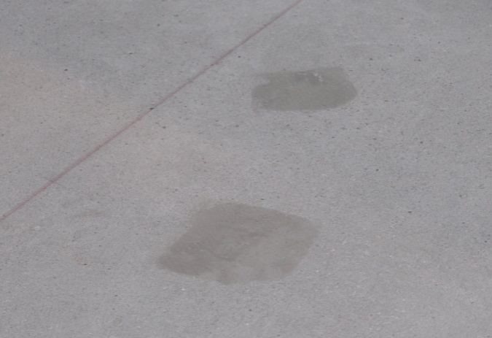
Patching compounds are designed to fill holes, cracks, grooves and damaged areas that are too large for a self-levelling smoothing compound to fill efficiently.
Hairline cracks are generally not a problem, but anything larger than about
5 mm should be filled with a patching compound.
Some patching compounds are cement-based mortars and are applied with a putty knife or trowel. Others are made from epoxy or polyurethane, and can either be applied like a mortar or injected into the crack.

You should never use gypsum-based products, like water putty or cornice cement.
These products are high in alkali and can destroy adhesives, they swell when they get wet, and they don’t have sufficient long-term adhesion to last the lifetime of the floor.
Set out below is the general installation procedure for a typical cement-based patching compound.

Preparation and installation procedure
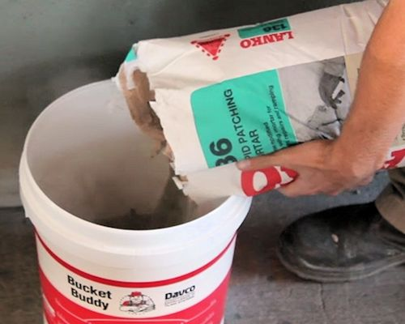
- Make sure that the substrate is dry,
firm and free from dust and any contaminants.
Depending on the product and the type
of substrate, you may need to prime the surface before applying the patching compound.
- Mix the powder with clean water in a mixing container to produce a mortar.

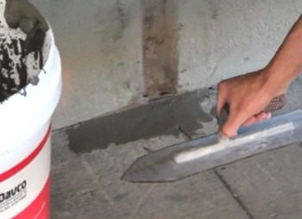
- Apply the mortar with a trowel to the holes or damaged areas. Push the mortar into the void and leave it ‘proud’ (sitting slightly high) of the surface.
- After about 15 minutes, trim off the excess mortar and finish the surface with a wet trowel or sponge.
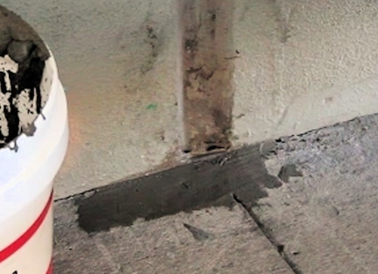
- Leave the mortar to harden. Under normal conditions, this may take about one hour.
- Apply the smoothing and levelling compound before the mortar dries. Note that if the area is allowed to completely dry before the levelling compound is installed, you may need to re-prime the surface.

Learning activity
Below is a link to a video clip demonstrating how to use Ardex Liquid Backerboard. At the beginning of the clip the installer mixes up a patching compound and applies it to a ply subfloor to fill the grooves between the plywood sheets.
Watch the clip and then answer the following questions relating to the patching compound:
- What is the mixing ratio of water to patching compound?
- What tool is used to apply the compound to the floor?
- What is the range of thicknesses that Ardex recommends for this compound?
http://www.youtube.com/watch?v=35NbjSh5h0w&list=PL854198DCA86F58A6

Applying levelling compounds
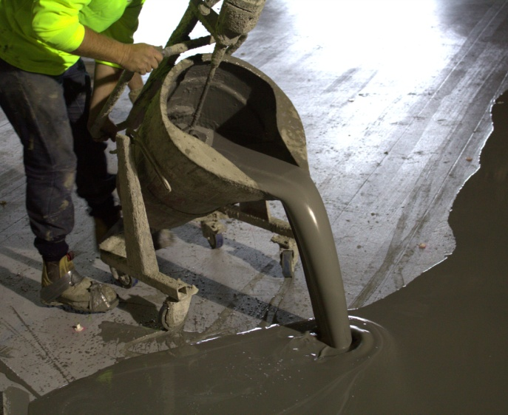
Most self-levelling smoothing compounds are cement-based mixtures that are poured onto the floor and spread with a trowel or spreader. Some industrial compounds are water-based, latex-based or two-part epoxy resins.
Each product has its own range of features and is designed for particular applications. The method of installation depends on the properties of the compound and the condition of the floor.
Set out below is the general installation procedure for a typical cement-based underlayment.

Preparation and installation procedure
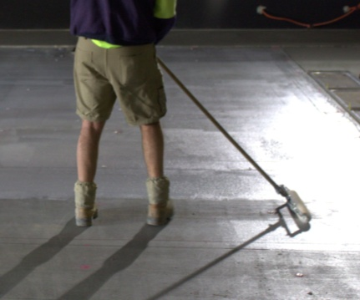
- Make sure that the subfloor surface meets the required standards. This includes checking that the moisture content and pH levels are suitable and that the surface is clean and properly prepared.
- Apply the primer specified by the manufacturer, using a sprayer, roller or brush. Wait the required amount of time for the primer to cure.
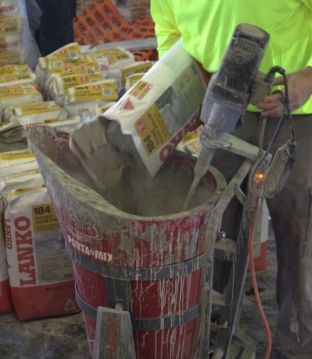
- Set up the area where you will mix the levelling compound. Make sure there is good ventilation and lighting. Cover the floor of the mixing area with plastic sheeting to make the clean-up process easier.
- Mix the levelling compound in a bucket using an electric drill and mixing paddle. Measure the proportions of water and compound accurately, according to the manufacturer’s instructions, using measuring buckets.

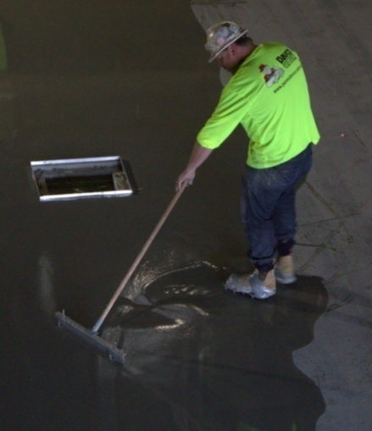
- Apply the levelling compound to the floor. Depending on the product and the thickness, you may need to use a steel trowel and/or a thickness spreader. Most underlayments can be installed from a true ‘feather edge’ up to 6 mm thick. For thicker application, some manufacturers specify aggregate as a filler.
- Check the surface finish and floor levels to make sure that they’re within the required standards (see below for more details).
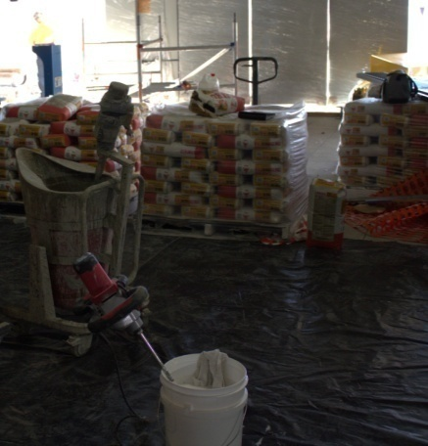
- Clean up the work area and all tools and equipment. Store the unused levelling compound in resealed plastic bags or containers.
- Once the underlayment has set, scrape down any dags or ridges that might be present, sweep up the particles and then vacuum the floor surface. Also vacuum the window sills, skirtings and other areas that have gathered dust during the activity. Bag up the dust and debris and remove it from the area.

Working to standards
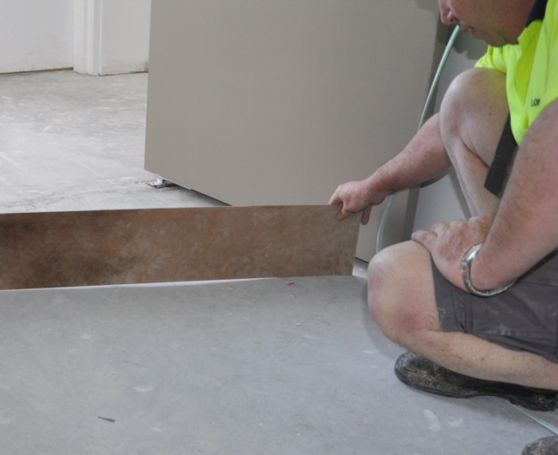
We talked about standards in the unit: Inspecting and testing subfloors. You’ll recall that the purpose of a ‘standard’ is to set the benchmark for what’s considered an acceptable job.
This not only gives you a specific level of performance to work to, it also means that you have a basic standard that you can agree on with the client if there is ever a dispute about the quality of your work.
The Australian Standards that specify the tolerances allowed in the ‘planeness’ and ‘smoothness’ of a subfloor surface are:
- AS 2455-2007: Textile floor coverings – Installation practice
- AS 1884-2012: Floor coverings – Resilient sheet and tiles – Installation practices.
The tolerances set out in AS 1884-2012 are as follows.
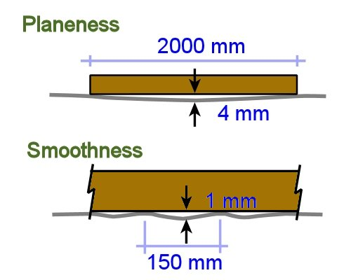
Planeness: When a 2 metre long straightedge is placed on a concrete floor, resting on two points that are 2 metres apart, the maximum deviation from planeness (or ‘flatness’) is 4 mm.
Smoothness: When a 150 mm long straightedge is placed on a concrete floor, resting on two points, the maximum deviation is 1 mm.

Learning activity

The link below will take you to a video produced by Concrete Artisans called ‘Ardex floor preparation (part A)’:
http://www.youtube.com/watch?v=JqEvSFxS1vM
Watch the clip and then answer the following questions:
- How did the installer minimise dust when he was using the grinder?
- Why did he put steel mesh down before laying the K15?

Estimating quantities
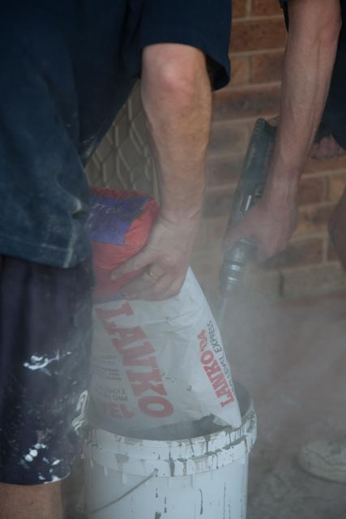
We looked at the basic principles of estimating primer and underlayment quantities in the unit: Planning and costing.
You’ll recall that the simple formula for working out the amount of primer needed to cover a floor is:
Area of floor ÷ coverage of product = volume required
The units of measure that these figures are generally expressed in are:
- Area of floor – square metres (m²)
- Coverage of product – square metres per litre (m²/L)
- Volume required – litres (L).
The same principle is used for working out underlayment quantities. However, this time the coverage is generally shown in square metres per bag or kilogram at a given thickness (m²/bag or m²/kg at whatever thickness the manufacturer nominates). This means that if your finished thickness is going to be different from the manufacturer’s nominated thickness, you’ll need to make an adjustment to the quantity.
For example, say you were going to spread a levelling compound at an average thickness of 3 mm on the subfloor, and the coverage rate printed on the bag reads:
Coverage: 13 m² at 1 mm thick
To work out the total quantity of compound required, you would need to use the formula shown above and then multiply your answer by 3.
If you need to revise these basic principles before we move on to some more complex examples, go to the following lessons in Planning and costing:
- Primers and adhesives
- Levelling compounds.
You may also want to revise the maths basics that underlie these calculations in the unit: Making measurements.

Ramps
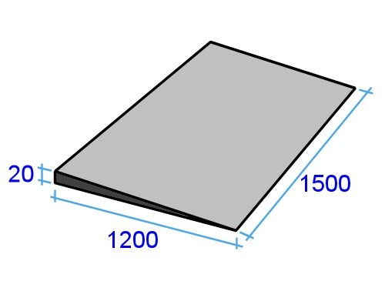
In geometric terms, ramps are actually triangular prisms. That is, they are a normal square or rectangular shape on top, but their depth is triangular.
Let’s say you needed to build a ramp between two rooms to accommodate a floor height difference of 20 mm – as shown in the diagram at right. You have chosen a slump-free repair mortar with a coverage rate that reads:
Coverage: 12 m² at 1 mm thick (per 20 kg bag)
The steps involved in working out the quantity are as follows. Remember that we have to convert all measurements from millimetres to metres for these calculations.

1. Find the surface area
Area = width x length = 1.5 x 1.2 = 1.8 m²

2. Find the coverage for the given thickness
The nominated coverage is 12 m² per 20 kg bag when spread at an average thickness of 1 mm. So if the ramp was only 1 mm thick, you would need:
1.8 m² ÷ 12 = 0.15 bags

3. Find the total number of bags
In our case, the ramp thickness goes from 0 mm at one end to 20 mm at the other. So the average thickness is 10 mm. In other words:
Average thickness = thickness at start + thickness at end ÷ 2
= 0 + 20 ÷ 2 = 10 mm
This means we need to multiply the Step 2 figure by 10:
0.15 x 10 = 1.5 bags

Diluted primer
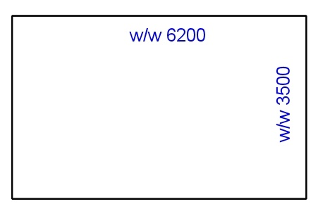
Some primers are diluted with water when the substrate surface is very porous. Let’s say that you have diamond ground the concrete subfloor shown at right and are about to coat it with primer.
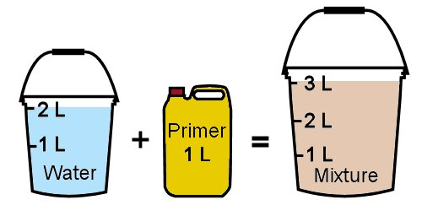
The container says that the coverage rate is 3.5 m²/L, but that for porous concrete the primer should be diluted with water at a 2:1 ratio.
This means that 2 parts water will be added to every 1 part primer.
In other words, if there was a total of 3 litres required for the floor, 2 litres would be water and 1 litre would be primer.
How much water and primer will you need for this job?

Step 1: Find the area
Area = 3.5 x 6.2 = 21.7 m²

Step 2: Find the total volume at the normal coverage rate
Volume (L) = area (m²) ÷ coverage (m²/L)
= 21.7 m² ÷ 3.5 = 6.2 litres

Step 3: Find the water and primer volumes
A water/primer ratio of 2:1 means: 2 parts water + 1 part primer = 3 parts in total. So:
Volume of water = total volume ÷ total no. of parts x no. of parts water
= 6.2 litres ÷ 3 parts (in total) x 2 parts (water)
= 4.1 litres
Volume of primer = 6.2 litres ÷ 3 parts (in total) x 1 part (primer)
= 2.1 litres
You can check your answer by adding the two components together:
4.1 litres water + 2.1 litres primer = 6.2 litres in total

Wastage factors
Depending on the type of job and the products you’re using, you may want to build a wastage factor into your calculations. This helps to compensate for slight variations in estimates or small amounts of wastage.
Installers often allow for 5 to 10% wastage on primers and levelling compounds. For example, if you wanted to add 10% wastage to the primer calculation above, the total volume required would be:
6.2 litres + 10% (0.62 litres) = 6.8 litres
If you need more practise on using percentages, go to the ‘Decimals and percentages’ lesson in Making measurements.

Learning activity
You need to install a ramp between two floor levels, as shown in the drawing below. The slump-free repair mortar compound has a coverage rate of 14 m² at 1 mm thick per 20 kg bag.
You will then apply a primer to the finished ramp. The primer coverage rate is 5 m²/L. However, you will dilute the primer with water at a 1:1 ratio.
How much repair mortar and primer will you need for this job? Add a 10% wastage factor to each amount.
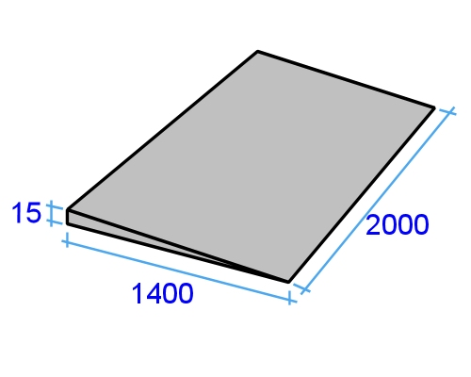

Assignment 3
Go to the Workbook for this unit to write your answers to the questions shown below. If you prefer to answer the questions electronically, go to the website version and download the Word document template for this assignment.
___________________________________________________________________________

Assignment questions
1. State the tolerance for ‘planeness’ in a concrete floor, as specified in AS 1884.
2. State the tolerance for ‘smoothness’ in a concrete floor (as specified in AS 1884).
3. Select the primer that you plan to use for one or more of your practical demonstrations. Obtain the manufacturer’s MSDS and technical data sheet for the product and answer the following questions.
(a) What is the product’s brand name and who is the manufacturer?
(b) What is its chemical basis?
(c) What items of PPE are required when mixing and using this product?
(d) What other safety precautions apply to the use of this product?
(e) How many coats are required? If more than one coat is required under certain conditions (or certain types of subfloor), state the number of coats and the conditions that apply. Also state the recommended drying time between coats.
(f) Are there times when the primer should be diluted or be mixed with other additives? If so, what are they and what additives should be used?
(g) What is the drying time after the final coat has been applied (that is, how long should you wait before moving onto the next stage of the subfloor preparation)?
4. Select the patching compound that you plan to use for one or more of your practical demonstrations. Obtain the manufacturer’s MSDS and technical data sheet for the product and answer the following questions.
(a) What is the product’s brand name and who is the manufacturer?
(b) What is its chemical basis?
(c) What items of PPE are required when mixing and using this product?
(d) What other safety precautions apply to the use of this product?
(e) What types of holes, cracks and voids is this product suitable for?
(f) Are there any types of cracks or other defects that this product is not suitable for? If so, what are they, and what product would you use in those instances?
(g) How long should you wait before moving onto the levelling stage?
5. Select the levelling compound that you plan to use for one or more of your practical demonstrations. Obtain the manufacturer’s MSDS and technical data sheet for the product and answer the following questions.
(a) What is the product’s brand name and who is the manufacturer?
(b) What is its chemical basis?
(c) What items of PPE are required when mixing and using this product?
(d) What other safety precautions apply to the use of this product?
(e) What types of subfloor is this product suitable for?
(f) Are there any types of subfloor that this product is not suitable for? If so what are they, and what type (or types) of levelling compound would you use in those instances?
(g) What is the maximum recommended thickness for applying this levelling compound (without adding any aggregate)?
(g) Is this product suitable for using as a bulk filler? If so, what extra components would you need to add and how would you go about it?
(g) What is the curing time after the levelling process has been completed (that is, how long should you wait before beginning the floor covering installation)?
___________________________________________________________________________

Practical demonstrations
Before you’re signed off as competent, you will be asked to carry out three separate subfloor preparations involving priming, patching and levelling the substrate. See the ‘Practical demonstration’ chapter on the following pages for more information on these assessment activities and sample checklists showing the sorts of things you’ll need to demonstrate.

Practical demonstrations
Your trainer may ask you to keep a log book or diary of the work you do on-the-job that relates to the practical components of this unit. This will help them to determine when you will have had sufficient hands-on practice in these tasks to undertake the assessment events.
When you are ready to be assessed, your assessor will ask you to complete a range of practical demonstrations. These may include:
- One moisture barrier installation on a concrete subfloor, designed to either address a moisture problem from an external source or to waterproof a wet area (such as a bathroom or hospital room).
- One moisture suppressant installation on a concrete subfloor, designed to address residual construction moisture in a green slab or a low-level moisture problem from an external source.
- Three separate subfloor preparations involving priming, patching and levelling the concrete or timber substrate.
The sample checklists below set out the sorts of things your assessor will be looking for when you undertake these practical tasks.
Make sure you talk to your trainer or supervisor about any of the details you don’t understand, or aren’t ready to demonstrate, before the assessment events are organised. This will give you time to get the hang of the tasks you’ll need to perform, so that you’ll feel more confident when the time comes to be assessed.

Installation of moisture barrier on a concrete subfloor
- Measures the moisture content of the concrete subfloor and compares the level to the relevant Australian Standards and/or flooring specifications that apply.
- For slabs with a moisture problem, correctly assesses whether the moisture present is due to hydrostatic pressure, capillary action or green concrete.
- For slabs with a moisture problem, determines whether any external moisture is entering due to a damaged vapour barrier, poor building practices or other causes.
- Removes all surface contaminants and other substances to expose clean bare concrete.
- Removes all dust and debris from the substrate surface.
- Correctly identifies any structural cracks and takes appropriate action according to their severity, including reporting them to a structural engineer and the client.
- Notes all expansion joints and deals with them in accordance with the building specifications and design characteristics of the joint.
- Notes all other cracks and carries out repairs or other treatments as necessary.
- Covers all joints, waste junctions and other penetrations with an appropriate bond breaker material.
- Mixes and prepares the liquid moisture barrier according to the manufacturer’s instructions.
- Applies the moisture barrier evenly to the floor using suitable tools.
- Ensures that the coating is free of pinholes or bubbles, and that the correct thickness is maintained across the whole area.
- Waits for the required amount of time, and then applies a second coat at 90 degrees to the first coat, or as specified by the manufacturer.
- Inspects second coat and ensures that thickness is even, at the appropriate depth and of an acceptable quality.
- Cleans up tools and equipment and packs them away.
- Disposes of waste materials according to site policy.

Installation of moisture suppressant on a concrete subfloor
- Measures the moisture content of the concrete subfloor and compares the level to the relevant Australian Standards and/or flooring specifications that apply.
- Correctly assesses whether the moisture present is due to hydrostatic pressure, capillary action or green concrete.
- Determines whether any external moisture is entering due to a damaged vapour barrier, poor building practices or other causes.
- Removes all surface contaminants and other substances to expose clean bare concrete.
- Removes all dust and debris from the substrate surface.
- Correctly identifies any structural cracks and takes appropriate action according to their severity, including reporting them to a structural engineer and the client.
- Notes all expansion joints and deals with them in accordance with the building specifications and design characteristics of the joint.
- Notes all other cracks and carries out repairs or other treatments as necessary.
- Mixes and prepares the moisture suppressant according to the manufacturer’s instructions.
- Applies the moisture suppressant evenly to the floor using suitable tools.
- Ensures that the coating is free of pinholes or bubbles, and that the correct thickness is maintained across the whole area.
- Waits for the required amount of time, and then applies a second coat, if specified by the manufacturer.
- Cleans up tools and equipment and packs them away.
- Disposes of waste materials according to site policy.

Application of primer on a concrete or timber subfloor
- Checks that the moisture content and pH level of the substrate is appropriate for the primer being used and the underlayment that will be applied over the top.
- Assembles the correct tools and personal protective equipment (PPE) for the tasks to be undertaken.
- Assesses the ventilation requirements and any other health or safety issues that apply to the site and takes the steps needed to minimise risks.
- Estimates the required volume of primer for the area to be coated and selects appropriate-sized containers.
- Wears the correct items of PPE for each task being carried out, and follows safe work practices at all times.
- Removes all surface contaminants and other substances to expose a clean bare substrate.
- Removes all dust and debris from the substrate surface.
- Notes any expansion joints and deals with them in accordance with the building specifications and design characteristics of the joint.
- Mixes and prepares the primer according to the manufacturer’s instructions.
- Applies the primer evenly to the floor using suitable equipment.
- Cleans up tools and packs them away.
- Disposes of waste materials according to site policy.

Application of patching and levelling compounds
- Assembles the correct tools and personal protective equipment (PPE) for the job to be undertaken.
- Assesses any other health or safety issues that apply to the site and takes the steps needed to minimise risks.
- Estimates the required volumes of repair mortar and levelling compound for the job at hand and selects appropriate-sized bags or containers.
- Sets up a mixing station in a well ventilated area and ensures that plastic sheeting or other protection is in place to make the clean-up process easier.
- Wears the correct items of PPE for the tasks to be undertaken, and follows safe work practices at all times.
- Notes any expansion joints and deals with them in accordance with the building specifications and design characteristics of the joint.
- Mixes and prepares the repair mortar according to the manufacturer’s instructions.
- Applies the mortar to all holes, cracks or damaged areas that need patching using suitable tools.
- Trims off excess mortar and finishes the area with a trowel or sponge, as required.
- Waits for the appropriate amount of time for the mortar to cure before commencing the levelling process.
- Mixes the levelling compound, using the correct proportions of water and compound, according to the manufacturer’s instructions.
- Applies the levelling compound to the floor using suitable tools.
- Maintains an appropriate thickness throughout the floor area and adds aggregate if required, according to the manufacturer’s recommendations.
- Checks the surface finish and levels to make sure that they are within the required standards.
- Cleans up the work area and tools and equipment, and disposes of waste materials according to site policy.
- Stores unused levelling compound in resealed plastic bags or containers.

General criteria for all demonstrations
- Carries out trial applications of products, where necessary, to check that the finished job meet the quality requirements and specifications of the project.
- Communicates effectively with the site supervisor, other workers and the client.
- Works cooperatively with others and maintains a steady and productive workflow.
- Anticipates problems and wastage by pre-checking site conditions, materials and measurements.
- Reports problems as per site procedures, and deals effectively with issues outside their own level of competence or authority.

