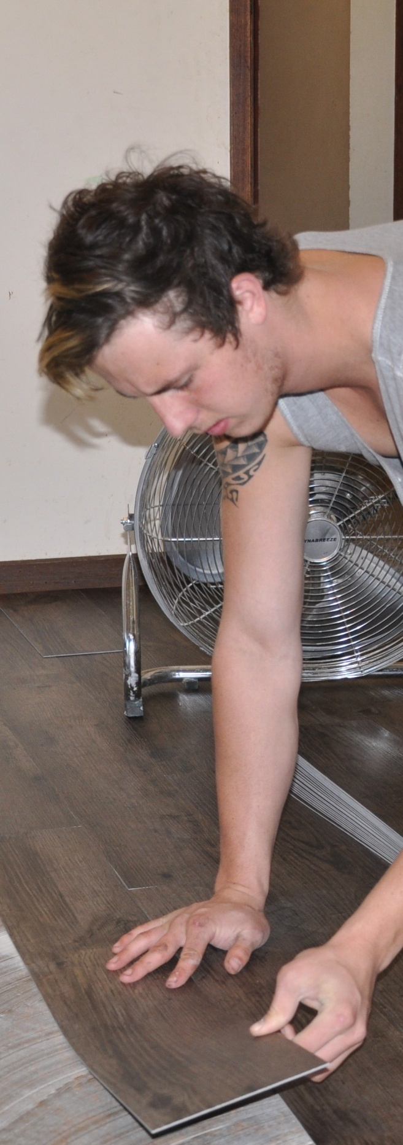
Safety at work
Developed in 2012-2013 for the WELL Program
DRAFT VERSION
October 11

Learner guide
Supporting:
MSAPMOHS200A:
Work safely

LMFFL3002A:
Establish and maintain a safe flooring technology work environment

Safety at work
Learner guide

This unit is also available in an e-learning format, which contains additional photos, interactive exercises and a voice-over narration of the text. It can be viewed on CD-ROM, or live on the web at:
www.flooringtech.com.au


Developed by Workspace Training for the 2012-2013
Workplace English Language and Literacy (WELL) Program
Flooring Technology resource development project





Copyright and disclaimer
ISBN: 978-0-9873327-3-8
Funded under the Workplace English Language and Literacy Program by the Australian Government through the Department of Industry, Innovation, Climate Change, Science, Research and Tertiary Education.
© Commonwealth of Australia. 2013

CC BY-NC-SA
This work is copyright. Except where otherwise indicated, and save for the Commonwealth Coat of Arms, the Department has applied the Creative Commons Attribution-Noncommercial-Share Alike 3.0 Australia Licence to this work.
The Department of Industry, Innovation, Climate Change, Science, Research and Tertiary Education must be attributed as the author of the Department’s copyright material.
As far as practicable, material for which the copyright is owned by a third party has been clearly labelled. The Department has made all reasonable efforts to ensure that this material has been reproduced in the print-based resources and accompanying website with the full consent of the copyright owners.
Requests and enquiries concerning the Department’s copyright material should be addressed to:
The Legal Branch
Department of Industry, Innovation, Climate Change, Science, Research and Tertiary Education
GPO Box 9839 Canberra ACT 2601
Email: legalservices@innovation.gov.au
Questions about the design and content of the resource itself should be addressed to the project manager:
David McElvenny
Workspace Training
PO Box 1954 Strawberry Hills, NSW, 2012
Email: david@workspacetraining.com.au

Disclaimer
The content of this Learner guide is provided for educational purposes only. No claim is made as to the accuracy or authenticity of the content. The views expressed in this publication do not necessarily represent the view of the Minister for Tertiary Education, Skills, Science and Research or the Australian Government. The Australian Government does not give any warranty nor accept any liability in relation to the contents of this work.

About this resource
This Learner guide is part of a suite of resources developed for the Flooring Technology project, funded by the WELL Program. The resources support 19 competencies from the Certificate III in Flooring Technology (LMF31208). The project comprises a website and an accompanying set of Learner guides and work books.
The individual competencies are grouped into ‘Learning units’ as shown below. Each one is given a title describing the main theme of that set of integrated competencies.

Learning unit title Competencies covered
Safety at work MSAPMOHS200A: Work safely
LMFFL3002A: Establish and maintain a safe flooring technology work environment
Inspecting and testing subfloors LMFFL2004A: Moisture test timber and concrete floors
LMFFL3101A: Inspect sub-floors
Planning and costing LMFFL3001A: Plan and cost flooring technology work
Subfloor coatings and toppings LMFFL2102A: Prepare, select and apply smoothing and patching compounds
LMFFL2103A: Select and apply appropriate compounds and additives
LMFFL2105A: Select, prepare and apply moisture barriers and damp proof membranes to concrete sub-floors
Concrete grinding LMFFL2107A: Select, operate and maintain grinding equipment
Preparing floor coverings LMFFL2002A: Receive and prepare floor covering materials for installation
Lay flat vinyl LMFFL2301A: Install lay flat vinyl floor coverings
Resilient tiles LMFFL2302A: Install resilient tiles using standard installation practices
Commercial vinyl LMFFL3302A: Install commercial vinyl floor coverings
LMFFL3303A: Install resilient floor coverings using custom designs and decorative finishes
Linoleum LMFFL3301A: Install linoleum floor coverings
ESD floors LMFFL3308A: Install anti-static resilient floor coverings
LMFFL3309A: Install conductive resilient floor coverings
Making measurements MSAPMOPS101A: Make measurements
Working sustainably MSAENV272B: Participate in environmentally sustainable work practices
The purpose of these resources is to help trainee floor layers acquire the background knowledge needed to satisfy the theoretical components of the competencies covered in this project. However, the resources are not designed to replace the practical training necessary to develop the hands-on skills required. Learners will still need to receive extensive on-the-job training and supervision before they will be ready to be formally assessed in the relevant competencies.
E-learning version
All of the content material contained in this Learner guide is also available in an e-learning format, which has additional photos, interactive exercises and a voice-over narration of the text. The e-learning version can be viewed on the web at: www.flooringtech.com.au
The web version can also be purchased on a CD at a cost-recovery price from the project developer:
Workspace Training
PO Box 1954 Strawberry Hills, NSW, 2012
Email: david@workspacetraining.com.au

Acknowledgements
Project team
Project manager: David McElvenny
Instructional designer: Kath Ware
Technical developer (website): Jim Vaughan
Assistant technical developer (and voice-over artist): Alex Vaughan
Quality assurance consultant: Giselle Mawer
Industry coordinator: Gary Dunshea (MSA Industry Skills Council)
Technical Advisory Group
Lead advisors
William Tree – South West Sydney Institute of TAFE
Mark Willis – Council of Textile and Fashion Industries of Australia
Craig Bennett – Hunter Institute of TAFE
Reviewers
Ian Ciesla – Polytechnic West
Robert Cole – Furnishing Industry Association of Australia
Steven Dalton – Marleston TAFE
Shane Eales – SkillsTech Australia
David Hayward – Australian Timber Flooring Association
Bruce Ottens – Holmesglen TAFE
Chris Shaw – Skills Institute Tasmania
Warren West – Australian Resilient Floor Covering Association
Industry advisors
Peter Brack – Forbo Flooring Systems
Don Considine – IKW Consulting Group
Gary Eggers – Tarkett Flooring
Jim Hilston – Hilston Floors
Lionel Jacobs – Epoxy Solutions
Owen Jordian – Choices Flooring
Steven King – Armstrong Floors
Jarka Kluth – Pro Grind Australia
Haydn Reynolds – Floorex Products
Naomi Archer – All Preparation Equipment
Photographs
Most of the photos in this suite of resource were taken by David McElvenny. Additional photos were provided by:
David Beeforth (ParexDavco)
Don Considine (IKW Consulting Group)
Craig Bennett (Hunter TAFE)
David Hayward (Australian Timber Flooring Association)
Gary Eggers (Tarkett)
Lionel Jacobs (Epoxy Solutions)
Jarka Kluth (Pro Grind Australia)
Haydn Reynolds (Floorex Products)
Naomi Archer (All Preparation Equipment)
We would like to thank the following organisations for allowing us to take on-site photos of their employees at work or students in class.
Choices Flooring – Sandgate, Bulleen, Thomastown and Mornington
Lidcombe College of TAFE
Lomac Commercial Flooring
Tarkett
Epoxy Solutions
Graphics
Graphics were drawn by Kath Ware. Many of these graphics are based on line drawings or photographs from installation manuals published by the following flooring manufacturers:
Armstrong: http://www.armstrong.com/flooring/guaranteed-installation-systems.html
Forbo: http://www.forbo-flooring.com.au/Commercial-flooring/Support-installation-and-maintenance/Installation/Installation-technique/
Tarkett: http://professionals.tarkett.com.au/commdocu?field_docu_type_value=
Installation+guide
Financial contributions
This resource was funded by the Workplace English Language and Literacy Program by the Australian Government through the Department of Industry, Innovation, Climate Change, Science, Research and Tertiary Education. Additional financial assistance was provided by Manufacturing Skills Australia (Industry Skills Council).

Table of contents
Introduction 1
Section 1 Safe work procedures 3
Overview 5
Safe operating procedures 6
Safe work method statements 8
Personal protective equipment 11
Material safety data sheets 13
Manual handling 16
Looking after your knees 20
Assignment 1 23
Section 2 Laws and systems 25
Overview 27
Laws and regulations 29
Rights and responsibilities 31
Consulting with workers 33
WHS management systems 35
Assignment 2 38
Section 3 Managing risks 39
Overview 41
Identifying hazards 42
Assessing risks 44
Controlling risks 46
Assignment 3 48
Section 4 Dealing with emergencies 49
Overview 51
Emergency evacuations 52
On-site fires 55
Hazardous spills 60
Assignment 4 62

Introduction
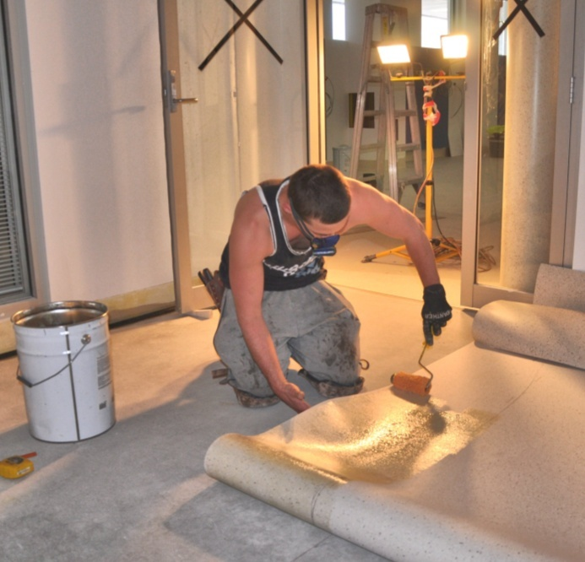
Everyone has the right to go home at the end of the working day as fit and healthy as when they arrived.
But a safe workplace doesn’t just happen by accident. It takes a lot of effort from everyone in the workplace – whether you’re the owner, a staff member or a worker.
In this unit, we’ll look at the factors that help to keep a worksite safe. We’ll start with the different types of procedures used to document ‘approved’ ways of carrying out a job.
We’ll also examine the laws and regulations that control safety in the workplace, the process of carrying out a risk assessment, and some of the procedures used to deal with emergencies.
This unit is designed for people who work in the flooring technology sector, including on-site installers, warehouse store persons, showroom salespeople and administrative staff. Although the specific risks you face each day may be different from those faced by others in your organisation, the general processes used to minimise risks and keep the workplace safe are much the same.
It all comes back to having a systematic approach to dealing with hazards and using approved ‘low risk’ techniques in all your activities.

Working through this unit
There are four sections in this unit:
- Safe work procedures
- Laws and systems
- Managing risks
- Dealing with emergencies.
Each section contains an Overview, an Assignment, and several Lessons which cover the content material.

Assignments
Your trainer may ask you to submit the assignments as part of your assessment evidence for the unit. You will find hard-copy templates for these assignments in the separate workbook.
Electronic ‘Word’ templates of the assignments are available on the website for this resource, at: http://www.flooringtech.com.au.
The electronic versions can be completed on-screen and sent to the trainer either as:
- a printed hard copy, mailed through the post
- an electronic file, emailed as an attachment.

Learning activities
Each of the lessons has a learning activity at the end. The Workbook for this unit contains all of the learning activities together with spaces for written answers.
If you are completing this unit in a face-to-face setting, your trainer might ask you to write your answers straight into the workbook. This allows the workbook to be used for assessment purposes as further evidence of ‘competence’.
If you are studying the unit by distance learning mode, your trainer may organise some form of electronic communication between you and other learners working through the same unit. For example, you could be asked to discuss the topics and share your learning activity answers through group emails or via a social networking site such as Facebook.
Again, you will find all of the learning activities on the website version of this resource.
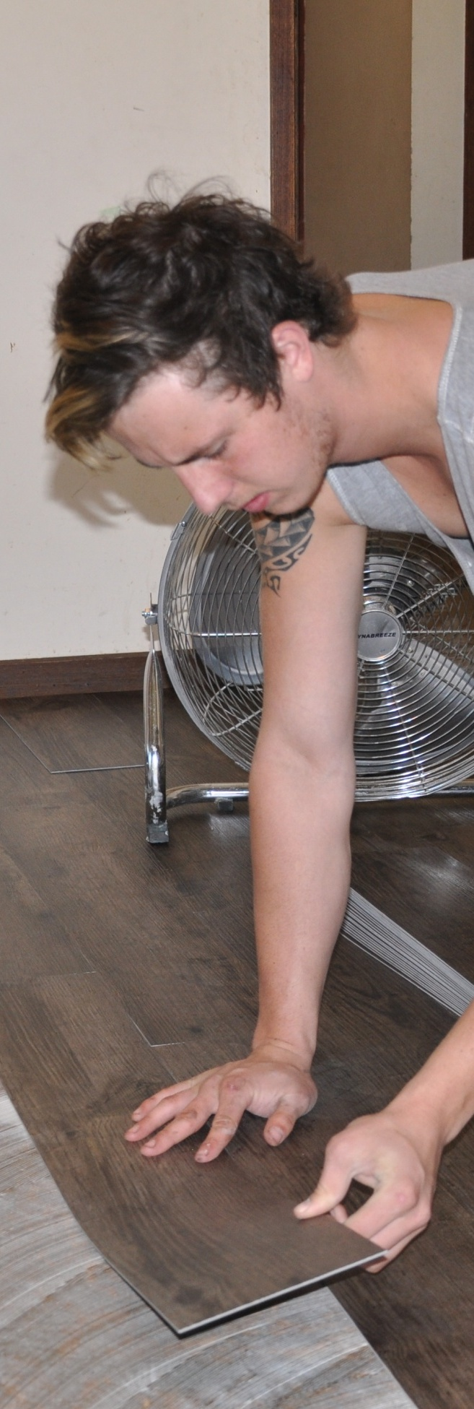

Section 1

Safe work procedures

Overview
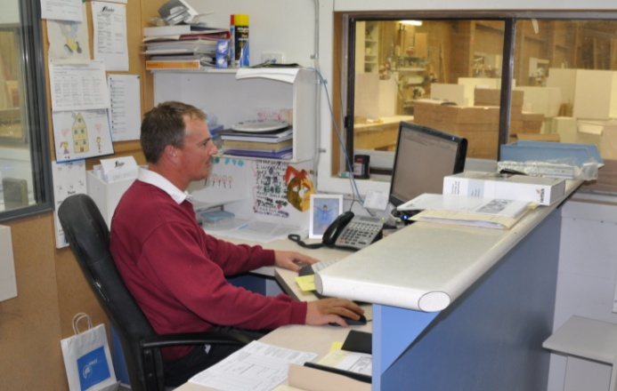
Safe work procedures can be written up in a variety of ways, and range from simple checklists through to formal documents.
What they all have in common is that they provide workers with approved methods for carrying out tasks or using particular products.
There are some procedures that you’ll be personally involved in, such as safe work method statements. Others will come from product suppliers, such as material safety data sheets. And there will be others still that may not exist as stand-alone documents, but will form part of your company’s ‘Policies and Procedures’ manual, like the requirement to wear personal protective equipment.
In this section, we’ll look at all of these types of procedures and discuss the effect they have on the way you do your job and the responsibilities you're given.

Completing this section

The assignment for this section is designed to test your understanding of personal protective equipment, manual handling techniques and material safety data sheets.
Have a look at the Assignment on page 24 to see what you’ll need to do to complete it.
There are also six lessons in this section:
- Safe operating procedures
- Safe work method statements
- Personal protective equipment
- Material safety data sheets
- Manual handling
- Looking after your knees.
These lessons will provide you with background information relevant to the assignment.

Safe operating procedures
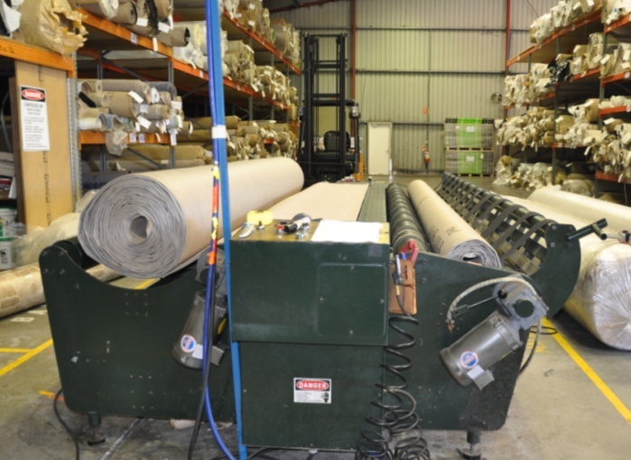
A safe operating procedure (SOP) is a document that sets out the approved method of operating a particular machine or carrying out a task.
In workplaces that have large static machines, SOPs are often put on a wall beside the machine to remind workers what the start-up and shut down procedures are, and what to do in the event of a malfunction or problem.
But SOPs can also be written up for hand held tools and work processes, particularly when they involve the use of personal protective equipment or special techniques to avoid injuries.

SOP layout
Although there are various ways of developing an SOP, they generally follow the same layout. The example on the next page shows an SOP for using a battery-powered circular saw. You’ll notice that it’s divided into the following components:
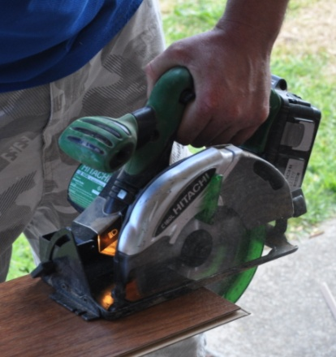
- Activity description – defining the task.
- Potential hazards and safety controls – listing the main hazards and how to deal with them (see Section 3 for more details on what a ‘hazard’ is)
- Pre-start checks – providing a set of safety checks to work through before turning on the equipment.
- Operational procedure – setting out the main steps involved in using the equipment safely.


Learning activity
Do you have SOPs at your workplace?
What machines or work processes do they cover?
Are there any activities you undertake at work that you believe should have an SOP but don’t?

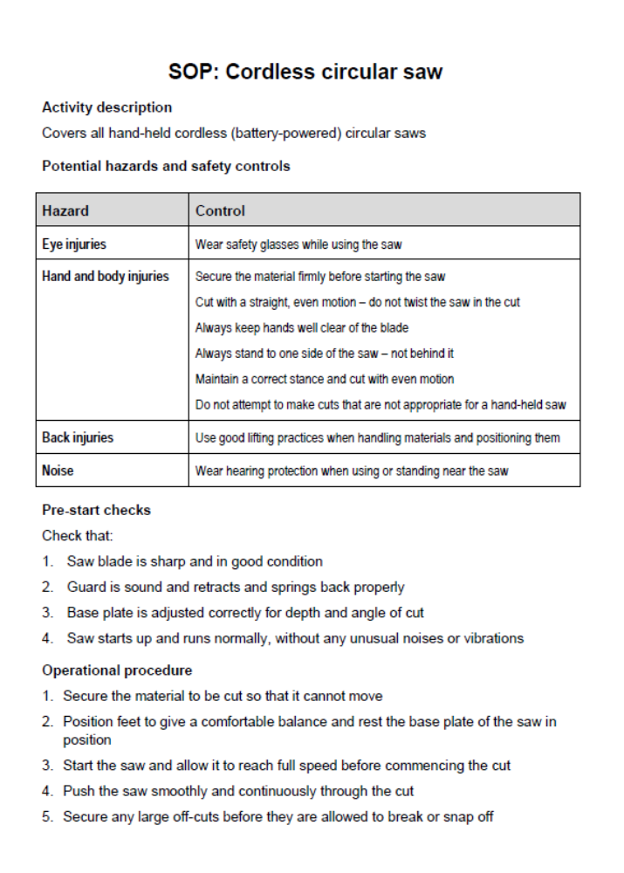

Safe work method statements

A safe work method statement (SWMS) is a formal document that lists all the tasks involved in completing a job and describes how the hazards will be controlled.
On building sites they are mandatory for ‘high risk construction work’. However, on some sites all contractors are asked to complete a SWMS before they start work – including flooring installers.
In some Australian states, a job safety analysis (JSA) is often used to document the hazards and control measures involved in carrying out a job. This is similar in layout to the SWMS and is sometimes used interchangeably. Nonetheless, even in the states where JSAs are common, it is now a legal requirement to develop a SWMS for high risk work.
Because SWMSs are legal documents that can end up being tendered in court proceedings, they need to be signed off by everyone directly involved. This helps the contractor to prove that each worker had understood what their responsibilities were before they started a job and had agreed to follow all of its safety provisions.
The law also says that everyone who uses the SWMS needs to be ‘consulted’ while the document is being developed. This gives workers the chance to express their views on the risks involved in doing particular tasks and the controls put in place to reduce the risks. We’ll talk more about the consultation process in the next section of this unit.
On the following two pages is a sample SWMS, based on the template provided in the ‘Construction Work’ Code of Practice, produced by Safe Work Australia. You can download this document from the web, as well as other template SWMSs produced by organisations such as WorkCover, industry associations and private companies. Just type ‘Safe Work Method Statement’ into your search engine and follow the links.


Learning activity
Do you have a safe work method statement covering the work you carry out? Does it look like the example on the next two pages? Do a comparison, and see where the differences are between your SWMS and this sample document.

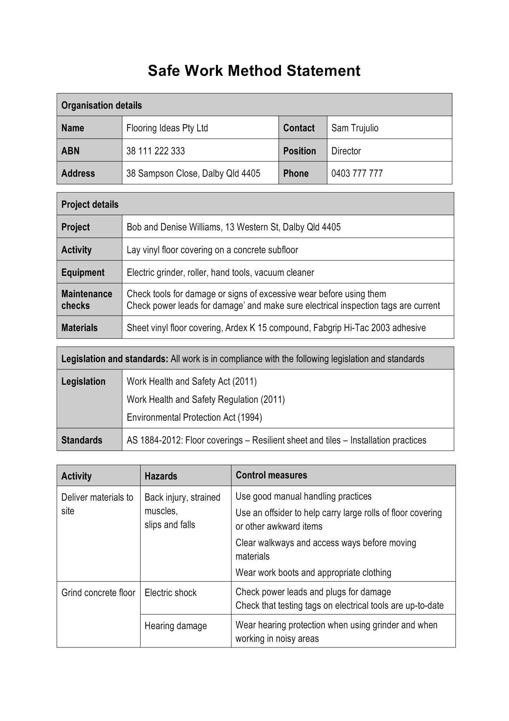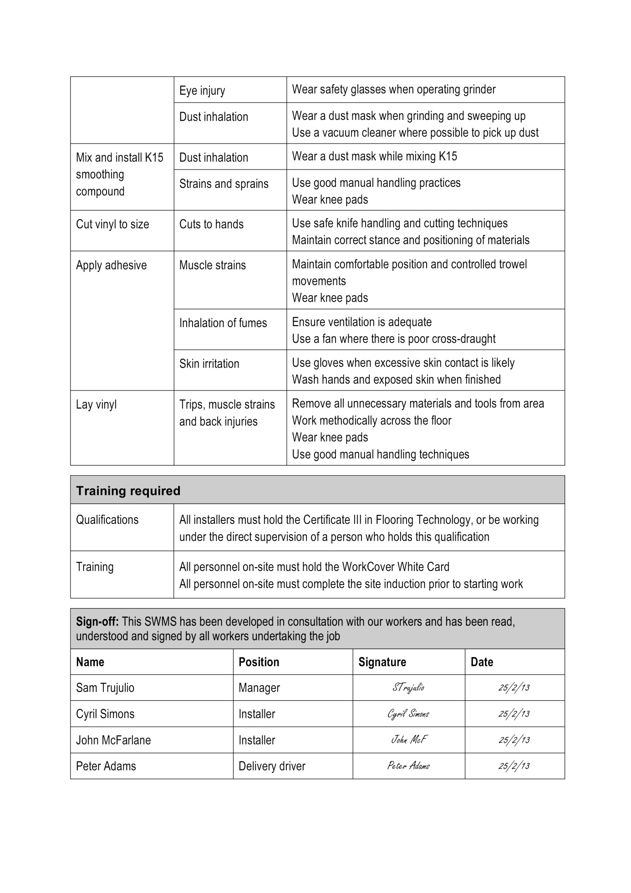

Personal protective equipment
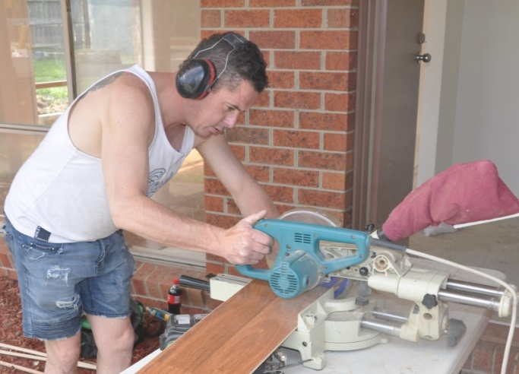
Personal protective equipment (PPE) refers to the safety gear you wear to protect particular parts of your body.
Some items, such as safety boots, are often compulsory for all people on-site. Other items are generally specified for particular jobs, such as ear muffs when using noisy equipment and knee pads when working on your knees.
Your company will have set procedures for the different items of PPE that you’re required to wear. These will be specified in the safe operating procedures or safe work method statements that apply to the work you’re doing.
On large building sites and in warehouses and factories, there might also be signs up on the wall or at entranceways to alert people to the PPE items required in those areas.
It's important to remember that if the company has made it a requirement to wear PPE, you have a legal obligation to do so. This means that if you get hurt and you're not wearing the necessary safety gear, you might end up being in trouble with the law, quite apart from any injuries you suffer.

Common symbols
Below are the main symbols you’re likely to see on building sites and in suppliers’ warehouses.
 | Safety helmet, or hard hat  Workers are normally required to wear a hard hat in any area where there is a danger of falling objects, or where equipment is being operated overhead.
 | High visibility vest  Anyone who is working near trucks, forklifts or other vehicles or machinery should wear a high visibility vest to make them as visible as possible to nearby operators.
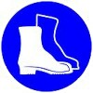 | Safety boots  Safety boots, also called steel capped boots, are needed if there is a risk of objects falling on your feet. Note that this includes sharp objects that may not necessarily be heavy.
 | Ear protection  If you're working in a noisy area, you should always wear ear muffs or ear plugs. Bear in mind that even if the noise isn't uncomfortably loud, it can still cause long-term hearing damage if you're subjected to it day after day over a long period of time.
 | Eye protection  Safety glasses should always be worn if you're doing a job that generates flying particles or dust that might get in your eyes. This includes drilling and grinding concrete and cutting timber with a hand-held power saw.
 | Dust mask  If you generate dust that can't be collected in an extraction system, you should wear a dust mask to protect your lungs. In the case of toxic fumes in confined spaces, you may need to wear a special respirator.

Learning activity
What items of PPE are you required to wear at work?
Write down a list of the items, and for each one briefly describe the hazards it is protecting you from.

Material safety data sheets
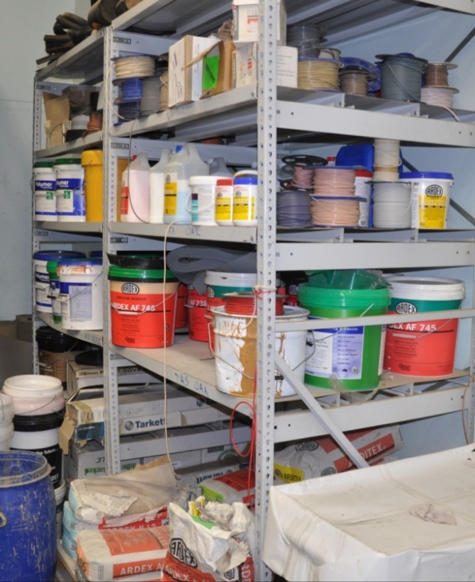
Every manufacturer of a hazardous substance or product is required to produce a material safety data sheet (MSDS) for it.
The purpose of the MSDS is to tell people how to use the product safely, what the long-term health effects are, and how to deal with environmental care issues, such as spillages and waste disposal.
You shouldn’t have any trouble finding an MSDS for a product, because your own workplace is required to have an MSDS on file for every hazardous product kept on-site. These are meant to be in an accessible place where workers can go to them at any time.
Some workplaces also produce their own summarised versions, which they develop by taking the full MSDS and turning it into a one-page ready-reckoner. These summaries can then be laminated or pinned up on the wall near where the products are stored.
On the following pages is a two page excerpt from the MSDS for Ardex K15 smoothing compound. You can access the original document from the following page of the Ardex Australia website, under the link ‘Ardex K15 MSDS’:
http://www.ardexaustralia.com/products/floor-levelling/ardex-k-15


Learning activity
Choose one hazardous product you use at work and get the container or bag that it comes in. Obtain a copy of the MSDS. Answer the following questions.
- What is the name of the product?
- Where is the MSDS kept?
- What types of information are shown on the packaging that are also contained in the MSDS? (Name the subheadings or topics that double up.)
- What types of information are not shown on the product packaging but are in the MSDS?
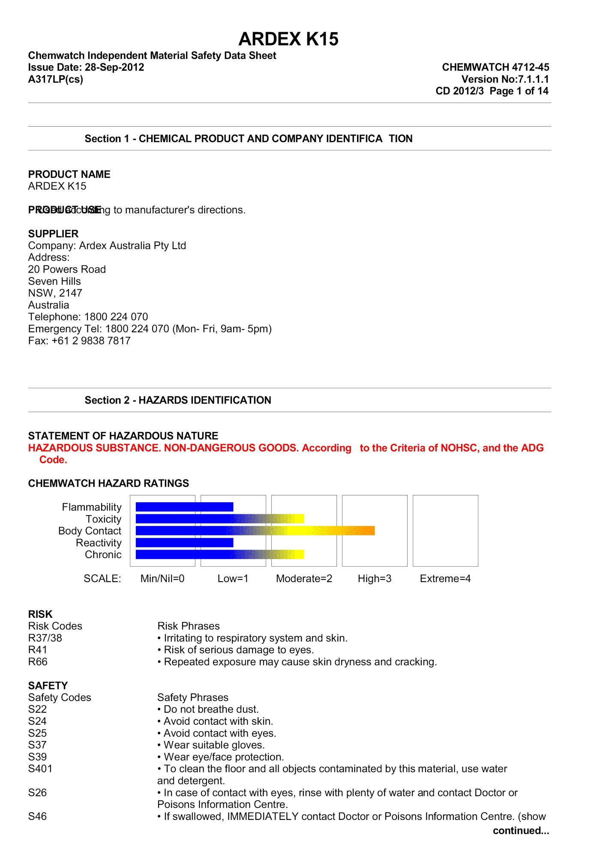

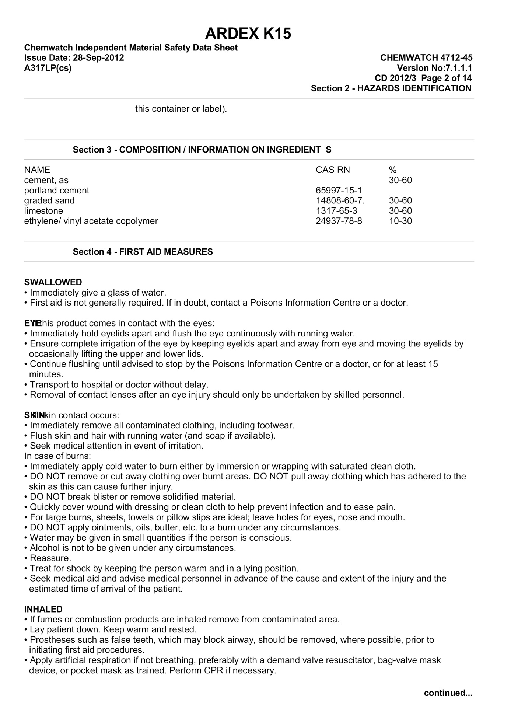

Manual handling
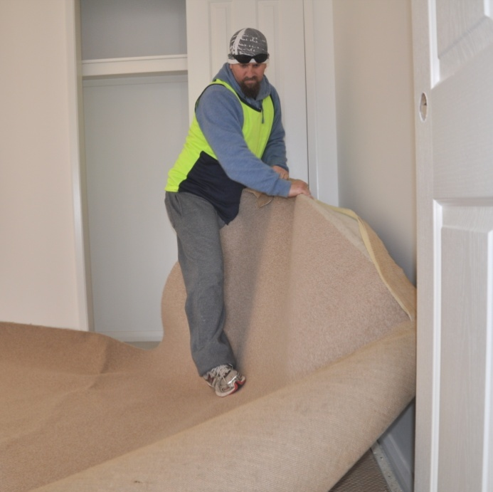
Whenever you're doing work that puts a strain on your muscles or joints, you need to think about manual handling techniques and body postures.
This includes the methods you use to lift and carry materials, place floor coverings in position and work on your hands and knees.
It's worth keeping in mind that joint and muscle problems are much more likely to be caused by gradual wear and tear on your body through bad work practices than from a one-off accident.
Flooring installers are particularly prone to injuries and long-term medical conditions in two parts of their bodies – their back and their knees. Because knees can cause so much trouble for floor layers, we’ll look at that separately in the next lesson. So for now, let’s talk about back care.

Looking after your back
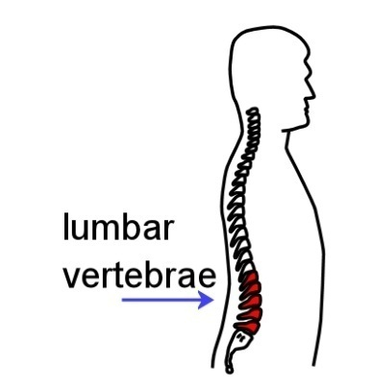
Back injury is sometimes caused by lifting a load that's too heavy, but it can also occur from pushing, pulling, or twisting while your back is under strain.
The real problem area for most people is the lumbar region. This is the area that allows you to bend forwards, backwards, from side to side and to twist around. To understand why the lumbar region tends to get injured, you need to know how it’s constructed.
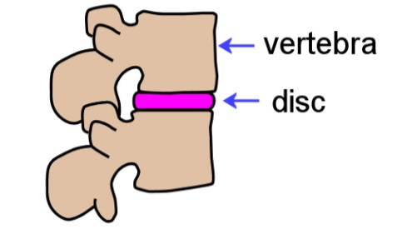
The spine is made up of a set of vertebrae stacked one on top of another. Between the vertebrae are discs, which act like shock absorbers – compressing when the spine is bearing a load, and springing back again when the load is taken away.

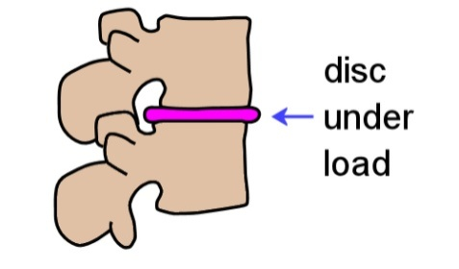
However, the discs can only cope with maximum pressure when your pelvis is level and your spine is in a balanced position above it. So when you bend or twist while holding a load, you’re putting uneven stresses on the discs in addition to the extra weight they have to bear.
Many injuries result in fatigued muscles going into spasm, causing back pain and difficulty in standing up straight. In serious cases, a bulging disc can rupture and come into contact with a nerve in the spinal cord. Some people call this a 'slipped disc'.
So how does this affect the way you should work? The general rule is – try to avoid putting too much stress on your back when:
- bending forward
- bending sideways
- twisting
- reaching past a comfortable distance.
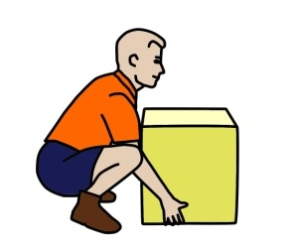
Here are the main steps you should follow when you need to lift and carry a large, heavy or awkward object.
- Size up the load and decide whether you’ll need help to lift or move it.
- Check the path you will be taking to make sure there are no obstacles in the way.
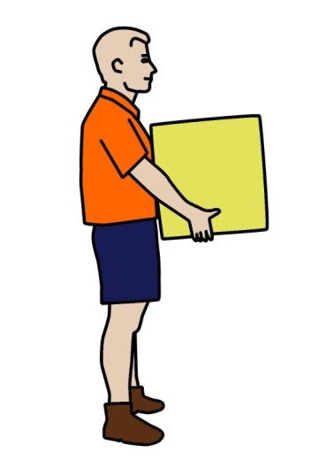
- Place your feet firmly on the ground and put your body in a balanced position.
- Bend your knees to get down to the load, and keep your back as straight as possible.
- Use your legs to do the lifting as you stand up straight.
- Keep the load close to your body while you’re carrying it.
To put the object down again, use the same procedure as for picking it up – keep your body well balanced and use your legs, not your back. Also remember that while your joints and muscles are under strain, you should avoid twisting your back.
If you need to change direction while you’re picking up, carrying or putting down a load, swivel on your feet so that your whole body moves in the same direction.

Carrying a roll
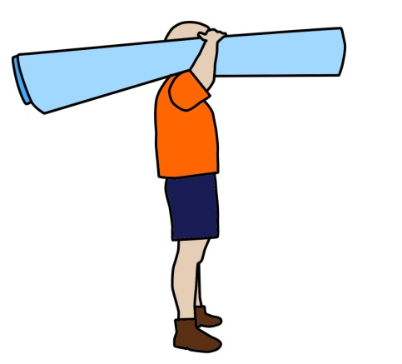
When you’re lifting and carrying a roll of carpet, the basic principles are all the same – keep your back as straight as possible and your body in a balanced position.
However, this time you should support the middle of the roll on your shoulder, as shown in the drawing at left.
If the roll is long or heavy, or if you need to manoeuvre it around awkward hallways or up stairs, it’s best to get an offsider to help.
But remember, if you’re lifting and carrying carpet with an offsider, good communication is vitally important. You both need to work in unison and know exactly what the other person is about to do.

Carrying a roll with two people
Here are some hints on how to carry a roll of carpet with another person.
1. Check that your offsider doesn’t have any back or muscle injuries that might affect the work you’re about to do.
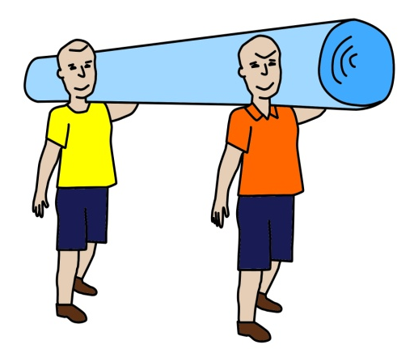
2. Talk through the process. State which side you are going to stand on, what path you’ll take, where you’re going to put it, and how you’ll deal with any obstacles or corners on the way.
3. Lift the carpet together. You might even want to lift on the count of three: ‘1, 2, 3, lift.’
4. When you get to the destination, count: 1, 2, 3, drop’, and both tilt your shoulders at the same time to let the carpet roll off and drop to the floor.
5. If at any time you’re not comfortable or the carpet is too heavy, call out ‘Stop’ and do the ‘1, 2, 3, drop’ procedure together. Don’t let go of your end unexpectedly, because this will jar the other person.

Learning activity
Do you know any flooring installers who have suffered a back injury or developed long-term problems in their joints or muscles?
What was the problem, and what caused it?
What steps would you take to avoid this problem in the future?

Looking after your knees
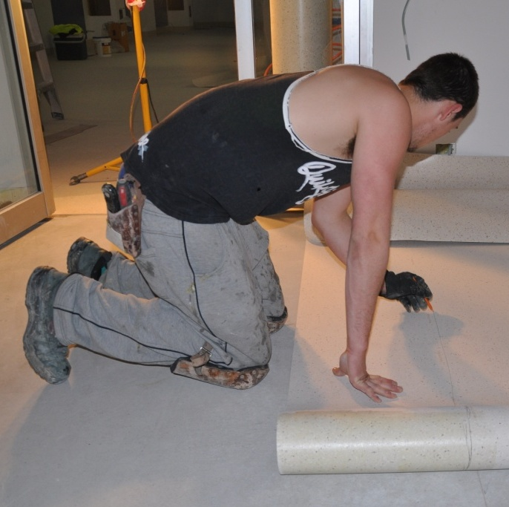
It’s a basic fact that flooring installation occurs at floor level, so you’re going to spend a lot of time on your knees.
The problem is that although knees are very good at carrying the body’s weight when you’re upright, they not designed to bear a lot of weight when you’re moving around in a kneeling position.
One of the medical conditions that a floor layer can develop is kneecap bursitis. This is caused by repeated pressure on the kneecap, which inflames a small sac called the pre-patella bursa.
There are several other bursas in the knee, including the infra-patella bursa, that can also become inflamed if you spend a lot of time working on your knees.
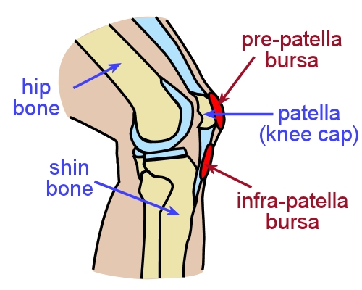
When a bursa is operating normally, it holds a few drops of fluid which lubricate the movement between the bones and tendons. But if the joint is put under too much pressure or strain, it tends to collect excess fluid and swells up, sometimes quite dramatically.
Bursitis makes the knee very painful to move. In serious cases it can also become infected, which may require surgical cleaning.
Long term abuse of your knees eventually wears out the surfaces of the joints between the bones, causing arthritis.
The simplest treatment for a mild case of bursitis is to rest your knee and put ice on it. In more serious cases the bursa may need to be drained with a needle. If the pain and swelling become chronic, the bursa might have to be removed through surgery.
The easiest way to avoid knee problems is to take care of them while you’re working. You can do this by wearing knee pads whenever you’re working on your knees, and giving your legs a break by periodically by standing up, stretching and walking around.

Knee pads
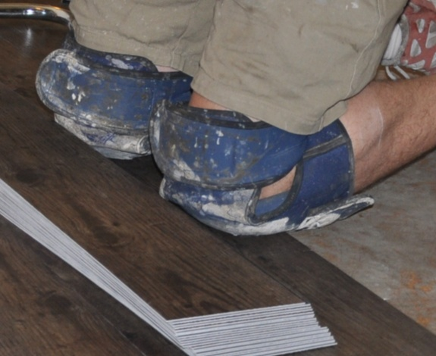
There are lots of different knee pads on the market, ranging from cheap mass-produced products to high quality custom-fitted models.
Don’t wait until you’re nursing an injury before you start to wear knee pads! You should put them on whenever you’re going to be working on your knees. It goes without saying that if you look after your knees while they’re still healthy, you’ll be able to keep them that way for many years.

Stretches and exercises
Keeping the muscles around your knees strong and flexible will help you to reduce the chance of an injury. Below are some simple exercises you can do every day.
Note that if any these exercises hurt, you should see a doctor before continuing with them. Pain might indicate that you’ve already done some damage to your knees.
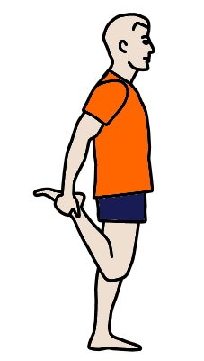
- Keep your knees together and your back straight. Pull one foot up towards your backside and hold for six seconds.
Make sure the foot points straight behind your body, not to one side.
Do this exercise several times. Then do the same for the other leg.

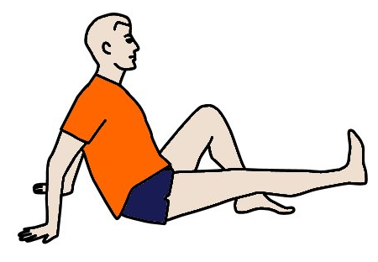
- Sit on the floor with one leg outstretched and the other leg bent. Raise the outstretched leg about 200 mm off the floor.
Point the toes towards your head and hold for six seconds.
Do this exercise several times. Then do the same for the other leg.

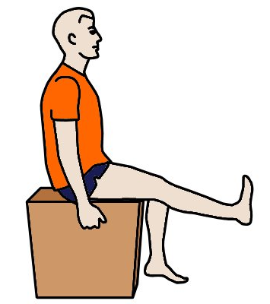
- Sit on a chair or box to support your legs above the knee. Raise one leg until it’s fully stretched out, with your foot flexed back towards your head. Hold for six seconds.
Then lower the leg about 30 degrees with the foot still flexed and hold for another six seconds.
Do this exercise several times. Then do the same for the other leg.

Reference
The above exercises are adapted from those shown in an article called ‘Preventing job-site knee injuries’ written by Steven Bond, an orthopaedic surgeon. The article appears in the members’ area of the Fine Homebuilding website. To see the full article you will need to join as a member, but you can access lots of other articles and information pages on the website by going to:
http://www.finehomebuilding.com/

Learning activity
Do you have your own knee pads? If so, what brand are they? Are they comfortable to wear, and do they stay in place while you’re working?
If you haven’t yet bought your own pair of knee pads, do a search on the web to see what brands and models are available. Choose a suitable one for your needs. Write down the brand, price and a brief description of the design.
Share your answers with your trainer and other learners in your group.

Assignment 1
Go to the Workbook for this unit to write your answers to the questions shown below. If you prefer to answer the questions electronically, go to the website version and download the Word document template for this assignment.
___________________________________________________________________________
- What items of PPE are you required to wear at work? Put the PPE into the following three categories and describe the purpose of each item.
- General items of PPE – to be worn in all areas of the workplace
- Specific items of PPE – to be worn in particular areas of the workplace
- Specific items of PPE – to be worn while doing certain types of jobs or operating particular machines

- What is the difference between an SOP and an SWMS? In your answer, explain what the abbreviations stand for, and what the purpose of each document is.

- Name two types of manual handling injury you could suffer doing the activities you typically carry out each day. For each injury, describe some good manual handling practices you could use to reduce the risk of it occurring.

- Choose one hazardous product or substance you commonly use at work. Look up the MSDS for the product to answer the questions below.
- What is the name of the product?
- What is the product used for?
- Where should the product be stored?
- What PPE is required when using the product?
- What other safety measures apply to using the product?
- What is the procedure for disposing of the product?

Section 2

Laws and systems

Overview
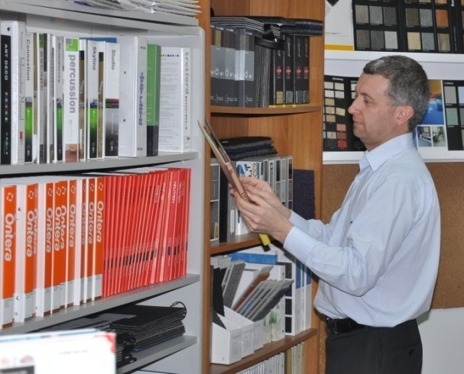
Most companies spend a lot of time and money keeping their Work Health and Safety (WHS) system up-to-date, so that it stays compliant with changing legislation, codes of practice and insurance company requirements.
But the bottom line can always be summed up in the basic question:
Is the system making the workplace safer?
If the answer is ‘Yes’, then your safety system is working. Not that this means you can relax and take it for granted. An effective system is only effective while everyone continues to apply its policies to their daily activities.
If the answer is ‘No’, then you’ve got a problem on your hands. No-one likes filling out forms if they think it’s pointless. And people soon lose the motivation to follow strict procedures if they don’t see any benefit in it.
In this section, we’ll look at the legislation that underlies safety in the workplace, and the administrative system that turns these laws into workplace practices.
We’ll also discuss the role of the new ‘model’ Work Health and Safety Act (2011) that has replaced the old Occupational Health and Safety (OHS) Acts in most states and territories, and the continuing process of ‘harmonisation’ occurring between them.

Completing this section

The assignment for this section will ask you to describe your own role in workplace safety and the consultation process, and identify the laws that apply to your state or territory.
Have a look at the Assignment on page 39 to see what you’ll need to do to complete it.
There are also four lessons in this section:
- Laws and regulations
- Rights and responsibilities
- Consulting with workers
- WHS management systems.
These lessons will provide you with background information that will help you with the assignment.

Laws and regulations
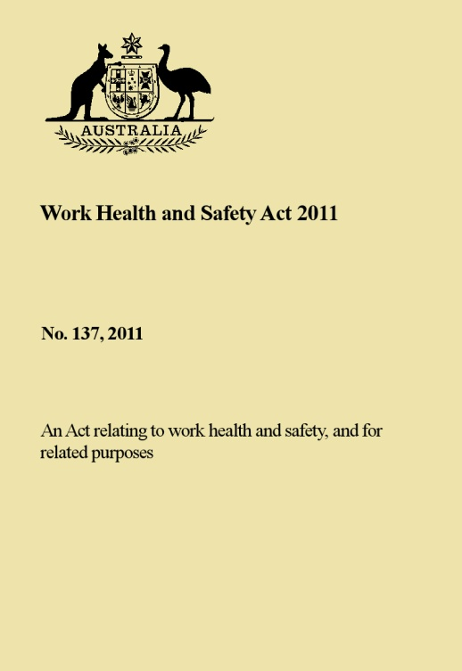
All states and territories in Australia have laws that cover workplace safety. Although the laws have always been very similar, until recently they were developed separately by each jurisdiction and given titles like the Occupational Health and Safety Act or Workplace Health and Safety Act.
Each of these Acts has a set of legally-binding Regulations, which expands on particular aspects of the Act and provides details on how it should be implemented.
Over the last couple of years, the states and territories have been working towards ‘harmonising’ their laws – that is, aligning them to a set of new ‘model’ laws developed by the Federal Government.
Along with this new Work Health and Safety Act are model Regulations and Codes of Practice. These documents have been developed by Safe Work Australia, the new government body created to oversee the harmonisation process.
It was hoped that by the end of 2012 all states and territories would have adopted the new Act and Regulations. However, it’s turned out that Victoria and Western Australia have decided to remain with their existing laws, for the time being at least, while they consider how they will proceed.

Changes in the WHS Act and Regulations
In practice, the new Act and Regulations are much the same as the previous state-based laws. The purpose of these national laws was not to make a whole lot of changes, but to bring all the little differences between the jurisdictions into line. This is especially helpful for people who work interstate and companies that have a national coverage.
One obvious difference between the new WHS Act and the old state-based Acts is the terminology used to describe ‘employers’ and ‘employees’. Because there are so many ways of working under the direction of a ‘boss’, the person in charge of an operation is no longer called the ‘employer’. They are now a ‘person conducting a business or undertaking’, or PCBU.
The term ‘employee’ is also no longer used, and anyone who carries out work for a PCBU is now simply called a worker. This change was needed so it could include volunteers, students, subcontractors and anyone else who works for another party, whether they’re technically ‘employed’ by them or not.

Learning activity
Which Act applies to your state or territory? Write down its full title, including the date it was passed by the state or territory government.
If you’re not sure which Act is currently in place, go to the Safe Work Australia website to see the latest update on the harmonisation process, at:
http://www.safeworkaustralia.gov.au/sites/swa/model-whs-laws/pages/jurisdictional-progress-whs-laws
On the same website, you’ll see a list of ‘model’ Codes of Practice at:
http://www.safeworkaustralia.gov.au/sites/swa/model-whs-laws/model-cop/pages/model-cop
Which of these codes relate to the sort of work you do? Write down their titles.
Follow the links to the codes that interest you most and have a look at the work practices they describe.

Rights and responsibilities
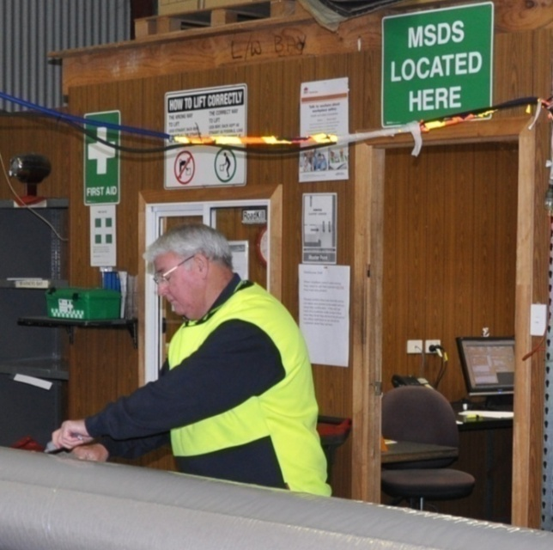
In general, the rights and responsibilities of all people in the workplace are defined in the WHS Act or OHS Act that applies to that state or territory, and the Regulations that go with the Act.
Whichever laws are in place, they all say that everyone has a duty of care to ensure that their actions don’t endanger others.
Everyone is also required to report any hazards they notice in the workplace, so that steps can be taken to minimise the risk of an injury or illness occurring.
As well as these general responsibilities there are specific responsibilities relating to each level of employment, as shown below.

Specific responsibilities
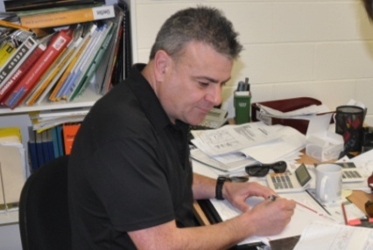
Directors are responsible for:
- ensuring that the company’s WHS policies are effective in keeping the workplace safe
- ensuring that the company’s activities comply with all WHS legislation.
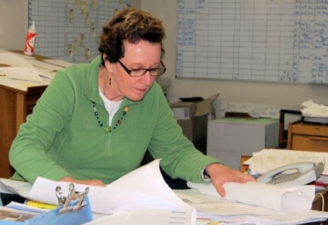
Managers are responsible for:
- developing and implementing safe work policies and procedures
- consulting with the workforce on WHS issues
- distributing all relevant information to employees.
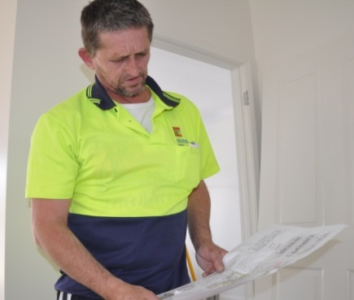
Supervisors are responsible for:
- supervising the performance of workers
- ensuring that workers are properly trained
- carrying out regular safety inspections
- correcting unsafe work practices and disciplining workers who disregard WHS policies.
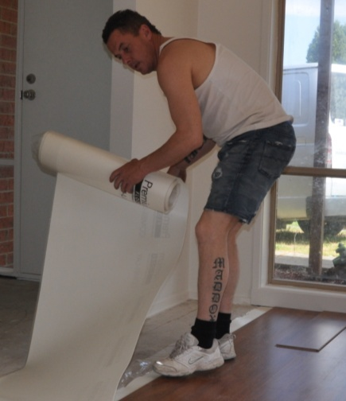
Workers are responsible for:
- taking care of the health and safety of themselves and others who may be affected by their actions
- following safe operating procedures and other safety directions from management
- reporting hazards or unsafe work practices to their supervisor
- reporting any injuries to their supervisor
- cooperating in health and safety programs.

Rights
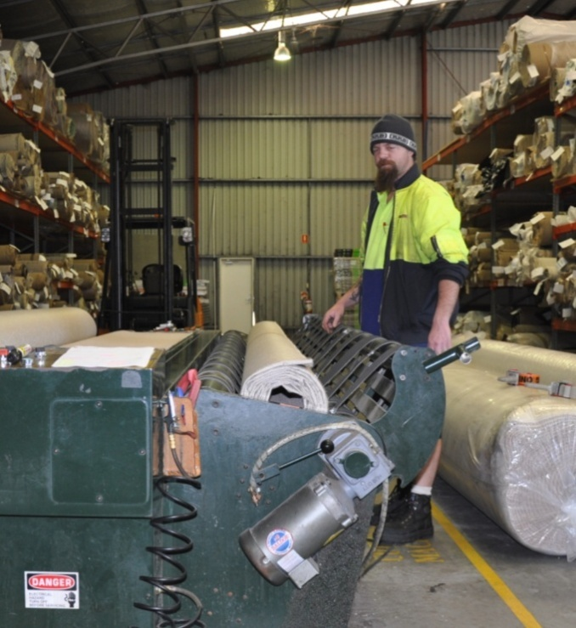
The laws also give workers certain rights. For example, workers have the right to raise genuine safety issues with their supervisor or manager and have their concerns taken seriously.
They’re also protected from discrimination if they report a hazard or unsafe work practice.
Safety officers and WHS committee members are also protected from discrimination as they carry out the duties relating to that position, such as doing site inspections or investigating the causes of accidents.

Learning activity
What are your responsibilities for safety in your own workplace? Use the dot point lists shown above as a guide, and include any extra responsibilities that apply to your particular job role.
Write out your own list and compare it with the responsibilities of other learners in your group.

Consulting with workers
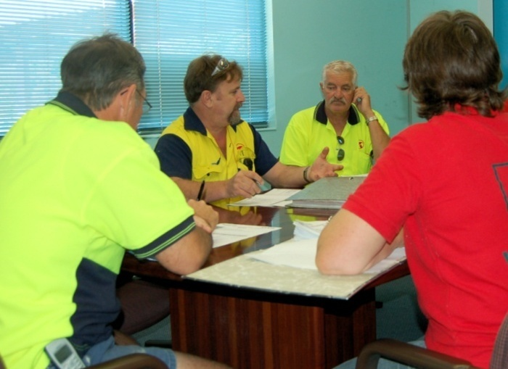
Experienced workers generally have a very good idea of where the hazards are in the work they do. They’re also likely to feel a lot more inclined to put new work methods into practice if they’ve had a hand in developing them.
This is why consultation between managers and workers is essential for any WHS system to work properly. It’s also a requirement under the law.
Managers are required to consult with their workers whenever:
- issues arise that might affect the health or safety of workers
- risk assessments are undertaken
- new measures are put in place to control risks
- new work or safety procedures are introduced
- decisions are made about workers’ facilities
- changes are made to the workplace, equipment or systems of work that may affect safety and welfare.

Methods for consulting with employees
Depending on the size of the workplace, there are various ways a business can consult with its workers.
Large organisations generally have a safety committee that meets regularly and has members representing management and the workforce. Formal minutes are taken at each meeting, and particular members are given duties to carry out in the workplace, which are reported back to the committee when completed.
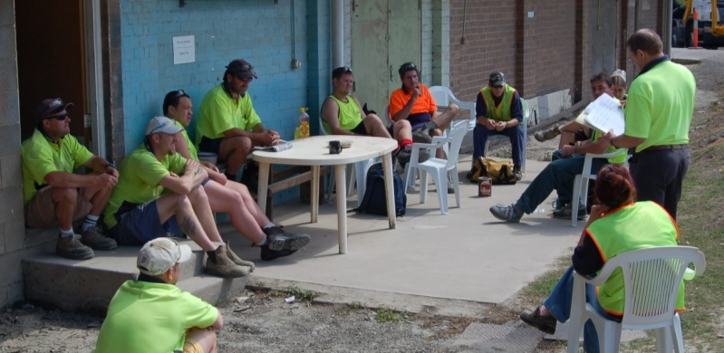
Companies also conduct regular toolbox meetings with workers.
These are generally organised by the supervisor in each section of the workplace, and minutes are taken of the points discussed. A toolbox meeting allows workers to raise safety concerns or report hazards. It also lets the supervisor pass on WHS information, or discuss new procedures that are being introduced.
Regardless of the size of the workforce, every business is required to have arrangements in place to allow the free flow of information between management and workers. In the case of a very small business, this may simply involve you speaking directly to your boss.
But whatever the arrangements are, documentary records must be kept to show that consultation is occurring properly, and workers views are being taken into account when the boss makes decisions about workplace health and safety.

Learning activity
Describe your input into 'workplace consultation' in relation to safety.
If you had a concern about a safety issue, who would you report it to? What would happen then?

WHS management systems
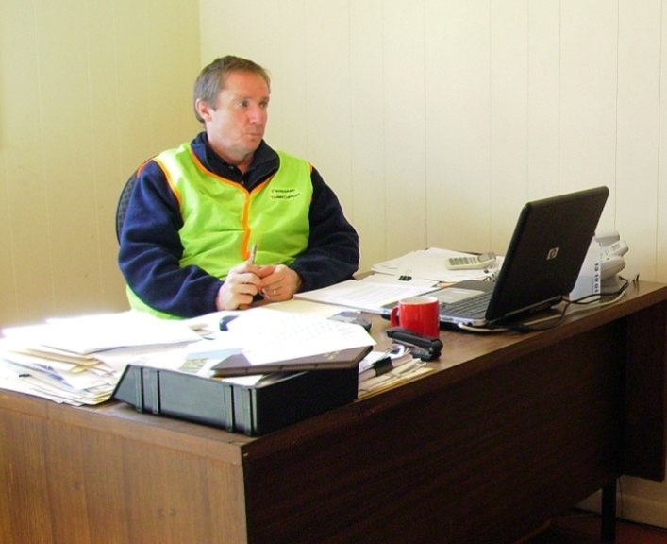
If your company’s WHS system has turned into a big paper shuffling exercise, then it’s not doing the job it’s supposed to.
A good system doesn’t need a lot of fancy documents, it just needs a user-friendly set of policies, procedures, and checklists – to help encourage everyone to keep the records up-to-date, and most importantly, put the safety procedures into action.
This is where a WHS management system comes into play.
The WHS management system allows a company to integrate its safety policies and procedures into all of its activities, and record the effort it is making to handle safety issues. This not only provides evidence that the company is complying with WorkCover requirements, it also gives the directors a sound picture of how well everything is working.
Set out below are some typical documents that a company might keep in its WHS management system.

SOPs and MSDSs
- Safe Operating Procedures: showing the safe operating procedures for workplace machines and processes.
- Materials Safety Data Sheets: showing the properties and correct handling procedures for all hazardous substances kept on-site.

Risk assessments and work method statements
- Risk Assessment: completed before starting a new job or commissioning a new machine.
- Safe Work Method Statements: completed by subcontractors carrying out installation work.
- Incident Report: completed after an incident involving property damage or injury.

Registers and log books
- Injuries Register: recording all workplace injuries sustained by employees.
- Hazardous Substances Register: listing all hazardous substances kept on site.
- Plant and Equipment Register: showing the servicing and maintenance schedule for all machines.
- Safety Hazard Log: used by employees to record potential safety hazards or near misses.
- Training register: showing the safety-related training undertaken by employees and any accreditations received.

Workplace safety inspections
- Site Inspection Checklist: used to identify hazards around the site.
- Forklift Pre-start Inspection Checklist: completed by the forklift driver each day.
- Delivery Truck Pre-start Inspection Checklist: completed by the truck driver each day.

Minutes of meetings
- Toolbox Minutes: recorded by the supervisor at the regular Toolbox meetings.
- Safety Committee Minutes: recorded by the secretary at the regular safety committee meetings.

Return to Work documents
- Return to Work Plan: for injured workers returning to work on ‘suitable duties’.

Forms
- Contractor Insurance Form: completed by contractors prior to carrying out work.
- Workers Compensation Claim Form: completed by injured workers when lodging workers compensation claims.
- WorkCover Accident Report Form: for reporting serious accidents or incidents to WorkCover.

Safety Induction manuals
- Induction Manual for Employees: issued to new employees at the commencement of their employment.
- Induction Manual for Subcontractors: issued to contract tradespersons who come on-site.

Policies and Procedures manuals
- WHS Policies and Procedures Manual: setting out the company’s safety policies and procedures.
- Emergency Procedures Manual: setting out the procedures for dealing with emergencies.

Learning activity
As you can see, there’s a wide range of documents that might be included in a company’s WHS system.
If the business you work for is very small, it may not use all of these documents, or it may combine some of them so that the one document has several functions.
Which of these documents do you use in your workplace?
Are there any other safety-related documents you use that are not listed above? What are they, and what is their purpose?

Assignment 2
Go to the Workbook for this unit to write your answers to the questions shown below. If you prefer to answer the questions electronically, go to the website version and download the Word document template for this assignment.
___________________________________________________________________________
- What is the title of the Act of Parliament relating to workplace safety in your state or territory? What is the title of the Regulation that accompanies the Act?
- Describe your input into 'workplace consultation' in relation to safety. How do you make your views known to management, and how do you report safety concerns or hazards?
- State your job role and describe the responsibilities you have for maintaining a safe workplace. Include all general responsibilities and any specific duties, such as carrying out workplace inspections, risk assessments, etc.

Section 3

Managing
risks

Overview
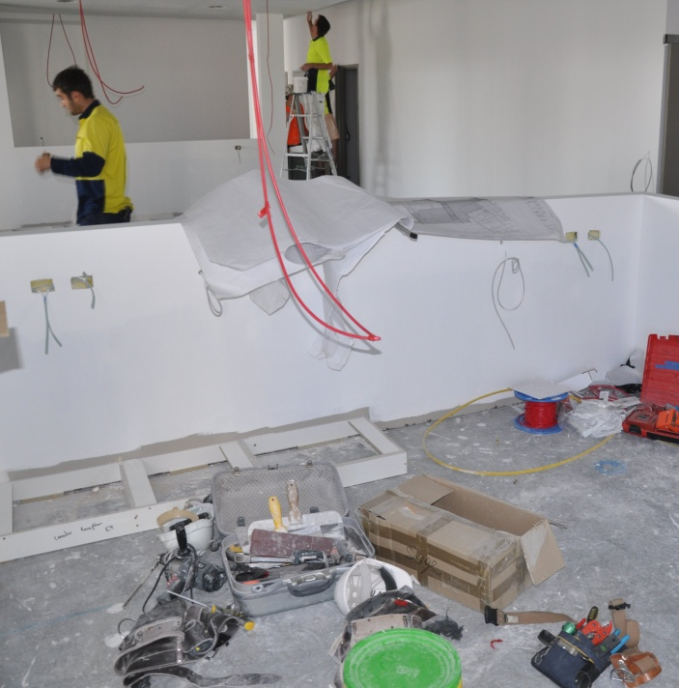
Risk management is all about identifying hazards and minimising the risk of them causing an illness or injury.
The most effective way to identify hazards and decide on what action that should be taken is to carry out a risk assessment.
There are three basic steps involved in carrying out a risk assessment:
- identify the hazards
- assess the risks
- control the risks.
In this section, we’ll look in detail at the three-step process of carrying out a risk assessment.


Completing this section
The assignment for this section is a risk assessment exercise that you will need to undertake in an area of your workplace.
Have a look at the Assignment on page 50 to see what you’ll need to do to complete it.
There are four lessons for this section:
- Identifying hazards
- Assessing risks
- Controlling risks.
These lessons will provide you with background information that will help you with the assignment.

Identifying hazards
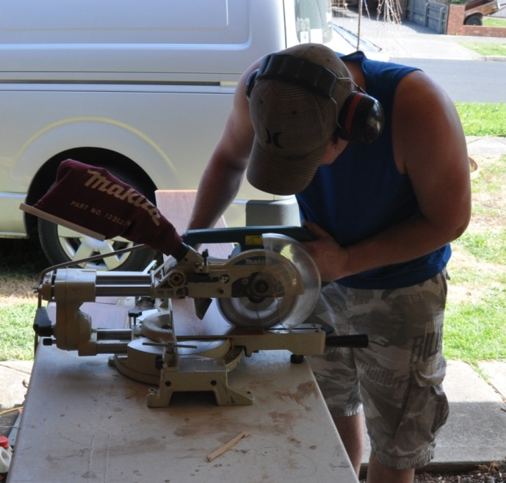
A hazard is anything that might harm the health or safety of someone.
Depending on where you’re working, it could include airborne dust, sharp blades, obstacles, electrical currents, vehicles, noise, chemical fumes, or anything else that might cause an injury or illness.
The most obvious way to identify hazards is to go out into the workplace and look for them. But there are other methods of finding potential hazards.
Here are the most common methods used to identify hazards:
- carry out a workplace inspection
- talk to other workers
- check injury records
- check the ‘safety hazard log book’
- get expert advice from an industry consultant
- review the code of practice.

Learning activity
To be effective at identifying hazards, you need to know what sorts of injuries tend to be associated with particular types of work.
Have a look at the statistics table on the following page to see what the most common injuries are in manufacturing industries, and the main causes of those injuries.
Have you or your work mates ever suffered from any of these injuries? Think about the causes and any changes made afterwards to the way the job was done. Did these changes reduce the chance of the injury happening again?

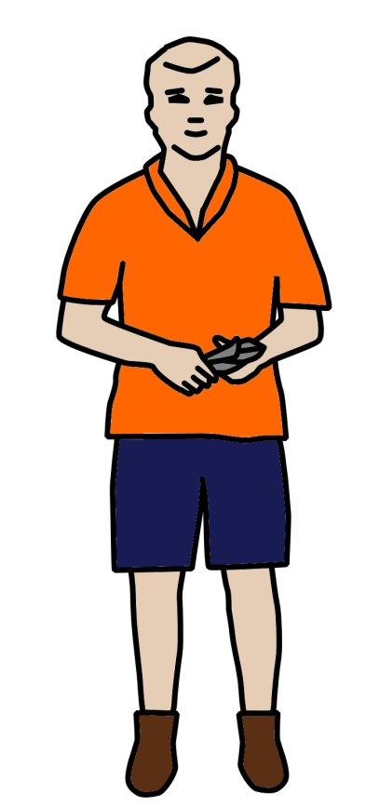
1
2
3
4
5
6
7
8
9
10

Table of injury statistics
No. | % total injuries | Body part | Injuries
1 | 24% | Hand and fingers | Lacerations and open wounds
2 | 16% | Back | Sprains and strains from bending, lifting or carrying
3 | 11% | Eye | Fragments in eyes from grinding or welding
4 | 7% | Shoulder | Sprains and strains from repeatedly lifting or moving things
5 | 5% | Knee | Sprains and strains from kneeling, crouching or twisting
6 | 5% | Wrist | Sprains and strains from repeatedly lifting or moving things
7 | 3% | Ankle | Sprains and strains from tripping or falling over
8 | 3% | Foot and toes | Bruising and crushing from falling or dropping objects
9 | 3% | Elbow | Sprains and strains from repeatedly doing the same thing
10 | 3% | Forearm | Wounds from using knives
Adapted from Injury statistics for manufacturing (2008) from Queensland Worksafe: www.worksafe.qld.gov.au

Assessing risks
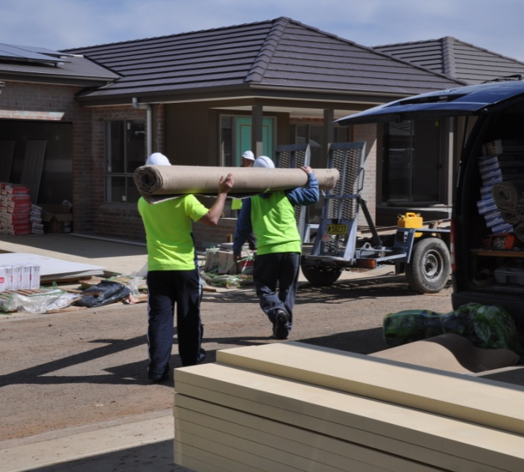
Once the hazards have been identified, they can be given a risk rating, depending on how urgently they need to be addressed.
Below is a typical risk matrix to rate the likelihood of an accident occurring and the seriousness of the harm that might result.
This allows a priority rating to be put against each of the hazards identified, so that the most serious ones can be dealt with first.

Risk Matrix | Likely  Could happen frequently | Moderate  Could happen occasionally | Unlikely  May occur, but only in exceptional circumstances
High level of harm  Death, permanent disability, major structural failure or damage | 1 | 1 | 2
Medium level of harm  Temporary disability, minor structural failure or damage | 1 | 2 | 3
Low level of harm  First aid required | 2 | 3 | 3
(Adapted from the ‘OHSE Risk Matrix’ developed by WorkCover for its ‘SubbyPack’)

Let’s take a couple of examples to see how you can use the risk matrix to rate the seriousness of a hazard and decide on the best course of action to take.

1. Hazard in the warehouse
There is a large pothole near the entranceway to the warehouse. The forklift truck could tilt to one side if its tyre went into the hole, which would destabilise the load and may even cause the forklift to fall sideways. This could happen any time, and if it did, might result in someone being seriously injured and cause major damage to the forklift.
When you go to the risk matrix, you would choose ‘likely’ (column 1) and ‘high level of harm’ (row 1). This is a risk rating of 1 – the highest level – so the problem needs to be dealt with urgently.
In practice, you would immediately isolate the area with barrier boards or witches hats and then get the pot hole filled in as soon as possible.

2. Hazard out on-site
An installer needs to apply a levelling compound to a concrete subfloor. He knows that when the cement-based compound gets on his hands it causes his skin to dry out, and repeated contact results in dermatitis. The last time he developed dermatitis, he had to go to the doctor and get a prescription for a medicated hand cream.
Although he uses tools to mix and apply the patching compound, there is still a ‘moderate’ chance (column 2) he could get it on his skin, which would result in a ‘low level of harm’ (row 3). Therefore, the risk rating is 3.
In practice, the installer would wear a pair of gloves while he’s mixing and applying a patching compound, especially if he needs to push any of the wet mix into the holes or cracks by hand.

Learning activity
See if you can come up with an example of a potential safety hazard for each of the three risk ratings – 1, 2 and 3. Use examples from your own workplace or the on-site jobs you go to.
Write down the nature of the hazard, as well as your reasoning for why you have given it that risk rating.
Share your answers with your trainer and other learners in your group.

Controlling risks
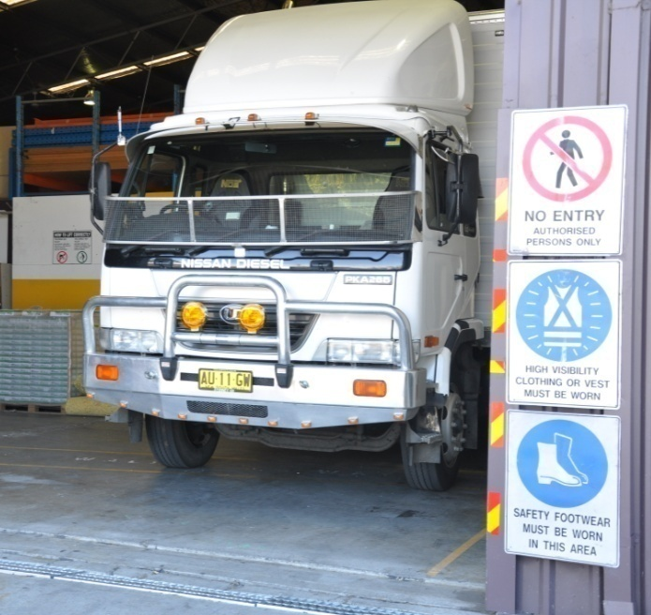
Most hazards can be controlled in a variety of ways. Obviously, the best control would be to eliminate it completely. But that isn’t always possible.
So the most practical process for deciding on how to address a hazard is to find the best solution from the ‘hierarchy of controls’.
It's called a hierarchy because you start at the top of the list – removing the hazard from the workplace – and work progressively down to the bottom – accepting that the hazard must remain and providing personal protective equipment.

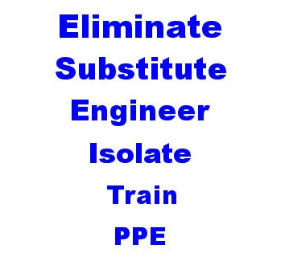
Hierarchy of controls
Below is the order you should work through to find the control that is most appropriate. In many cases, you may find that more than one control is necessary. For example, training might be used as one of the controls with most hazards.
- Eliminate the risk, such as through removing the dangerous machine or situation, or changing the way the job is done.
- Substitute the hazardous machine or process with a safer one.
- Engineer a solution to control the risk, such as with guards, dust extraction systems or other mechanical aid.
- Isolate the machine, process or area to keep workers clear of the hazard.
- Train workers to avoid the risk, such as through the use of Safe Operating Procedures.
- Issue personal protective equipment to workers, such as hearing protection, eye protection or safety boots.

Learning activity
See if you can think of one example from your own experience to illustrate each control measure in the hierarchy of controls. For each of the measures shown below, state the hazard first and then the control. The first one is done for you.

Hierarchy | Hazard | Control measure
Eliminate | Asbestos fibres used in fibre cement sheeting and flooring products | Ban asbestos as a component in the manufacture of building products
Substitute
Engineer
Isolate
Train
PPE

Assignment 3
Go to the Workbook for this unit to write your answers to the questions shown below. If you prefer to answer the questions electronically, go to the website version and download the Word document template for this assignment.
___________________________________________________________________________
Carry out a risk assessment in your workplace. You may choose:
- a particular area of the workplace or building site that you’ll be working at
- a work process that you regularly undertake or machine you use.
For each of the hazards you identify:
- describe the situations where they occur
- rate the risk of injury or illness from 1 to 3, using the Risk Matrix
- suggest practical control measures that would minimise the risks, in keeping with the risk rating you have given the hazard.
Risks to be assessed:
- Pinch points and crush injuries
- Cuts, punctures or strikes
- Hydraulic or pneumatic leaks
- Electrical hazards
- Manual handling injuries
- Operator controls and isolation problems
- Slips and falls
- Personal protective equipment
- Lighting
- Fatigue management
- Traffic control.

Section 4

Dealing
with emergencies

Overview

Emergencies are situations that are dangerous to life, property or the environment. They may arise from a fire, explosion, accident, or some other incident that occurs without warning.
By their very nature, emergencies are unexpected and catch people by surprise. But if you’ve already put procedures in place to cope with the incident, you’ll be able to take control of the situation in an organised way.
In this section we’ll discuss various types of emergencies that you may encounter, either on-site at a client’s property or in your own workplace. We’ll also describe the general procedure for carrying out an emergency evacuation.

Completing this section
The assignment for this section will test your knowledge of how to deal with emergency situations at work.
Have a look at the Assignment on page 64 to see what you’ll need to do to complete it.
There are three lessons for this section:
- Emergency evacuations
- On-site fires
- Hazardous spills.
These lessons will provide you with background information that will help you with the assignment.

Emergency evacuations
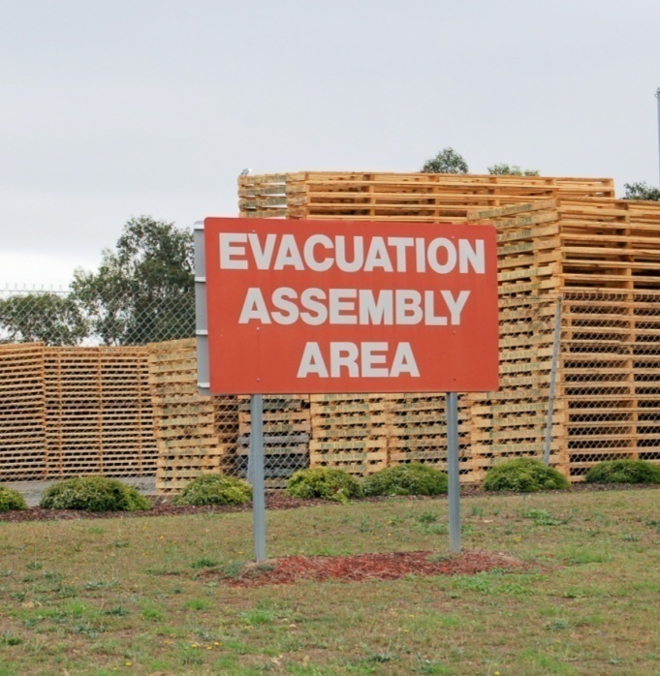
Most workplaces and large building sites have an evacuation procedure in place, with a designated Assembly Area for people to go to. The evacuation procedure and site map are often posted up in various places around the worksite.
If you’re at a domestic building site or in a client’s home, there probably won’t be a formal procedure for carrying out an evacuation.
In these cases, all people on-site should assemble in an open area clear of the building so that everyone can be easily accounted for.

General emergency evacuation procedure
Where there is a site procedure for emergency evacuations, it’s normal practice for everyone who comes on-site to be ‘inducted’ when they arrive for the first time. At the induction session you’re given information about the site’s safety policies and procedures, including what to do in the event of an emergency.
The procedure shown below is a general guide on how to respond to an emergency if there is no formal procedure in place.

Raising the alarm
If you’re the first person to know about the emergency:
- Notify your supervisor or the person in charge immediately, or send another person to tell them.
- If it is safe to do so, try to control the emergency by isolating the power supply, or using the appropriate equipment.
- If safe, remove any people in immediate danger of further injury from the area.
- Follow all directions regarding evacuation of the area from your supervisor or the person in charge.

Evacuation procedure
If you are told to evacuate, or if you hear the emergency evacuation alarm:
- Stop what you are doing and switch off the power in your immediate work area, if possible.
- Take the safest route to the Emergency Assembly Point, or the front gate of the site.
- Advise other people along the way to evacuate.
- Ensure that you have been accounted for by your supervisor or the person in charge.
- Wait at the assembly point until directed otherwise by the person in charge. Do not go in search of other people unless given explicit instructions from an authorised person.

Notifying emergency services
If it is your place to call the emergencies services for help, you should dial ‘000’, remain calm, and provide the following information:
- your name
- your location
- location of the emergency
- number of people injured
- types of injuries sustained
- assistance required; such as ambulance or fire brigade
- any hazards that might exist; such as toxic fumes or spilt chemicals
- contact phone number.

Vehicle drivers
If you are driving a vehicle on-site when the emergency alarm sounds, you should:
- pull over to the side of the road or access way
- park the vehicle, making sure it is well clear of any thoroughfare that may be needed for emergency vehicles
- leave the vehicle unlocked, with the keys in the ignition
- report to the Assembly Area.

Learning activity
What arrangements do you have in place for emergency evacuations? (If you work at clients’ sites, answer this question in relation to the last jobsite you were at.)
Also describe where you would assemble if you had to evacuate.

On-site fires
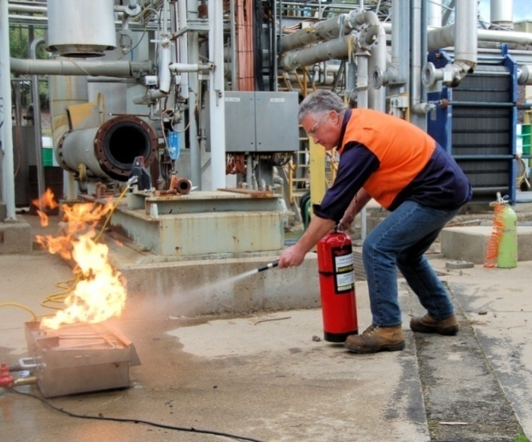
Combustible and flammable materials are present everywhere. They include:
- board products used for underlay
- floor covering materials
- timber and sawdust
- cardboard and paper
- plastics
- furniture
- solvents, glues and other chemicals.
There will also be various ‘ignition sources’ that may set these fuels alight under the right conditions, such as:
- electrical sparks from loose wiring or faulty machinery
- sparks from welding or grinding activities
- naked flames from matches or cigarette lighters
- smouldering cigarette butts.

Prevention
The two most important prevention measures you can take to avoid the possibility of a fire are:
- maintain good housekeeping
- keep potential ignition sources away from flammable and combustible materials.
This means that you should always try to keep the workplace clean, especially at the end of the day before you knock off, and always make sure that any activities that may cause sparks or flames are carried out well away from areas that contain combustible materials.

Fire fighting equipment
Fire extinguishers and hose reels are the most common equipment kept to fight fires on-site. Fire extinguishers are colour coded and labelled according to their contents.
It's very important to match the correct extinguisher to the type or class of fire. The contents of some extinguishers may be unsuitable, or even dangerous, if used on the wrong type of fire. The tables below show the different classes of fire and the range of fire extinguishers used to combat these fires.

Classes of fire
Fire classes are categorised according to the type of material that is burning and range from Class A to Class F.
Class | Symbol | Fuels | Examples
A | 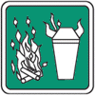 | Ordinary combustible solids | Wood, paper, cloth, plastics, rubber, coal
B | 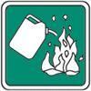 | Flammable and combustible liquids | Petrol, oil, paint, thinners, kerosene, alcohol
C | 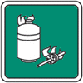 | Flammable gases | LPG, butane, acetylene, hydrogen, natural gas
D | 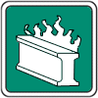 | Combustible metals | Magnesium, aluminium, sodium or potassium
E | 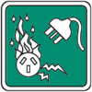 | Electrical fires | Computers, switchboards, power-boards
F | 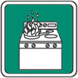 | Cooking oils and fats | Cooking oils and fats usually found in industrial kitchens

Fire extinguisher colour codes and labels
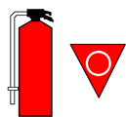 | Colour: Solid red.  Contents: Water.  Label: Class A fires; paper, wood, cardboard.  Dangerous if used on cooking oils, fats electrical fires.

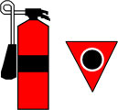 | Colour: Red with a black band.  Contents: Carbon dioxide.  Label: Class E fires; electrical.

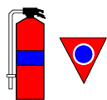 | Colour: Red with a blue band.  Contents: Foam.  Label: Class A and B fires; paper, wood, cardboard, and flammable and combustible liquids, e.g. methylated spirits.  Dangerous if used on electrical fires.

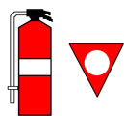 | Colour: Red with a white band.  Contents: Dry chemical or powder.  Label: Class A, B, C and E fires; most fires except for oils and fats.

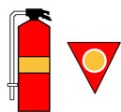 | Colour: Red with an oatmeal band.  Contents: Wet chemical.  Label: Class F fires; cooking oils and fats; also paper and wood.  Dangerous if used on electrical fires.

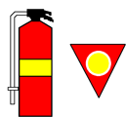 | Colour: Red with a yellow band.  Contents: Vaporising liquid.  Label: Class A and E fires; paper, wood, cardboard and electrical.

How to use fire fighting equipment

Fire extinguishers
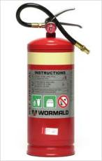
To use a fire extinguisher:
- pull out the pin
- squeeze the handle while aiming the hose at the fire
- use a sweeping action to spray the substance back and forth across the fire, from front to back and from side to side.

Hose reels
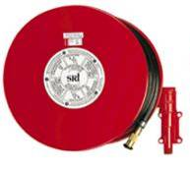
Hose reels use water, and are only designed for Class A fires, that is, fires involving materials such as paper, wood and cardboard. They must never be used on fires involving fats or electrical equipment.
To use a hose reel:
- turn the water on at the reel before unrolling the hose
- unroll the hose, with the assistance of another person if required
- turn the water on at the nozzle.

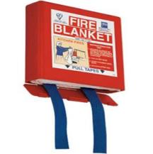
Fire blankets
Fire blankets are useful for smothering small fires associated with cooking stoves or other high-risk electrical appliances.
To use a fire blanket:
- pull the tabs downwards to remove the blanket
- shake the blanket open, holding onto the tags
- hold the blanket in front of the body to form a heat shield
- if an appliance is on fire – place the blanket over the fire and turn off the source of the flame
- if a person’s clothes are on fire – wrap the blanket around the person and roll them on the ground.

Learning activity

List the types of fire fighting equipment you have access to in your workplace or on-site (including in your vehicle).
Are there any types of fire you’re not properly prepared for? If so, what are they, and what could you do to better prepare yourself.

Hazardous spills
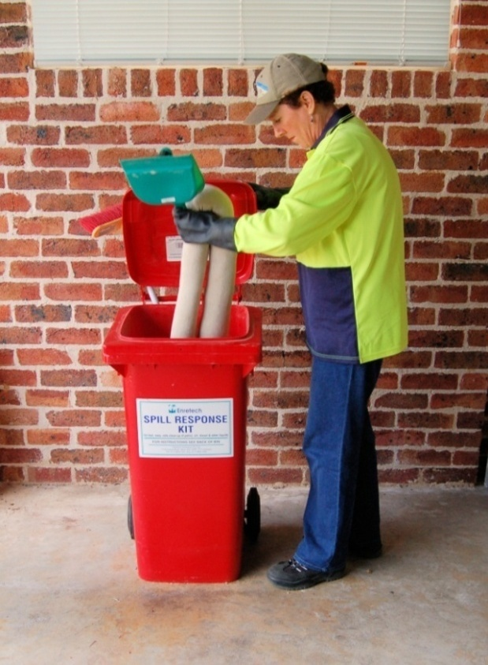
Some liquids are classified as hazardous because they have the potential to cause harm if they’re stored or handled incorrectly.
The sorts of hazardous liquids that you’re most likely to come across include:
- solvents, such as paint thinners, methylated spirits and mineral turpentine
- fuels, such as LP gas, petrol and diesel
- acids, such as battery acid or hydrochloric acid
- sealants and coating products.
Spills can be a real problem when they involve a hazardous substance. They should always be cleaned up straight away, no matter how small they are.

Response for a small scale spill
The general response for a small scale spill is:
- Stop the source of the spill straight away, if it’s safe to do so.
- Contain the spill, using the materials in a spill kit, if available, or by using sawdust or some other absorbent substance.
- Clean up the spill, in accordance with the Material Safety Data Sheet (MSDS).
- Store the clean-up waste in a sealed container.
- Contact a licensed waste contractor to take away the waste materials.
If a spill occurs that might harm the environment, you must tell the EPA or local council as soon as you become aware of it.
For serious spills, or where there is any doubt about the safety of the situation, contact the Fire Brigade on 000.

Learning activity
Choose an MSDS for a hazardous liquid that you use or store at work and answer the following questions:
What is the name of the product?
What is the product used for?
What is the procedure for dealing with a spill?

Assignment 4
Go to the Workbook for this unit to write your answers to the questions shown below. If you prefer to answer the questions electronically, go to the website version and download the Word document template for this assignment.
___________________________________________________________________________
Answer the following questions in relation to the emergency evacuation procedure at your own workplace (or alternatively at a building site you have worked at recently):
- Where is the emergency assembly area?
- What is the signal for an emergency evacuation (for example, is it three bursts of the hooter)?
- Briefly describe the procedure that people must follow for an emergency evacuation.
- For each of the fire extinguishers shown below, answer the following questions:
- What are the contents?
- What class or classes of fires the extinguisher designed for?
- Which types of fires is it not suitable for?

