
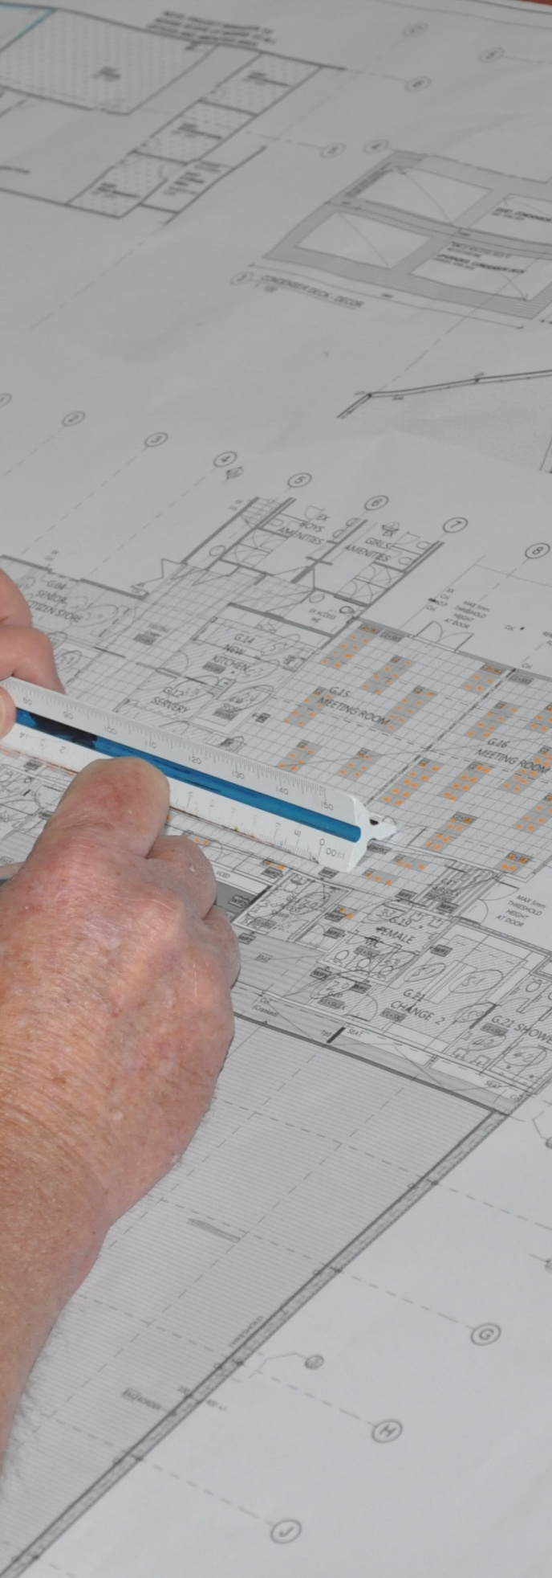
Supporting:

LMFGN3001B: Read and interpret work documents
Work documents
Learner guide
Developed in 2013-2014 for the WELL Program
DRAFT VERSION
October 11

Work documents
Learner guide

This unit is also available in an e-learning format, which contains additional photos, interactive exercises and a voice-over narration of the text. It can be viewed on CD-ROM, or live on the web at:
www.flooringtech.com.au



Developed by Workspace Training for the 2013-2014
Workplace English Language and Literacy (WELL) Program
Flooring Technology resource development project





Copyright and disclaimer

ISBN: 978-1-925087-12-3
Funded under the Workplace English Language and Literacy Program by the Australian Government through the Department of Industry.
© Commonwealth of Australia. 2014


CC BY-NC-SA
This work is copyright. Except where otherwise indicated, and save for the Commonwealth Coat of Arms, the Department has applied the Creative Commons Attribution-Noncommercial-Share Alike 3.0 Australia Licence to this work.
The Department of Industry must be attributed as the author of the Department’s copyright material.
As far as practicable, material for which the copyright is owned by a third party has been clearly labelled. The Department has made all reasonable efforts to ensure that this material has been reproduced in the print-based resources and accompanying website with the full consent of the copyright owners.
Requests and enquiries concerning the Department’s copyright material should be emailed to: media@innovation.gov.au
Questions about the design and content of the resource itself should be addressed to the project manager:
David McElvenny
Workspace Training
PO Box 1954 Strawberry Hills, NSW, 2012
Email: david@workspacetraining.com.au

Disclaimer
The content of this Learner guide is provided for educational purposes only. No claim is made as to the accuracy or authenticity of the content. The views expressed in this publication do not necessarily represent the view of the Minister for Industry or the Australian Government. The Australian Government does not give any warranty nor accept any liability in relation to the contents of this work.

About this resource
This Learner guide is part of a suite of resources developed for the Flooring Technology project, funded by the WELL Program. The resources support 27 competencies from the Certificate III in Flooring Technology (LMF31208). The project comprises a website and an accompanying set of Learner guides and work books.
The project has been completed in two stages. Stage 1 (undertaken in 2012-13) supported 19 competencies and Stage 2 (2013-14) supported a further 8 competencies.
The guides developed under Stage 2 of the project are shown below. Note that individual competencies are clustered in ‘Learning units’, with each unit being given a title describing the main theme of that set of integrated competencies.

Learning unit title Competencies covered
Communication and teams MSAPMSUP102A: Communicate in the workplace
MSAPMSUP106A: Work in a team
Work documents LMFGN3001B: Read and interpret work documents
Timber floor coatings LMFFL3402A: Apply solvent based coatings to timber flooring
LMFFL3403A: Apply water based coatings to timber flooring
LMFFL3404A: Apply oil based coatings to timber flooring
LMFFL3605A: Apply finishes to cork flooring
Hand and power tools LMFFL2001A: Use flooring technology sector hand and
power tools
The purpose of these resources is to help trainee floor layers acquire the background knowledge needed to satisfy the theoretical components of the competencies covered in this project. However, the resources are not designed to replace the practical training necessary to develop the hands-on skills required. Learners will still need to receive extensive on-the-job training and supervision before they will be ready to be formally assessed in the relevant competencies.
E-learning version
All of the content material contained in this Learner guide is also available in an e-learning format, which has additional photos, interactive exercises and a voice-over narration of the text. The e-learning version can be viewed on the web at: www.flooringtech.com.au
The web version can also be purchased on a CD at a cost-recovery price from the project developer:
Workspace Training
PO Box 1954 Strawberry Hills, NSW, 2012
Email: david@workspacetraining.com.au

Acknowledgements
Project team
Project manager: David McElvenny
Instructional designer: Kath Ware
Technical developer (website): Jim Vaughan
Assistant technical developer (and voice-over artist): Alex Vaughan
Quality assurance consultant: Giselle Mawer
Industry coordinator: Gary Dunshea (MSA Industry Skills Council)
Technical Advisory Group
Lead advisors
William Tree – South West Sydney Institute of TAFE
Mark Willis – Council of Textile and Fashion Industries of Australia
Craig Bennett – Hunter Institute of TAFE
Reviewers
Ian Ciesla – Polytechnic West (WA)
Robert Cole – Furnishing Industry Association of Australia (NSW)
Steven Dalton – Marleston TAFE (SA)
Shane Eales – SkillsTech Australia (QLD)
David Hayward – Australian Timber Flooring Association
Bruce Ottens – Holmesglen TAFE (VIC)
Chris Shaw – Skills Institute Tasmania (TAS)
Content material
The content material has been drawn from training notes provided by the reviewers and advisors listed above, plus the following publications:
ANTA, ABC and TAFE learner guides
Photographs and graphics
Most of the photos in this suite of resource were taken by David McElvenny. Additional photos were provided by David Hayward (Australian Timber Flooring Association).
Graphics were drawn by Kath Ware.
Plans were adapted from TAFE NSW learner guides
Financial contributions
This resource was funded by the Workplace English Language and Literacy Program by the Australian Government through the Department of Innovation. Additional financial assistance was provided by Manufacturing Skills Australia (Industry Skills Council).

Table of contents
Introduction 1
Section 1 Working drawings 3
Overview 1 5
Building plans 6
Architectural conventions 10
Key information on plans 14
Floor covering plans 19
Assignment 1 21
Section 2 Other documents 23
Overview 25
Standards and specifications 26
Work procedures 29
Planning and checking 36
Maintaining files 39
Assignment 2 42

Introduction
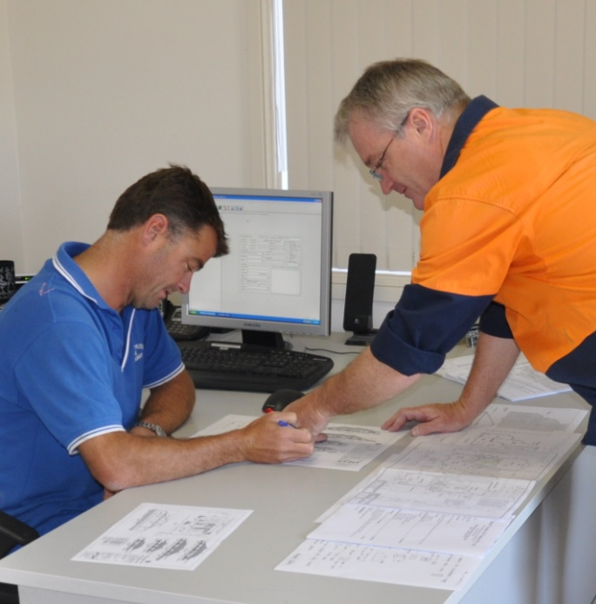
Work documents include all of the printed or electronic records that are used to ‘document’ information.
So although some of them are text-based official-looking papers, such as contracts and specifications, other documents can come in the form of plans, drawings, spreadsheets and even hand-written notes.
In this unit, we’ll look at the main types of documents that you need to be able to read and understand as a professional tradesperson.
Some of these documents are also discussed in other learning units from the Flooring project. We’ll refer to the relevant lessons from those units at various points throughout this guide.

Working through this unit

There are two sections in this unit:
- Working drawings
- Other documents
Each section contains an Overview, an Assignment and Lessons which cover the content material.

Assignments
Your trainer may ask you to submit the assignments as part of your assessment evidence for the unit. You will find hard-copy templates for these assignments in the separate Workbook.
Electronic ‘Word’ templates of the assignments are available on the website for this resource, at: www.flooringtech.com.au

Learning activities
Each of the lessons has a learning activity at the end. The Workbook for this unit contains all of the learning activities together with spaces for written answers.
Again, you will find the learning activities on the website version, together with some interactive ‘Just for fun’ exercises.

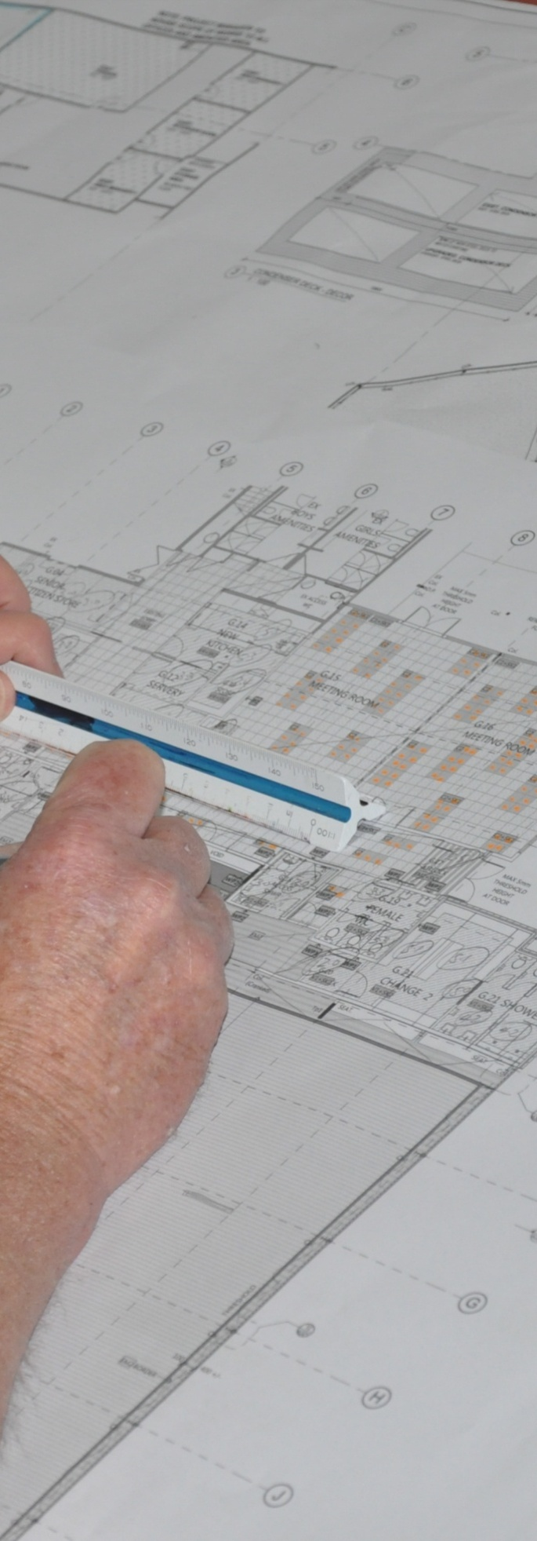

Section 1

Working
drawings

Overview
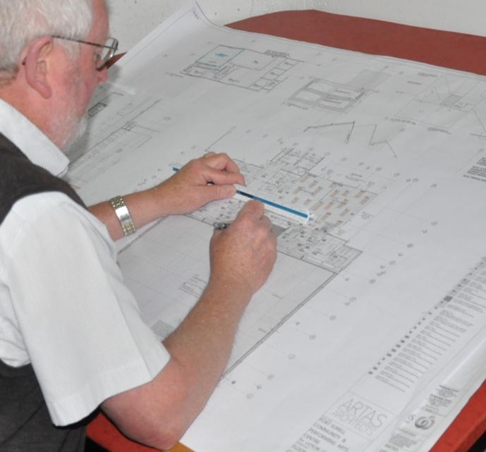
The working drawings for a building or construction project are the plans that specify the design details of a project.
Traditionally, working drawings were always printed onto paper, generally on large sheets that were rolled up to take out to the jobsite.
But these days, drawings and specifications are sometimes provided on a CD, so they can be viewed on a computer screen and printed off when necessary.
In this section, we’ll examine the working drawings you’re likely to come across as a floor layer, and the different parts that make up a set of building plans.

Working through this section

The assignment for this section asks you to interpret a set of plans given to you by your trainer.
Have a look at the Assignment on page 21 to see what you’ll need to do to complete it.
There are four lessons in this section:
- Building plans
- Architectural conventions
- Key information on plans
- Floor covering plans.
These lessons will provide you with background information relevant to the assignment.

Building plans
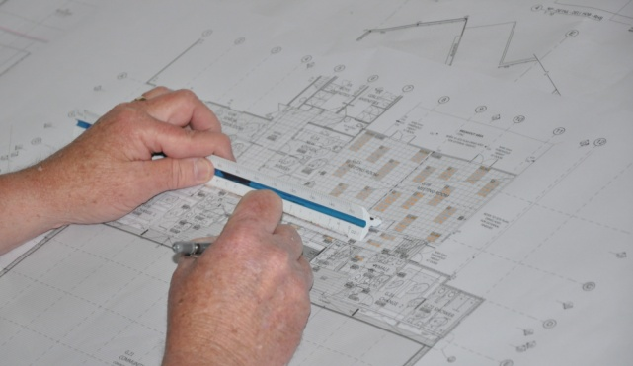
Building plans are called the working drawings for a building because they’re what the various tradespeople use to carry out the work. Often the term ‘building plans’ is simply shortened to ‘plans’.
The main drawings that make up a set of plans are as follows.

Site plan
The site plan shows the whole block of land, or if it is a large acreage, the area of land where the proposed building will go. It also shows the location of the proposed building, together with any other existing buildings or structures.
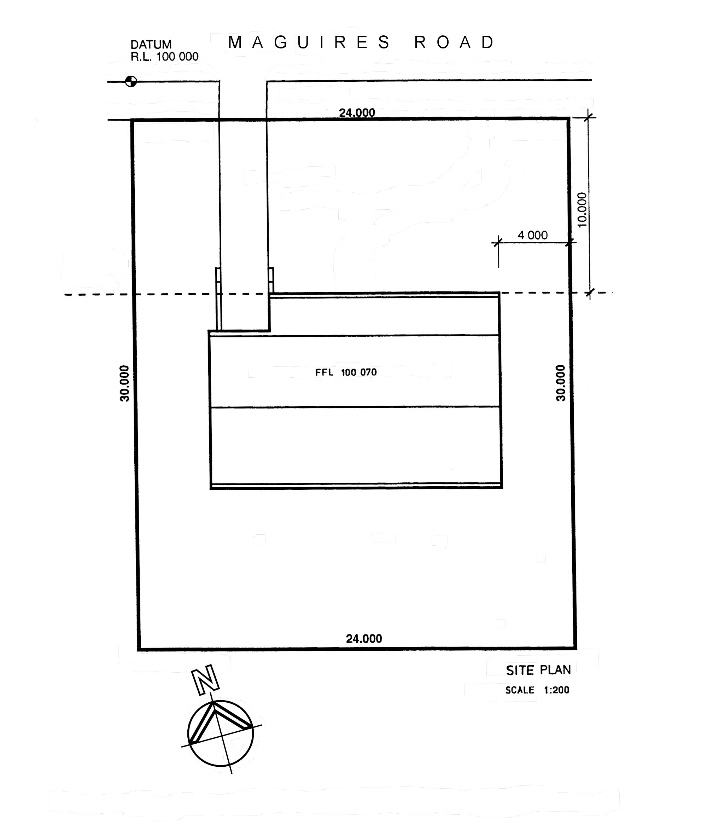
In some instances, it may also show landscaping, driveways, ground levels, mains water, and other information relevant to the work being carried out.

Floor plan
The floor plan gives you a 'bird's eye view' of the floor area. If there is more than one floor, there will be a separate floor plan for each level.
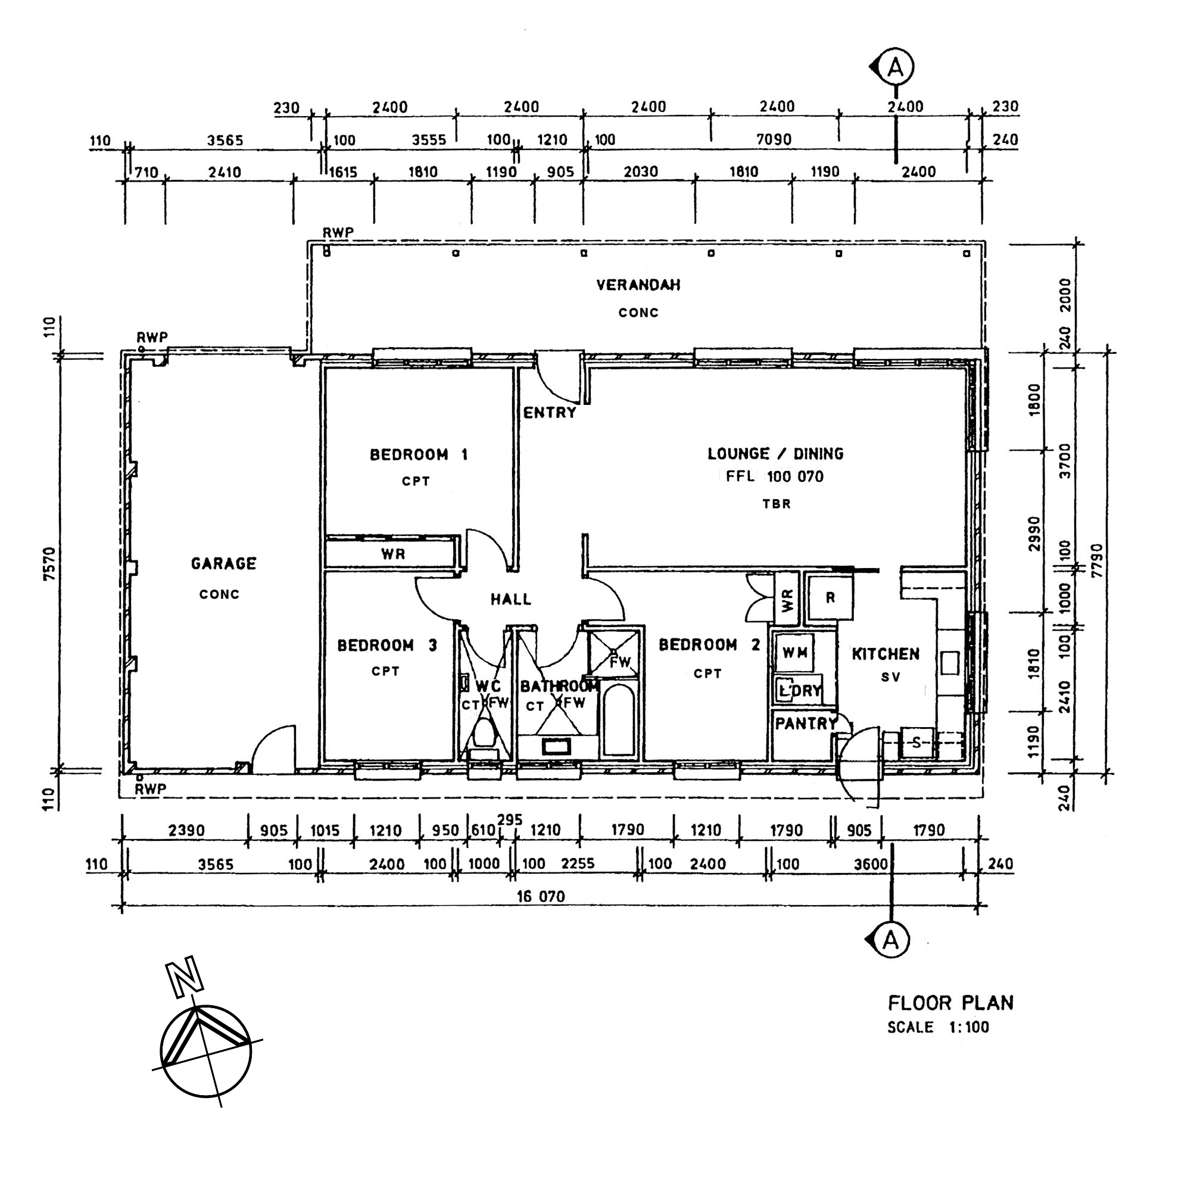
Floor plans show the overall dimensions of the building as well as rooms, openings, wall thicknesses and other important features. They also show certain details of internal features, such as door swings, floor finishes, and the location of fixtures and fittings.

Elevation
An elevation is a side-on view of the building. There are normally several elevations shown in the building plans, because different sides generally have different design features. Each elevation is identified according to the direction that the side is facing, such as 'North Elevation' or 'East Elevation'.
Elevations show height dimensions – in particular the Finished Floor Level (FFL) and Finished Ceiling Level (FCL). Note that the FFL shown in the elevation below is marked as 100.070. This means it is 70 mm (.070 m) above the surveyor’s datum point, which is shown in the site plan (see above) as 100.000.

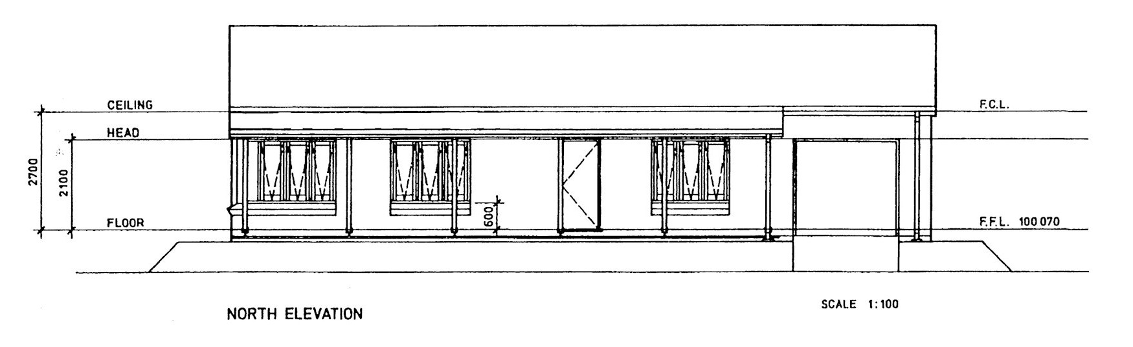
Section
A section drawing looks a bit like an elevation, but it actually shows a cross section through the building. Sections are used to indicate the basic structural characteristics of the roof, walls, subfloor and footings. They also show the floor levels clearly, including any split levels or sunken rooms.
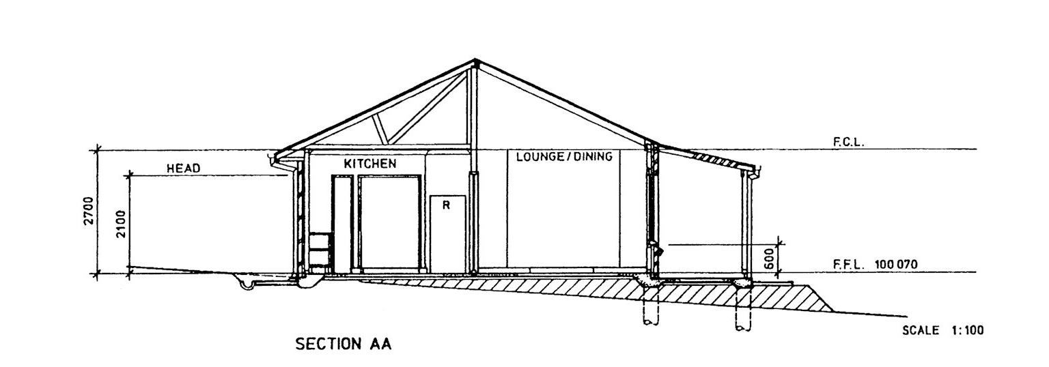
You’ll see that the drawing below is called ‘Section AA’. This means it represents the section view through the invisible line on the floor plan (above) between the two points marked ‘A’.

Detail
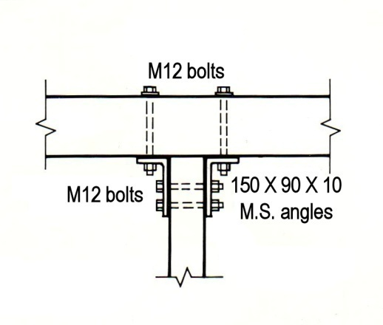
Detail drawings are used to provide a close up view of particular construction details. They are generally drawn as a section through the area or feature.
Some detail drawings show the design and specifications of important structural components. The example at right shows the fixing details for a post supporting a beam, with specifications for the bolt and bracket sizes.
Others drawings might be used to show the fittings and set-outs in certain rooms, such as kitchens, bathrooms and other special purpose areas. These internal elevations would show things like skirting heights, splashbacks, plumbing fixtures, door kickplates and joinery details.

Learning activity

Below is the South Elevation for the house we’ve been looking at in the plans shown above.
The numbers along the roof indicate the different rooms across the back of the house.
Go back to the floor plan on page 7 and find out which rooms correspond to these numbers. Write down your answers in the Workbook.
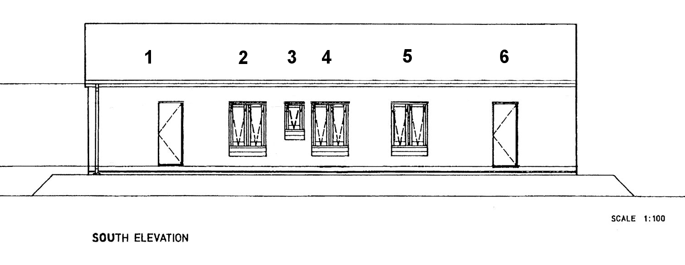

Architectural conventions
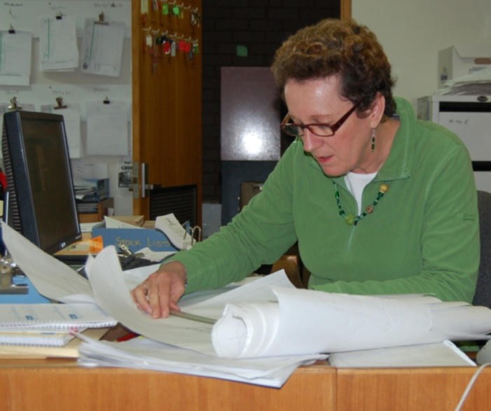
The easiest way to ensure that everyone who uses a technical drawing will have the same understanding of what it's trying to say is to use a standardised 'language' of symbols and conventions.
Different sectors of the industry use their own specialised symbols for details that relate to their specific line of work, however, there are some general conventions that are common to all drawings.
Although these conventions sometimes vary in style, according to the software used or person producing the drawing, the basic concepts remain the same. Below are some examples of standardised architectural symbols.

Lines
Centre line  Long and short dashes, used to indicate geometric centre | 
Visible line  Heavy unbroken line, used to show all visible edges | 
Hidden line  Short dashes, used to indicate edges hidden from view | 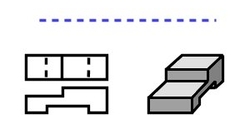
Dimension lines  Two ‘extension lines’ specifying the starting and finishing points of a measurement, and a ‘dimension line’ indicating the distance between them. | 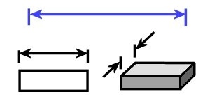
Break  Solid line with zigzag in the middle, used to break the length of a line that is too long to show in full | 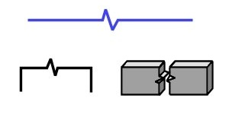
End section  Thin line in a cross to show a piece of timber being viewed in section | 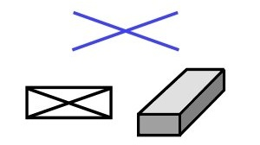

Materials and items
Single brick wall |  | Bath | 
Double brick wall |  | Shower bath | 
Concrete | 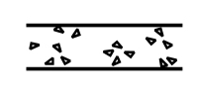 | Shower | 
Earth |  | Hand basin | 
Rock | 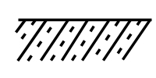 | Vanity basin in benchtop | 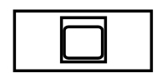
Single swinging door |  | Water closet  (toilet) | 
Double swinging door | 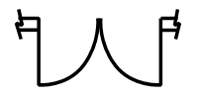 | Single sink | 
Window | 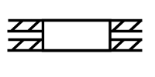 | Double sink | 

Reading two dimensional plans
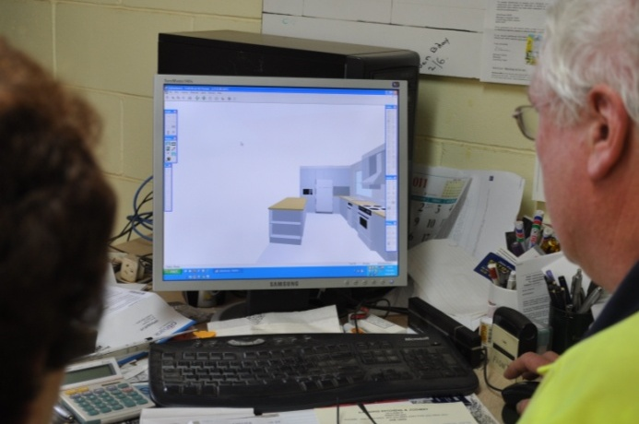
Although clients are often shown three dimensional drawings of what a finished project will look like, the actual working drawings that specify the dimensions and other installation details will always be two dimensional.
In other words, they will either be in plan view (from above), elevation (from the side) or section (a cross section).

Learning activity
As a tradesperson, you need to be able to ‘see’ the different 2D views in your head and be able to match them up with the real world 3D installation area.
Here is an exercise that will help you practise this skill.
Below are three drawings of a kitchen project generated in a computer aided design (CAD) software program. They show a plan view, rear elevation and 3D drawing. Have a close look at the different views and examine the way particular features appear from each of these perspectives.
See if you can do a simple sketch in your Workbook of the floor plan using only the 3D drawing and rear elevation on the next page as a guide. Then turn back to this page and compare your drawing with the floor plan shown below. There is no need to mark in the dimensions, but try to draw to scale as accurately as possible.
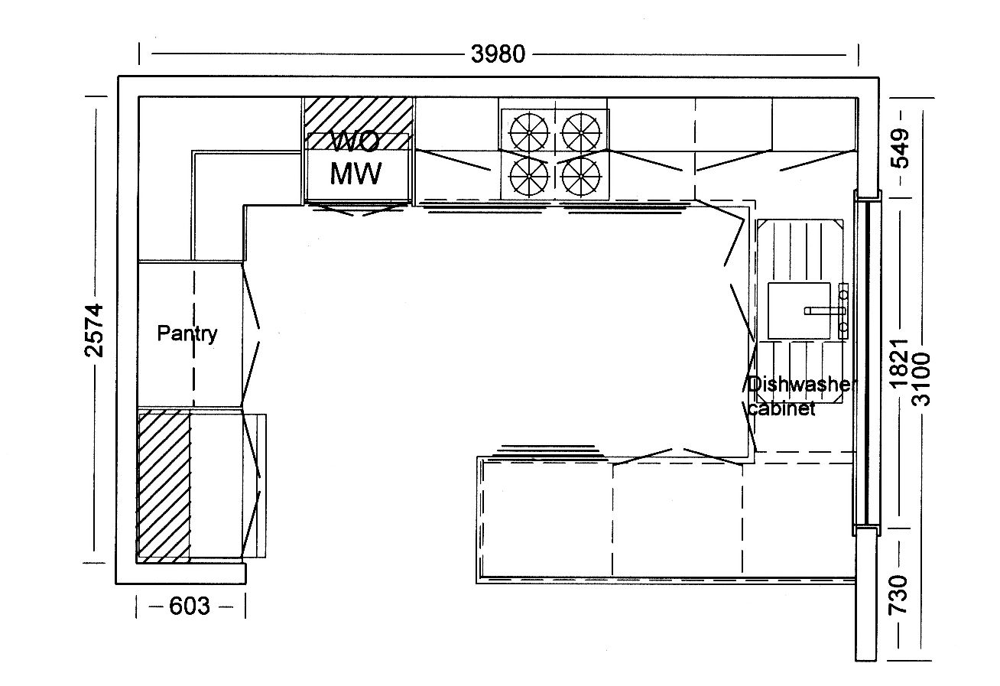

Floor plan
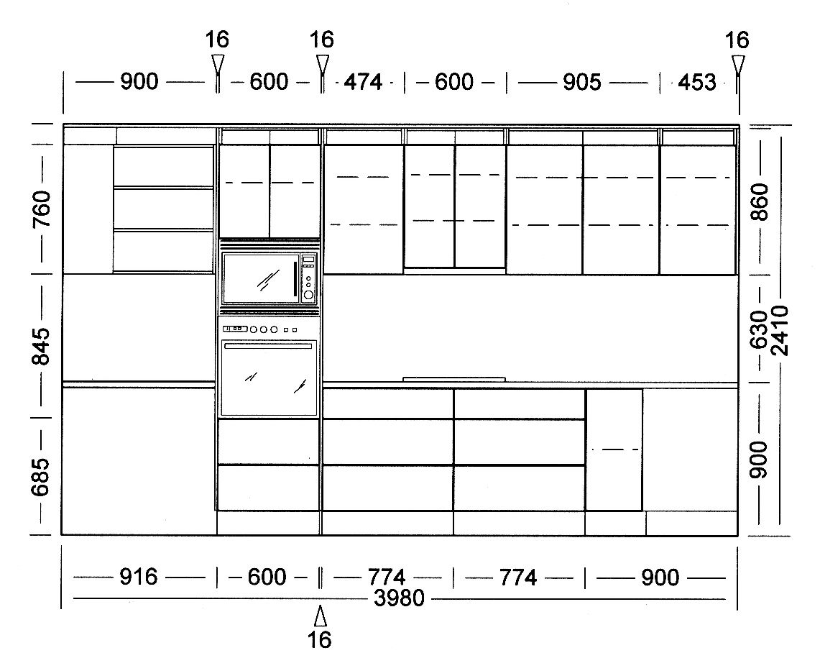

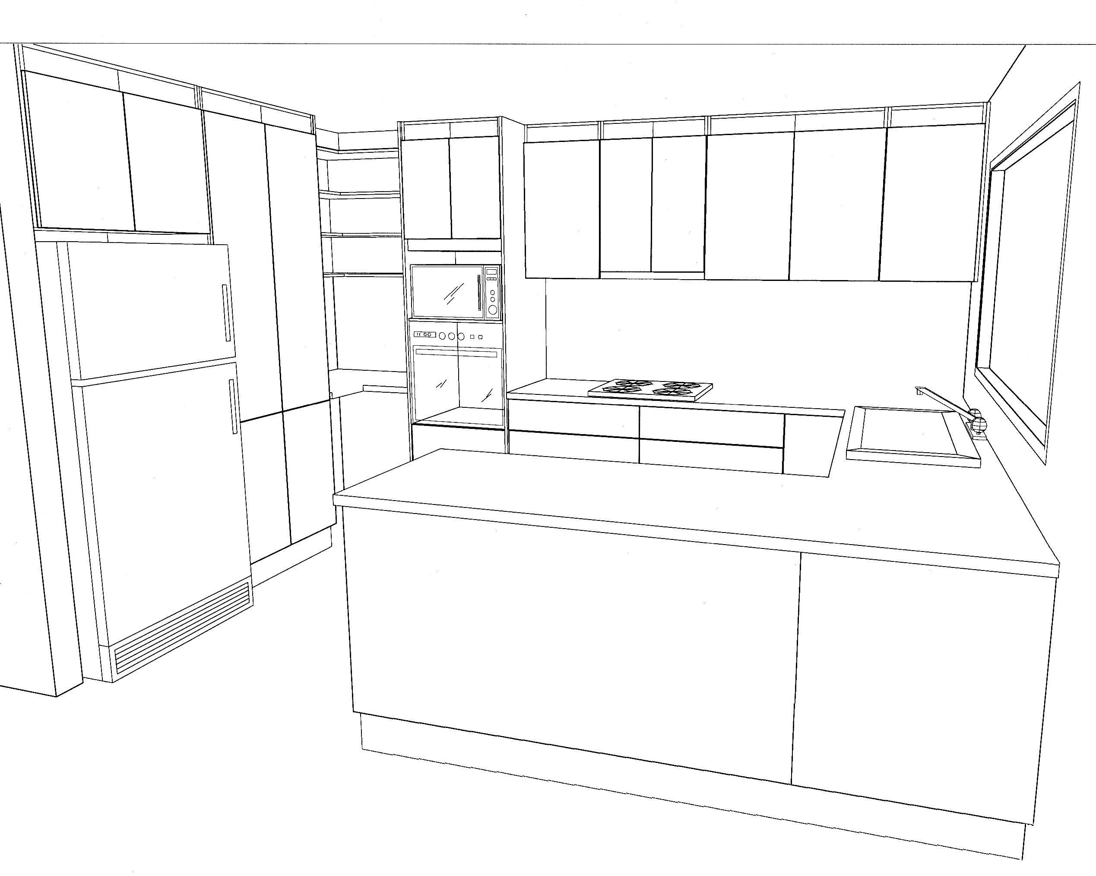
Rear elevation
3 D

Key information on plans
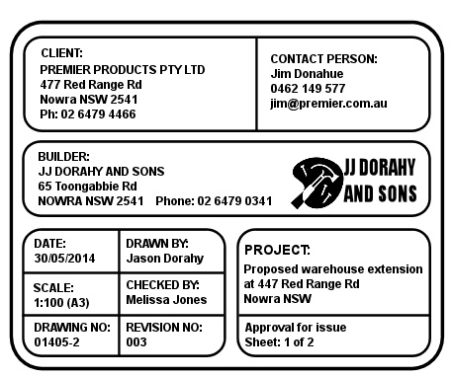
Plans provide a graphic representation of a building or object, together with basic information on dimensions, components and structural details.
We’ve looked briefly at the graphic elements in the previous lesson, so
now let’s turn to the other items of information shown on a plan.

Title block
The title block is generally at the bottom of the page on the right hand side. It contains the title of the drawing, name of the client, name of the architect, builder or contracting company who drew it, date it was drawn, scale and version number. The architect or builder may also add other information, such as their company logo, spaces for people’s signatures and copyright details.
The image above shows an example of a typical title block.

Scale
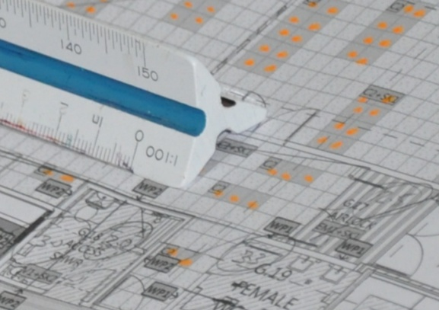
The scale of the drawing refers to the ratio used to reduce the size of the real-life building or object down to a size that can be drawn conveniently on a piece of paper.
Most building plans are printed onto A3 paper, so a scale of 1:100 is generally used for floor plans. This means that every 1 mm on the plan represents 100 mm on the full-sized object.
However, other scales are commonly used for different types of drawings. Below are the most common scales used for A3 plans.
Site plan: 1:200 (or 1:500 if the block is large)
Floor plan: 1:100, 1:50
Elevations: 1:100, 1:50, 1:20
Sections: 1:100 (or less, such as 1:50 or 1:20, if close-up details are shown)
Detail drawings: 1:10, 1:5, 1:2 1:1 (full size)
If you’re not sure about how these ratios work or how they are used in plans, go to Understanding measurements in the unit: ‘Planning and costing’. There is also more information on the metric system in the unit: ‘Making measurements’.

Dimensions
All dimensions in building plans are shown in millimetres (mm).
Although floor layers have typically used centimetres (cm) in their own floor covering plans until recently, the new Australian Standard for resilient floor coverings (AS 1884-2012) now specifies that these plans must also be drawn in mm.
Dimension lines are used to show the starting and finishing points of a particular dimension.
It is normal practice to put overall measurements on the outside dimension line and more detailed internal measurements on the inside lines.

Legend
Plans use lots of abbreviations and symbols to indicate particular features.
Obvious features – such as windows, doors, wardrobes and bathroom fixtures – are shown using standardised symbols, which generally don’t need any explanation in a legend.
However, industrial plans and complex buildings often have specialised or unusual inclusions.
To avoid cluttering up the drawing with terms or phrases written out in full, the symbols and abbreviations used are explained in a legend to one side of the drawing.
Below are some of the more common abbreviations that might appear in a legend.

Abbreviation | Definition | Abbreviation | Definition
AL | Aluminium | GRC | Glass reinforced concrete
AO | Access opening | HW | Hot Water
APF | Acid proof floor | HWD | Hardwood
AW | Acid Waste | IO | Inspection opening
B | Basin | MSB | Main switch board
BHD | Bulk head | O | Oven
BN | Bull nose | PBD | Plasterboard
CD | Clothes drier | R | Refrigerator
CF | Concrete floor | S | Sink
CT | Ceramic tile | SV | Sheet vinyl
CPT | Carpet | SWD | Softwood
BV | Brick veneer | TBR | Timber
CL | Ceiling level | U/S | Under side
CR | Cement render | VB | Vapour barrier
DG | Double glazing | VENT | Ventilator
DW | Dishwasher | VP | Vent pipe
EJ | Expansion joint | VT | Vinyl tile
FD | Fire detector | WC | Water closet (toilet)
FE | Fire extinguisher | WBD | Wall board
FFL | Finished floor level | WI | Wrought iron
FH | Fire hydrant | WM | Washing machine
FW | Floor waste | WMR | Water meter
GM | Gas meter | WP | Waste pipe
GPO | General purpose outlet | WR | Wardrobe

Finishing Schedule
In commercial projects, it’s common for rooms to have similar layouts and products installed, but with different finishes or colours. In these cases, a ‘Finishing schedule’ will let you know which colour goes where.
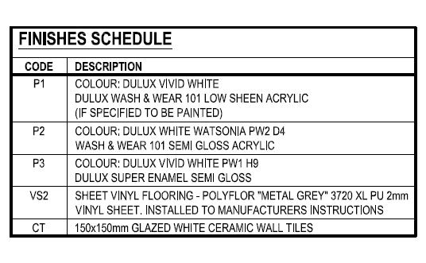
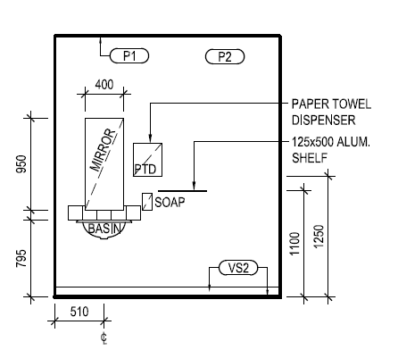

Drawing number
The drawing number is a reference number used by the architect or builder to distinguish the project and working drawing being shown. Sometimes the version control is built into the drawing number, such as ‘.1’ on the end of the number to indicate Version 1. However, it is more common to have a separate version control number or date in a separate box in the title block.
Always make sure you’re referring to the most recent version of a plan unless you’ve been instructed otherwise. Sometimes clients change their mind about certain details, or discover that particular materials are not available or the council has imposed new conditions on the project.
You don’t want to end up completing an installation only to find out that the specifications had changed before you started and you weren’t aware of it!

Learning activity
Below is an excerpt from the floor plan we looked at on page 7.
See if you can name all the items that are shown in an abbreviated form. Try to do it without referring to the abbreviation list on the previous page. Then check your answers against the list.
Write your answers in the Workbook.

Abbreviations
FW R
S WC
WM WR
CT CPT

Floor covering plans
The building plans for a project are designed to provide the trades and services with general information relating to the design, structure and dimensions of the building.
But they don’t provide sufficient details for the specialist installers to carry out their own work on the project.
Electricians, plumbers, kitchen and bathroom installers, tilers, floor layers and various other trades still need to have their own specialised plans.
These indicate the client’s selection of products to be installed and the positioning of service outlets, trims and other features. In the case of floor layers, these sorts of details are shown on a floor covering plan.

Parts of a floor covering plan
A floor covering plan consists of a proportional sketch or scale drawing of the floor area, together with information on:
- subfloor preparations and underlays required
- floor coverings to be installed, including product names, patterns and colours
- positioning of seams and joins
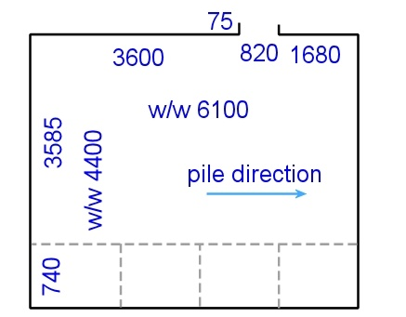
- direction of the pile
- types of accessories used
- any special features of the job.
At right is a simple example of a floor covering plan, showing the seams, pile direction and measurements in millimetres. The abbreviation ‘w/w’ refers to the overall ‘wall to wall’ dimensions of the room.
You can see that the measurements are set out differently from the building plans we looked at earlier. In those examples, the dimensions were shown around the outside of the drawing, next to their own sets of ‘dimension lines’.
But on the floor covering plan the dimensions are written on the inside, directly beside the wall they refer to. This is because a floor layer needs to know all measurements of a room when they’re working out the best fit for a covering material, including the dimensions of any recesses, projections, and returns.
For more information on floor covering plans, see the 'Planning and costing' unit. You'll find various lessons relating to the different components of a floor covering plan and details on how to produce them.

Learning activity
Have a go at drawing up a simple floor covering plan for yourself. Go back to the building plan on page 7 and do a line drawing of Bedroom 3 in the style of a ‘proportional sketch’. You can either draw it freehand or use a ruler.
Mark in the measurements on the inside of the walls, taking the dimensions off the building plan. Do the exercise in your Workbook, and show it to your trainer when you’ve finished.
If you want a more challenging room, choose one or more of the other rooms in the building plan. If you’ve got a tape measure to hand, you may even want to draw up the room you’re sitting in right now.

Assignment 1
Your trainer will give you a set of plans for a floor covering project. You will be asked to find the answers to a range of questions about the project by referring to the plans.
The questions will cover the following details:
- types of floor coverings to be installed
- dimensions of specific rooms
- widths of doorways and other openings
- which way the doors swing (that is, which side the hinges are on)
- structure of the walls and floor
- various details about the floor covering installation.

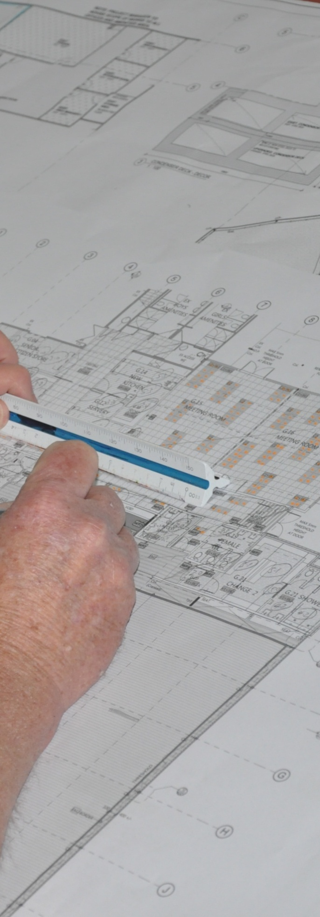

Section 2

Other documents

Overview

In addition to the working drawings for a project, there are many other documents you need to consult in order to know what the specifications are for the job, and how you should go about doing it.
These include Australian Standards, project specifications and cutting lists.
We’ll look at these types of documents in this section, along with various other forms and checklists that go hand-in-hand with the process of working safely and compying with company policies and legal obligations.
We’ll also discuss methods for cross-checking the documents you’re consulting and making sure they’re properly looked after and kept on file for future reference.

Working through this section
The assignment for this section asks you to describe 10 different workplace documents that you refer to at work.
Have a look at the Assignment on page 42 to see what you’ll need to do to complete it.
There are four lessons in this section:
- Standards and specifications
- Work procedures
- Planning and checking
- Maintaining files.
These lessons will provide you with background information relevant to the assignment.

Standards and specifications
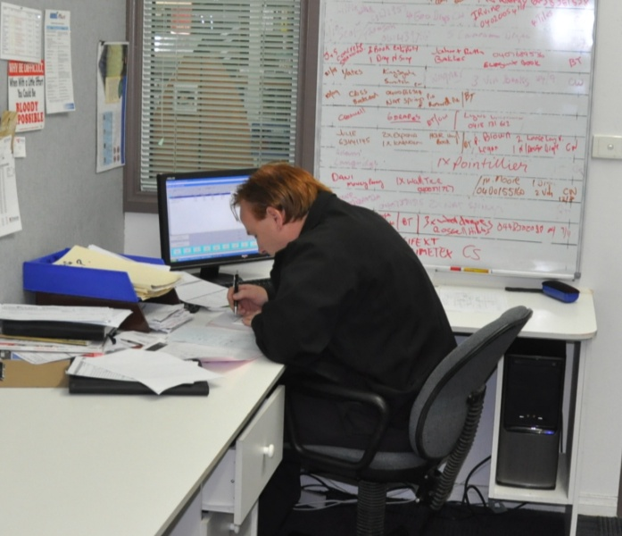
Standards and specifications are documents that set out the quality requirements, construction details and workmanship of a product or on-site installation.
When all aspects of an installation meet the standards that apply to the project, it can be considered a 'good quality' job.
Let’s look at the main standards and specifications you’re likely to come across in your installation work.

Australian Standards
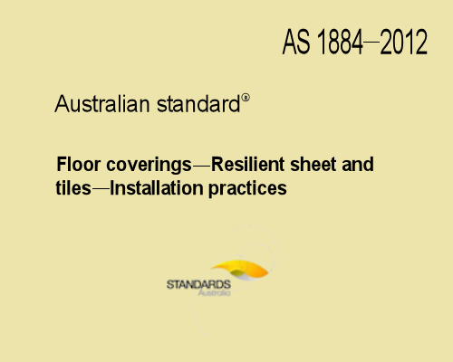
There are literally thousands of Australian Standards, covering everything from consumer products to building construction to environmental care.
They are developed by a non-government organisation called Standards Australia.
The Standards in themselves are not laws. However, when they are referred to in contracts or building regulations for work to be performed, they become legally binding.
This means that if a contract with your client or a local council regulation says you must comply with AS 1884-2012: Floor coverings – Resilient sheet and tiles, then you are required by law to meet the specifications contained in that standard.
The code at the front of the standard is read in the following way:
AS abbreviation for Australian Standard (note that AS/NZS means Australian / New Zealand Standard)
1884 identifying number
2012 year of issue
Below are the main Australian Standards that relate specifically to flooring covering installation:
AS 1884-2012 Floor coverings – Resilient sheet and tiles – Installation practices
AS 2454-2007 Textile floor coverings – Terminology
AS/NZS 2455.1-2007 Textile floor coverings – Installation practice – General
AS/NZS 2455.2-2007 Textile floor coverings – Installation practice – Carpet tiles
AS/NZS 2914-2007 Textile floor coverings – Informative labelling
AS 3740-2010 Waterproofing of domestic wet areas
AS 4288-2003 Soft underlays for textile floor coverings
AS/NZS 4858-2004 Wet area membranes


ISO Standards
ISO Standards are developed by the International Organization for Standardization, based in Switzerland. The organisation is made up of 164 member countries, with many different languages represented, so the title ‘ISO’ is designed to signify the name regardless of the language it is written in.
ISO is best known in Australia for its Standards on quality management (the ISO 9000 series) and environmental management (the ISO 14000 series). But you may come across other Standards in your work as a floor layer, including fire testing of textile floor coverings and sustainability in building construction.

Building Code of Australia
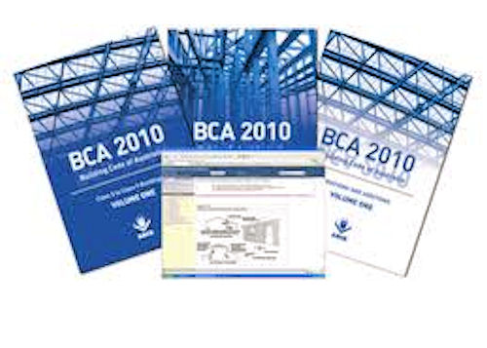
The Building Code of Australia (BCA) forms part of the National Construction Code, developed by the Australian Building Codes Board.
It sets out the technical requirements for all areas of building, from design through to construction, and has been given the status of building regulation in all states and territories.
There are many references in the BCA to Australian Standards. Because the BCA is used as the basis of local council building regulations, these Australian Standards become part of the regulation wherever they are referenced.

Building specifications
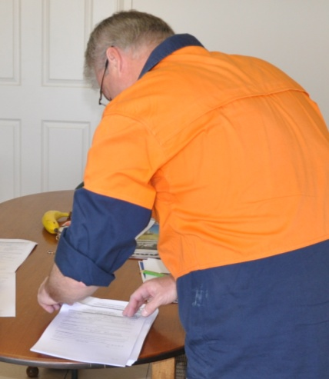
On building projects that require council approval, there will be a specification document that accompanies the plans.
This will set out the details for all technical aspects of the work to be undertaken, including materials and installation to be used.
It will also reference the relevant Australian Standards, BCA clauses and other regulations that apply to the work.

Other standards and codes
There are various other standards and codes of practice that on-site workers might need to comply with when they’re carrying out installations. These include:
- enterprise standards – used by companies to refer to their own internal set of standards they have developed for particular products or installation techniques
- manufacturer’s instructions – issued by product manufacturers to advise installers and end-users on how to install and care for the products
- codes of practice – developed by WorkCover, industry bodies and other organisations as ‘approved’ ways of going about particular types of work.

Learning activity
Which Australian Standards do you need to refer to in your day-to-day work?
Are there any other standards you use that aren’t listed above? What are they?

Work procedures
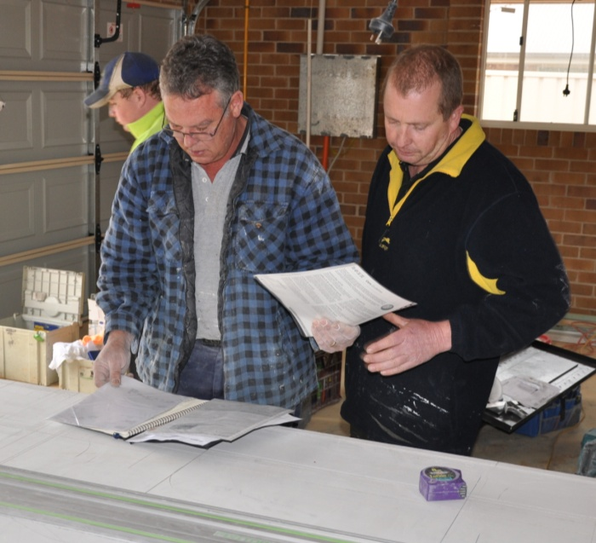
There are many types of documented work procedures.
Some are designed to provide safety guidelines for using certain types of equipment or products that are hazardous. Others are used to specify material quantities, finished sizes and cutting lists.
These documents are normally based on a template format, setting out the information in a standardised layout with fixed subheadings.
The advantage of a template is that you always know where to look to find the information you’re after, even though the details differ from one example to another.
Below is a summary of the main types of documented work procedures you’re likely to use in the floor covering industry. You’ll find more information on the various safe work procedures in the unit: Safety at work.

Cutting list
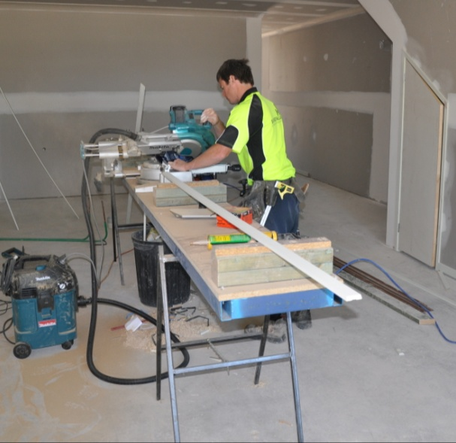
Cutting lists can be laid out in lots of different ways, depending on the material you’re cutting and the task you’re doing.
For example, if you were cutting skirting boards or trimming sheets, you may list the different lengths that need to be cut and the number of pieces required at each length.
There could also be times when you are given full rolls of floor covering for a large job and you have to make up your own cutting list to get the best recovery on the material.
‘Recovery’ refers to the amount of good pieces you are able to cut from of a roll, with the minimum of waste, by working the measurements you need into the roll lengths available.

SOP
The purpose of a safe operating procedure (SOP) is to describe how to use a machine or carry out the task safely and in accordance with the company’s policies and manufacturer’s guidelines. The sample SOP below has a typical layout, with an activity description that defines the task, a list of potential hazards and safety controls, a set of pre-start checks, and a brief operational procedure.
Nail gun SOP
Activity description
Covers pneumatic nail guns used for fixing fasteners into timber

Potential hazards and safety controls
Hazard | Control
Eye injuries | Wear safety glasses while using and handling the gun
Hand and body injuries | Keep free hand clear of the discharge area while firing  Avoid nailing into knots or unsound timber  Do not skew nail or fire too close to edge of material  Always remove finger from trigger when not firing  Always disconnect air hose immediately after use
Noise | Wear hearing protection when using gun and handling air hose

Pre-start checks
- Safety mechanism and trigger are moving freely, and all retaining screws are secure
- Airline and fittings are in good working order, and free from tangles and leaks
- Nail cartridge is free from obstructions

Operational procedure
- Insert nails into the magazine
- Pull the spring-loaded feeder shoe back and allow it to click into place
- Position the safety element against the work surface and pull the trigger to fire.

SWMS
A safe work method statement (SWMS) is a formal document that lists all the tasks involved in completing a job and describes how the hazards will be controlled. On building sites they are mandatory for 'high risk construction work'. However, on some sites all contractors are asked to complete a SWMS before they start work – including flooring installers.

Safe Work Method Statement
Organisation details
Name | Flooring Ideas Pty Ltd | Contact | Sam Trujulio
ABN | 38 111 222 333 | Position | Director
Address | 38 Sampson Close, Dalby Qld 4405 | Phone | 0403 777 777

Project details
Project | Bob and Denise Williams, 13 Western St, Dalby Qld 4405
Activity | Lay vinyl floor covering on a concrete subfloor
Equipment | Electric grinder, roller, hand tools, vacuum cleaner
Maintenance checks | Check tools for damage or signs of excessive wear before using them  Check power leads for damage’ and make sure electrical inspection tags are current
Materials | Sheet vinyl floor covering, Ardex K 15 compound, Fabgrip Hi-Tac 2003 adhesive

Legislation and standards: All work is in compliance with the following legislation and standards
Legislation | Work Health and Safety Act (2011)  Work Health and Safety Regulation (2011)  Environmental Protection Act (1994)
Standards | AS 1884-2012: Floor coverings – Resilient sheet and tiles – Installation practices

Activity | Hazards | Control measures
Deliver materials to site | Back injury, strained muscles,  slips and falls | Use good manual handling practices  Use an offsider to help carry large rolls of floor covering or other awkward items  Clear walkways and access ways before moving materials  Wear work boots and appropriate clothing
Grind concrete floor | Electric shock | Check power leads and plugs for damage  Check that testing tags on electrical tools are up-to-date
Grind concrete floor | Hearing damage | Wear hearing protection when using grinder and when working in noisy areas
Grind concrete floor | Eye injury | Wear safety glasses when operating grinder
Grind concrete floor | Dust inhalation | Wear a dust mask when grinding and sweeping up  Use a vacuum cleaner where possible to pick up dust
Mix and install K15 smoothing compound | Dust inhalation | Wear a dust mask while mixing K15
Mix and install K15 smoothing compound | Strains and sprains | Use good manual handling practices  Wear knee pads
Cut vinyl to size | Cuts to hands | Use safe knife handling and cutting techniques  Maintain correct stance and positioning of materials
Apply adhesive | Muscle strains | Maintain comfortable position and controlled trowel movements  Wear knee pads
Apply adhesive | Inhalation of fumes | Ensure ventilation is adequate  Use a fan where there is poor cross-draught
Apply adhesive | Skin irritation | Use gloves when excessive skin contact is likely  Wash hands and exposed skin when finished
Lay vinyl | Trips, muscle strains and back injuries | Remove all unnecessary materials and tools from area  Work methodically across the floor  Wear knee pads  Use good manual handling techniques

Training required
Qualifications | All installers must hold the Certificate III in Flooring Technology, or be working under the direct supervision of a person who holds this qualification
Training | All personnel on-site must hold the WorkCover White Card  All personnel on-site must complete the site induction prior to starting work

Sign-off: This SWMS has been developed in consultation with our workers and has been read, understood and signed by all workers undertaking the job
Name | Position | Signature | Date
Sam Trujulio | Manager | STrujulio | 25/2/13
Cyril Simons | Installer | Cyril Simons | 25/2/13
John McFarlane | Installer | John McF | 25/2/13
Peter Adams | Delivery driver | Peter Adams | 25/2/13

MSDS
A material safety data sheet (MSDS) – also called a safety data sheet (SDS) – is a summary of the safety procedures you should follow when using or handling a hazardous product, and the main health issues relating to it.
There are some variations in layout between different manufacturers’ MSDS, but they all have the same sorts of subheadings. The example below shows the first 2 pages of a 14 page MSDS for Ardex K15 levelling compound.

Learning activity
We’ve discussed SOPs, MSDSs and SWMSs in other units in the Flooring Technology resource. But we haven’t talked specifically about cutting lists elsewhere.
Do you use cutting lists for any products? For example, you might use them to pre-cut inlay pieces or pre-formed coving.
Or on larger jobs you might use them to cut rolls of material to a range of different lengths.
Describe the situations where you have used a cutting list and what it looked like.

Planning and checking
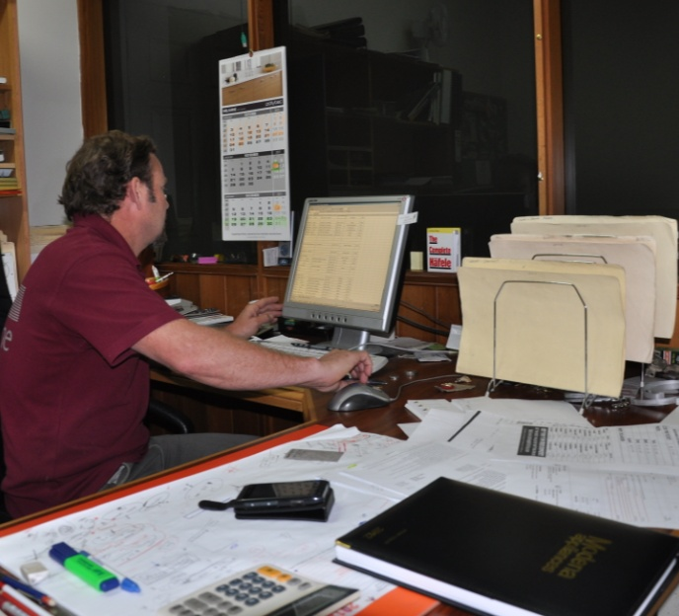
Good quality documentation helps you to visualise the project you’re about to start and mentally go through the steps involved in completing it.
If it’s a complex job, you should always document the steps in some form of work plan, such as a project schedule.
This will let you work through all the preparations required and determine how you will tackle the various tasks involved and what sequence you’ll do them in.
But even the simplest of jobs require planning, because you still need to know in advance what tools, materials and people will be needed, and what sequence you’ll follow. The only difference is that you don’t have to think as carefully about all the possible variables or potential problems, and you may not need to draw up a formal work plan.
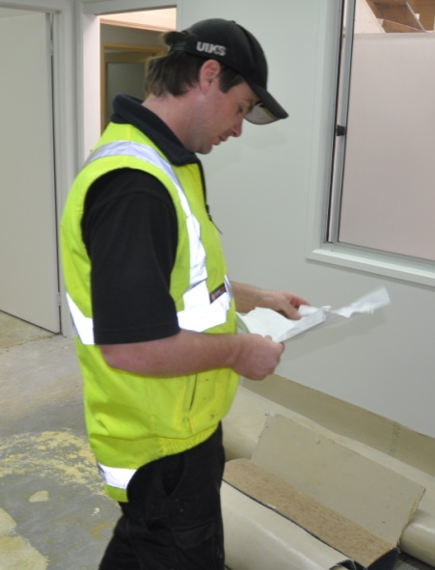
Good quality documents also allow you to check your work at various stages throughout the project to make sure everything is on track and in accordance with the job specifications.
This helps to avoid the problem of a small mistake turning into a big problem as the error starts to throw everything out of alignment.
Below are some of the things you should consider when you’re reading and checking work documents at different stages of a job – firstly, before you start, and secondly, once the project is underway.

Before you start the project
While you’re still in the planning phase of a project, ask yourself the following questions as you read the documents and cross-check the details.

- Are all the units of measure consistent?
You may find that some documents show measurements in centimetres and others in millimetres. If you’re using imported products or materials there may even be imperial measurements you’ll need to convert across to metric.
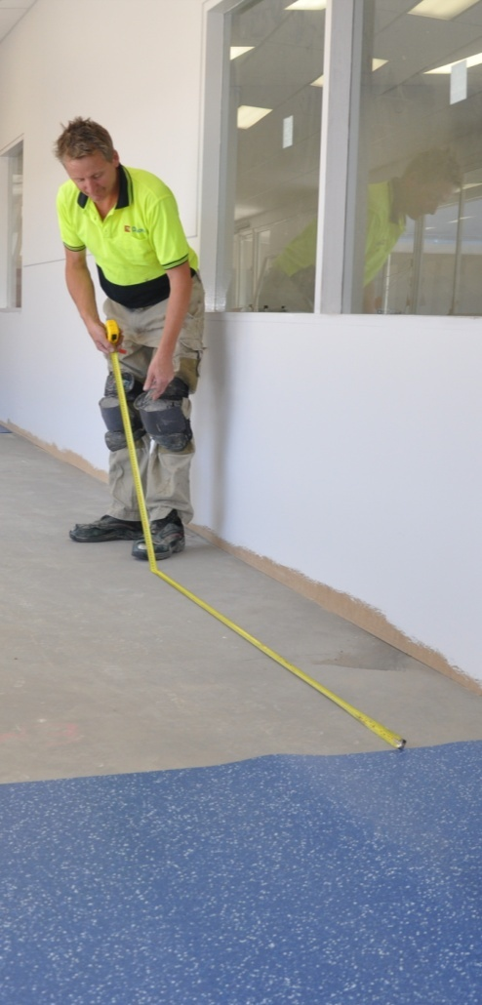
- Are the measurements accurate?
Never rely on building plans for precise measurements. The actual positioning and dimensions of walls and other structural features could vary from those shown on the plans.
If you need to do calculations with accurate measurements, make sure you take the figures from physical on-site measure-ups.
- Are the documents the latest version?
Plans, schedules, specifications and other project documents can change over time.
Sometimes it’s because the client has changed their mind. Other times it might be because certain materials are no longer unavailable or too expensive, or because new regulations have been imposed.
Always check that the version you have been given is the latest version before you go ahead with any work.
- Are the details consistent between documents?
Check that the product type, colour and any other features are consistent between the plans, specifications and your own internal project documents. If there are any discrepancies between the documents, make sure you find out why. It could be due to an error in writing up one of the documents, or because a document is out of date and the details have since changed.

While the project is underway
Once the project starts, you should keep any necessary plans, specifications and other technical documents on hand to re-check your work and the materials you’re using at various key stages.
Questions you should ask yourself include the following:

- Are the set-out marks correct for the work about to be done?
Once you’ve marked your set-out lines on the walls and floor, double-check them against the reference drawing before you physically install the products. It’s also good to re-check levels, alignments and measurements periodically throughout the installation, just to make sure everything is staying true to the plan.
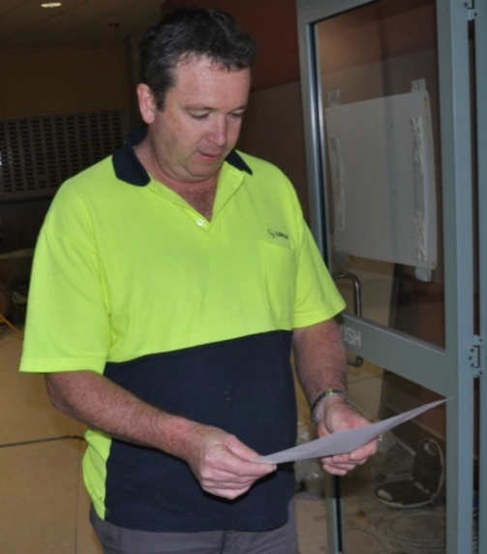
- Do the products to be installed match the description on the written documentation?
Sometimes a warehouse order person will misread the order form when preparing or loading the products.
Mistakes could be very easy to make, such as selecting the wrong colour or finish, or getting two similar orders mixed up.
If you’ve accidentally taken the wrong products with you, this is your last chance to correct the mistake before it's too late.
- Do the installation methods follow the manufacturer’s guidelines?
Most products are backed up by a manufacturer’s warranty, which means that if something goes wrong and the product is at fault, the manufacturer will support you. But if it turns out that you haven’t followed the manufacturer’s instructions – you could find that you’re on your own.
Always use the recommended installation techniques unless you’ve got a very good reason not to.
If you’re worried that an adhesive or fastener or particular technique is not compatible with the product you’re about to install, check the guidelines before you proceed. If you haven’t got a copy of the guidelines with you, ring the manufacturer on the spot and ask to speak to a technical advisor.

Learning activity
There may be times where you find a discrepancy between two documents, or see something that looks like a mistake in a plan or specification.
Has this ever happened to you? What were the circumstances? Who did you check with to resolve the problem?
If you haven’t had this experience, describe what you would do if you found a problem in the plans or specifications you were working with.

Maintaining files
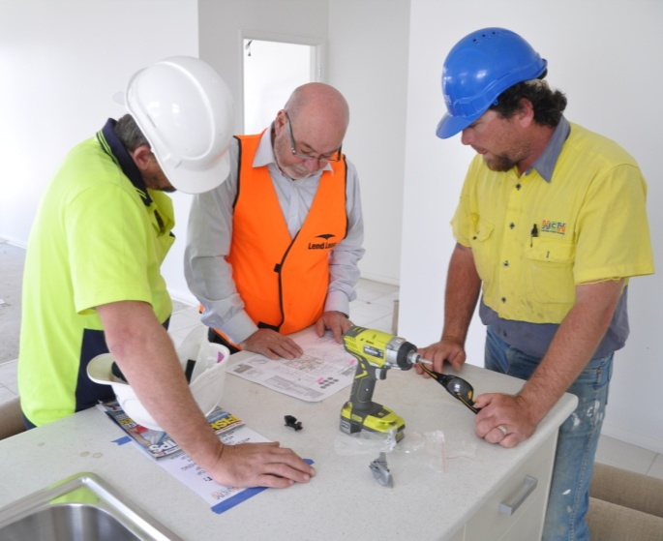
It’s true that most documents these days are kept electronically on the company’s main server or hard drive back at the office.
But it’s just as true that when you’re out working and need to consult a particular document or check on a detail, it’s best to have it on paper.
There are also many site documents you’ll receive from your clients that are only provided in a hard copy version.
Paper has its advantages and disadvantages. Its biggest plus is that you can carry it with you and have it on hand wherever you are. Its biggest minus is that it’s a physical item that can easily get damaged or lost.
You also need to be very careful if you’ve got several copies of a document that you make sure all copies are updated when you change details or add new information. This applies to both paper and electronic versions of a document – which is why a version control number or date is so important.
Set out below are some of the ways work documents are maintained and filed.

Building plans

Most local councils specify that building plans must be printed on A3 paper or larger. This means that if you’re given full sized copies, they will either be rolled up or folded multiple times.
In the office, you can lay out full sized plans on a large table or drawing board. When you’ve finished with them, they can either be hung up or put in a plan drawer to keep them flat.
If you’re taking the plans to a jobsite, it’s best to roll them up and keep them on the seat of the car, away from tools or materials that might crush them. While you’re on-site, try to keep them rolled up and out of harm’s way unless you’re actually looking at them – and don’t let other people handle them unless their hands are clean!

Detail drawings and installation plans
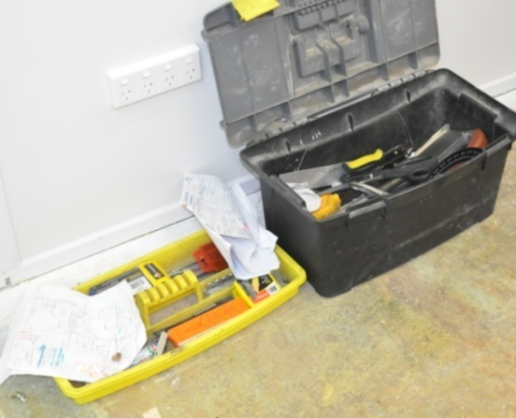
Your own company’s detail drawings, installation plans and job sheets are likely to be computer generated and printed on A4 paper. These can be kept in a folder and stored in your briefcase or toolbox.
If you make important notes on them or change any details, always make sure you tell the appropriate person back at your office, because they may need to update the electronic files.
Keeping files up-to-date is important, even after the job has been completed, because the client may contact your company at some time in the future to discuss the details of the project. For this reason, the paper documents are sometimes filed away in addition to have the electronic copies backed up on a hard drive.

Safe work method statements
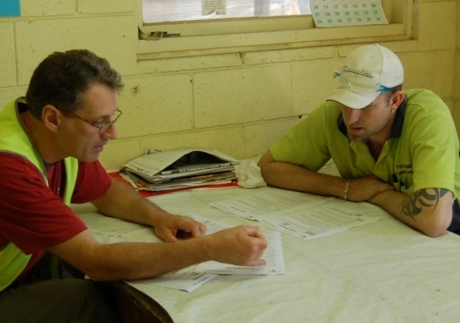
Safe work method statements (SWMSs) need to be kept on-site and signed by everyone involved in the installation.
If it’s your job to look after these documents, you should store them in a file in your briefcase. On large jobsites, the safety officer or site manager may ask to look at them at any time, so they need to be readily available.

Safe operating procedures
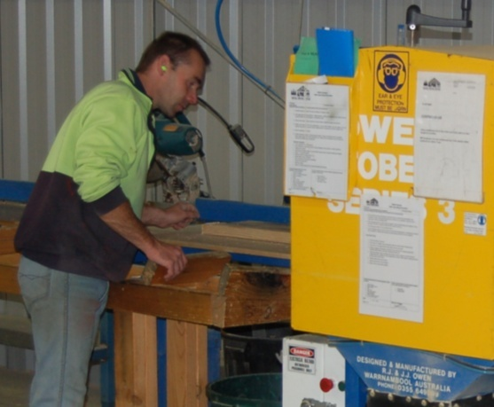
In workshops and on factory floors, each static machine often has its own safe operating procedure (SOP) posted up on a wall nearby or on the side of the machine itself. The SOP is generally laminated to keep it clean.
On-site, there may be separate SOPs for power tools and hazardous tasks. Sometimes these are referenced in the SWMS, which means they should be kept together in the same file.

Material safety data sheets
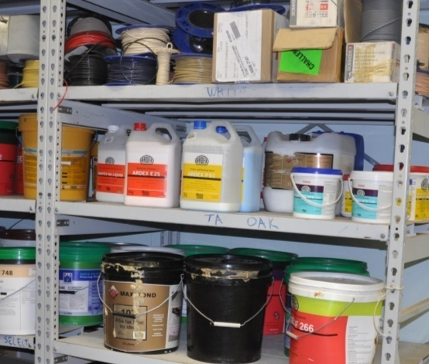
Like SOPs, material safety data sheets (MSDSs) need to be kept on hand wherever the hazard exists.
In the workshop or on the factory floor, some companies like to produce one-page summaries and post them up on the wall where the hazardous substances are being stored or used. Alternatively, they are kept in a file that workers can easily access.
On-site, the MSDSs should be kept with the SWMS and SOPs. But again, other workers need to know where these documents are, because if there is a chemical spill or medical emergency, it’s no good having this reference document filed away and well hidden.

Learning activity
Are you responsible for filling in particular documents at work? What are they?
Name each document and briefly describe its purpose and where you store it when it’s not being used.

Assignment 2
Go to the Workbook for this unit to write your answers to the questions shown below. If you prefer to answer the questions electronically, go to the website version and download the Word document template for this assignment.
___________________________________________________________________
List 10 different types of documents that you use at work. There must be at least one example of each of the following documents:
- Australian Standard
- manufacturer’s installation guidelines or technical manual
- material safety data sheet
- work plan, project schedule or equivalent
- building code or project specification
- safe operating procedure or equivalent
- safe work method statement, job safety analysis or equivalent
For each of the documents you have chosen, answer the following questions:
- What is the full title of the document?
- What is its purpose?
- Who is responsible for looking after it and making sure the employees are using the latest version? (Give the job title of the person, not their name.)
- What is the version control system – that is, how do you know you’re looking at the latest version?
- Where is it kept at your workplace, and if there are multiple copies, who has copies? (Give the job titles of the people who have their own copies.)
- Who would you consult if you were out on-site and had a query about a detail in the document? (Give the job title or role of the person you would consult.)

