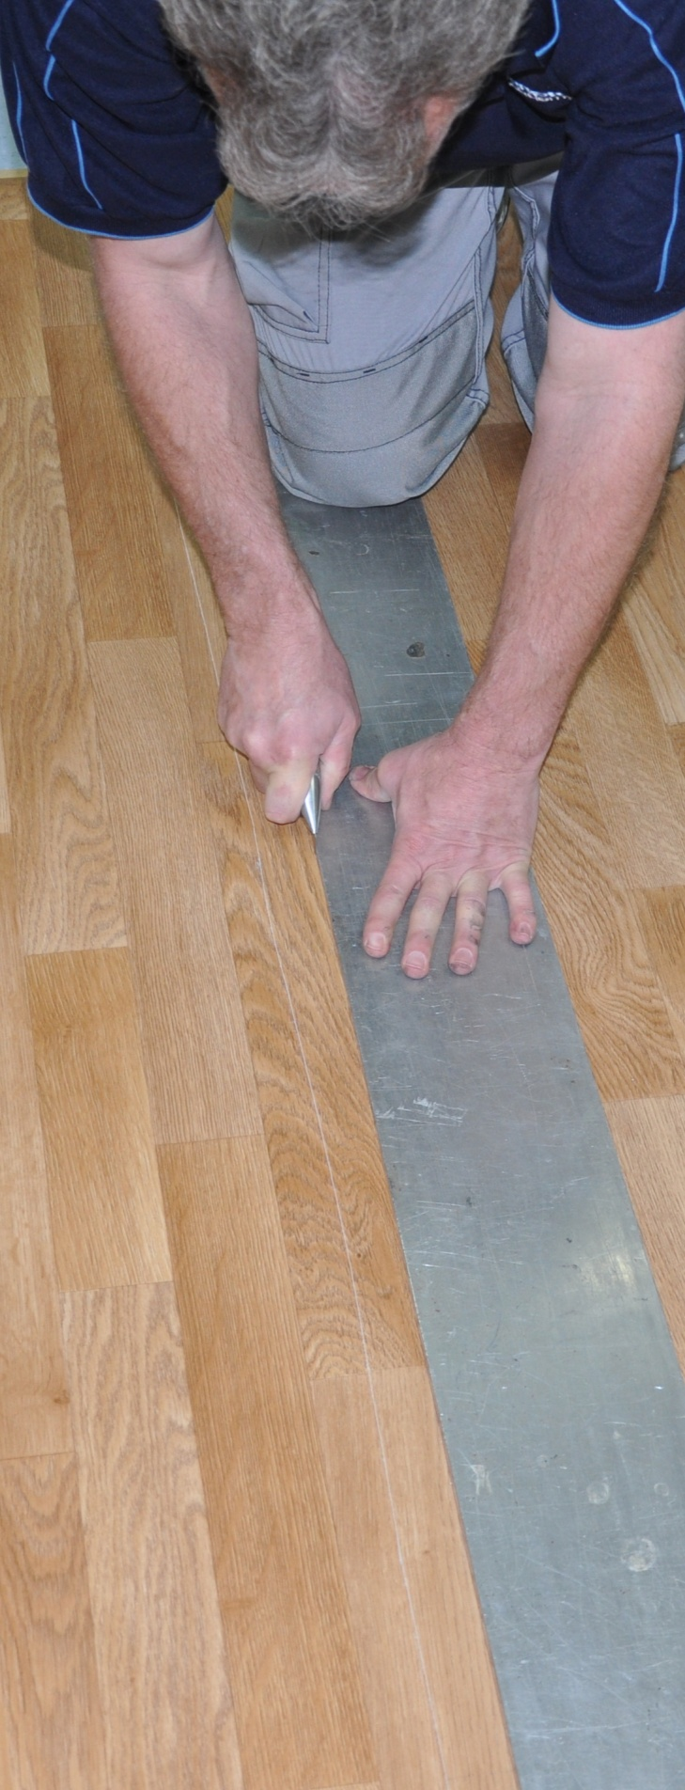
Lay flat vinyl
DRAFT VERSION
October 11
Learner guide


Supporting:
LMFFL2301A: Install lay flat vinyl floor coverings

Developed in 2012-2013 for the WELL Program

Lay flat vinyl
Learner guide

This unit is also available in an e-learning format, which contains additional photos, interactive exercises and a voice-over narration of the text. It can be viewed on CD-ROM, or live on the web at:
www.flooringtech.com.au


Developed by Workspace Training for the 2012-2013
Workplace English Language and Literacy (WELL) Program
Flooring Technology resource development project





Copyright and disclaimer
ISBN: 978-1-925087-02-4
Funded under the Workplace English Language and Literacy Program by the Australian Government through the Department of Industry, Innovation, Climate Change, Science, Research and Tertiary Education
© Commonwealth of Australia 2013

CC BY-NC-SA
This work is copyright. Except where otherwise indicated, and save for the Commonwealth Coat of Arms, the Department has applied the Creative Commons Attribution-Noncommercial-Share Alike 3.0 Australia Licence to this work.
The Department of Industry, Innovation, Climate Change, Science, Research and Tertiary Education must be attributed as the author of the Department’s copyright material.
As far as practicable, material for which the copyright is owned by a third party has been clearly labelled. The Department has made all reasonable efforts to ensure that this material has been reproduced in the print-based resources and accompanying website with the full consent of the copyright owners.
Requests and enquiries concerning the Department’s copyright material should be addressed to:
The Legal Branch
Department of Industry, Innovation, Climate Change, Science, Research and Tertiary Education
GPO Box 9839 Canberra ACT 2601
Email: legalservices@innovation.gov.au
Questions about the design and content of the resource itself should be addressed to the project manager:
David McElvenny
Workspace Training
PO Box 1954 Strawberry Hills, NSW, 2012
Email: david@workspacetraining.com.au

Disclaimer
The content of this Learner guide is provided for educational purposes only. No claim is made as to the accuracy or authenticity of the content. The views expressed in this publication do not necessarily represent the view of the Minister for Tertiary Education, Skills, Science and Research or the Australian Government. The Australian Government does not give any warranty nor accept any liability in relation to the contents of this work.

About this resource
This Learner guide is part of a suite of resources developed for the Flooring Technology project, funded by the WELL Program. The resources support 19 competencies from the Certificate III in Flooring Technology (LMF31208). The project comprises a website and an accompanying set of Learner guides and work books.
The individual competencies are grouped into ‘Learning units’ as shown below. Each one is given a title describing the main theme of that set of integrated competencies.

Learning unit title Competencies covered
Safety at work MSAPMOHS200A: Work safely
LMFFL3002A: Establish and maintain a safe flooring technology work environment
Inspecting and testing subfloors LMFFL2004A: Moisture test timber and concrete floors
LMFFL3101A: Inspect sub-floors
Planning and costing LMFFL3001A: Plan and cost flooring technology work
Subfloor coatings and toppings LMFFL2102A: Prepare, select and apply smoothing and patching compounds
LMFFL2103A: Select and apply appropriate compounds and additives
LMFFL2105A: Select, prepare and apply moisture barriers and damp proof membranes to concrete sub-floors
Concrete grinding LMFFL2107A: Select, operate and maintain grinding equipment
Preparing floor coverings LMFFL2002A: Receive and prepare floor covering materials for installation
Lay flat vinyl LMFFL2301A: Install lay flat vinyl floor coverings
Resilient tiles LMFFL2302A: Install resilient tiles using standard installation practices
Commercial vinyl LMFFL3302A: Install commercial vinyl floor coverings
LMFFL3303A: Install resilient floor coverings using custom designs and decorative finishes
Linoleum LMFFL3301A: Install linoleum floor coverings
ESD floors LMFFL3308A: Install anti-static resilient floor coverings
LMFFL3309A: Install conductive resilient floor coverings
Making measurements MSAPMOPS101A: Make measurements
Working sustainably MSAENV272B: Participate in environmentally sustainable work practices
The purpose of these resources is to help trainee floor layers acquire the background knowledge needed to satisfy the theoretical components of the competencies covered in this project. However, the resources are not designed to replace the practical training necessary to develop the hands-on skills required. Learners will still need to receive extensive on-the-job training and supervision before they will be ready to be formally assessed in the relevant competencies.

E-learning version
All of the content material contained in this Learner guide is also available in an e-learning format, which has additional photos, interactive exercises and a voice-over narration of the text. The e-learning version can be viewed on the web at: www.flooringtech.com.au
The web version can also be purchased on a CD at a cost-recovery price from the project developer:
Workspace Training
PO Box 1954 Strawberry Hills, NSW, 2012
Email: david@workspacetraining.com.au

Acknowledgements

Project team
Project manager: David McElvenny
Instructional designer: Kath Ware
Technical developer (website): Jim Vaughan
Assistant technical developer (and voice-over artist): Alex Vaughan
Quality assurance consultant: Giselle Mawer
Industry coordinator: Gary Dunshea (MSA Industry Skills Council)

Technical Advisory Group

Lead advisors
William Tree – South West Sydney Institute of TAFE
Mark Willis – Council of Textile and Fashion Industries of Australia
Craig Bennett – Hunter Institute of TAFE

Reviewers
Ian Ciesla – Polytechnic West
Robert Cole – Furnishing Industry Association of Australia
Steven Dalton – Marleston TAFE
Shane Eales – SkillsTech Australia
David Hayward – Australian Timber Flooring Association
Bruce Ottens – Holmesglen TAFE
Chris Shaw – Skills Institute Tasmania
Warren West – Australian Resilient Floor Covering Association

Industry advisors
Peter Brack – Forbo Flooring Systems
Don Considine – IKW Consulting Group
Gary Eggers – Tarkett Flooring
Jim Hilston – Hilston Floors
Lionel Jacobs – Epoxy Solutions
Owen Jordian – Choices Flooring
Steven King – Armstrong Floors
Jarka Kluth – Pro Grind Australia
Haydn Reynolds – Floorex Products
Naomi Archer – All Preparation Equipment

Photographs
Most of the photos in this suite of resource were taken by David McElvenny. Additional photos were provided by:
David Beeforth (ParexDavco)
Don Considine (IKW Consulting Group)
Craig Bennett (Hunter TAFE)
David Hayward (Australian Timber Flooring Association)
Gary Eggers (Tarkett)
Lionel Jacobs (Epoxy Solutions)
Jarka Kluth (Pro Grind Australia)
Haydn Reynolds (Floorex Products)
Naomi Archer (All Preparation Equipment)
We would like to thank the following organisations for allowing us to take on-site photos of their employees at work or students in class.
Choices Flooring – Sandgate, Bulleen, Thomastown and Mornington
Lidcombe College of TAFE
Lomac Commercial Flooring
Tarkett
Epoxy Solutions

Graphics
Graphics were drawn by Kath Ware. Many of these graphics are based on line drawings or photographs from installation manuals published by the following flooring manufacturers:
Armstrong: http://www.armstrong.com/flooring/guaranteed-installation-systems.html
Forbo: http://www.forbo-flooring.com.au/Commercial-flooring/Support-installation-and-maintenance/Installation/Installation-technique/
Tarkett: http://professionals.tarkett.com.au/commdocu?field_docu_type_value=
Installation+guide

Financial contributions
This resource was funded by the Workplace English Language and Literacy Program by the Australian Government through the Department of Industry, Innovation, Climate Change, Science, Research and Tertiary Education. Additional financial assistance was provided by Manufacturing Skills Australia (Industry Skills Council).

Table of contents
Introduction 1
Section 1 Materials and equipment 3
Overview 5
Lay flat vinyl 6
Adhesives 8
Tools and equipment 9
Assignment 1 11
Section 2 Preparing for installation 13
Overview 15
Dealing with the client 16
Health and safety 18
Documentation 21
Assessing the subfloor 23
Assignment 2 27
Section 3 Cutting and fitting 29
Overview 31
Seams and joins 32
Freehand cutting 35
Direct scribing 38
Pattern scribing 41
Assignment 3 43

Section 4 Laying techniques 45
Overview 47
Loose lay installation 48
Full spread installation 50
Cold welding 54
Finishing the job 56
Assignment 4 58
Practical demonstrations 59

Introduction

Resilient floor products are the most versatile floor coverings on the market. Apart from being easy to maintain and keep clean, they can be used in situations ranging from special-purpose buildings to domestic kitchens.
A few years ago some of these products had an image problem, especially in offices and domestic applications. That is, they were often considered functional but not very ‘classy’.
But this perception is rapidly changing as the variety of products and designs continues to increase.
In this unit, we’ll examine a very popular type of resilient floor covering – lay flat vinyl. We’ll look at the structure of the product, methods of installation and some of the general issues you need to deal with when you’re working on-site and preparing for installation.

References
The methods described in this book are based primarily on the information provided by Armstrong and Forbo in their installation guides. You can download the original PDF documents from their websites via the following links:
Armstrong: http://www.armstrong.com/flooring/guaranteed-installation-systems.html
Forbo: http://www.forbo-flooring.com.au/Commercial-flooring/Support-installation-and-maintenance/Installation/Installation-technique/

Working through this unit
There are four sections in this unit:

- Materials and equipment
- Preparing for installation
- Cutting and fitting
- Laying techniques.
Each section contains an Overview, an Assignment and Lessons which cover the content material.

Assignments
Your trainer may ask you to submit the assignments as part of your assessment evidence for the unit. You will find hard-copy templates for these assignments in the separate workbook.
Electronic ‘Word’ templates of the assignments are available on the website for this resource at: www.flooringtech.com.au

Learning activities
Each of the lessons has a learning activity at the end. The Workbook for this unit contains all of the learning activities together with spaces for written answers.
Again, you will find the learning activities on the website version, together with some interactive ‘Just for fun’ exercises.

Practical demonstrations
Your final assessment of competency in this unit will include various practical demonstrations. Their purpose is to assess your ability to install lay flat vinyl floor coverings in a range of situations. To help you get ready for these hands-on assessment activities, see the sample checklist shown in the Practical demonstrations section at the back of this Learner guide.
.

Section 1

Materials and equipment

Overview
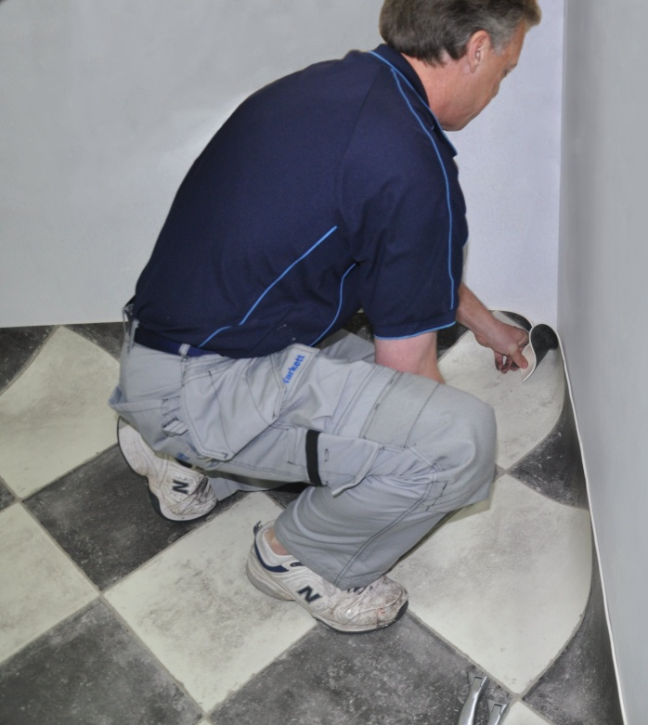
Lay flat vinyl gets its name from the fact that it has a very stable structure, and doesn’t curl up at the edges like other resilient sheet products.
Its stability comes from the layer of fibreglass that helps to balance the other layers.
In this section, we’ll look at the structure of lay flat vinyl to see how the different layers are arranged.
We’ll also discuss the adhesives used to stick it down and the tools and equipment required to carry out the installation.

Completing this section
The assignment for this section is designed to test your knowledge of lay flat products and the adhesives used to stick them down.
Have a look at the Assignment on page 11 to see what you'll need to do to complete it.
There are three lessons in this section:
- Lay flat vinyl
- Adhesives
- Tools and equipment
These lessons will provide you with background information relevant to the assignment and the practical demonstration requirements.

Lay flat vinyl
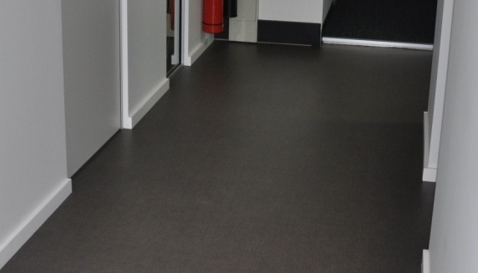
Lay flat vinyl is a form of heterogeneous vinyl. This means it is made up of several layers.
The term ‘heterogeneous’ is used to distinguish multi-layered products from ‘homogeneous’ vinyl, which is uniform throughout. We deal with homogeneous products in the unit: Commercial vinyl.
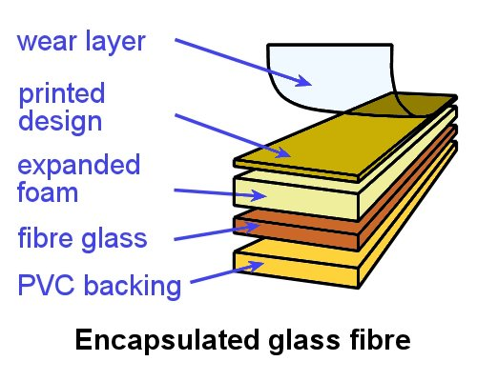
The most common structure for lay flat vinyl
is encapsulated glass fibre, where the fibreglass layer is surrounded by PVC (polyvinyl chloride).
In the middle is a layer of expanded foam, which improves the floor covering's softness underfoot.
This product is also referred to as ‘cushioned vinyl’.
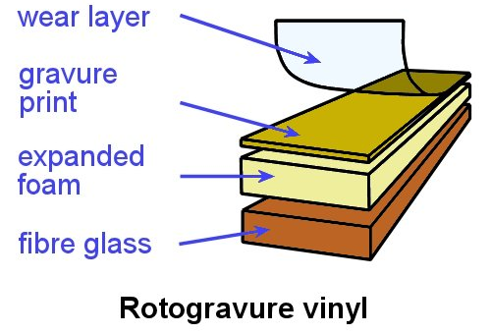
An alternative structure is rotogravure vinyl, which is made using a rotating ‘gravure’ cylinder to print the pattern.
After the print dyes set, a clear wear layer is put on the surface.
The life expectancy of the patterned finish depends on the durability of the wear layer.
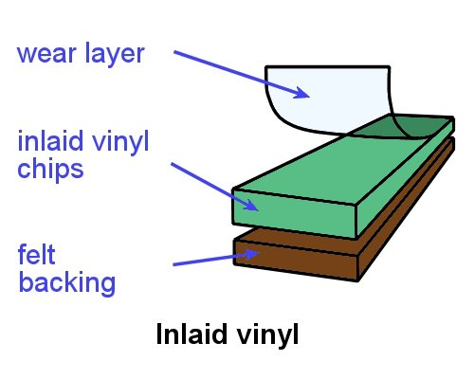
Less common is inlaid vinyl, although it is still a popular structure for certain lines of resilient tiles.
Inlaid vinyl is made from solid vinyl particles fused to a backing material and covered with a translucent vinyl mortar.
This allows the colours to extend right through to the backing, providing a longer wear life.

Roll widths
Lay flat vinyl is designed to be laid with the minimum number of seams, so the choice of width is determined by the floor dimensions.
Products imported from America are supplied in imperial widths – typically 6 feet (1.83 m) and 12 feet (3.66 m). If the products are made in Australia or Europe, they’re supplied in metric sizes – generally 2 m, 3 m and 4 m.

Conditioning
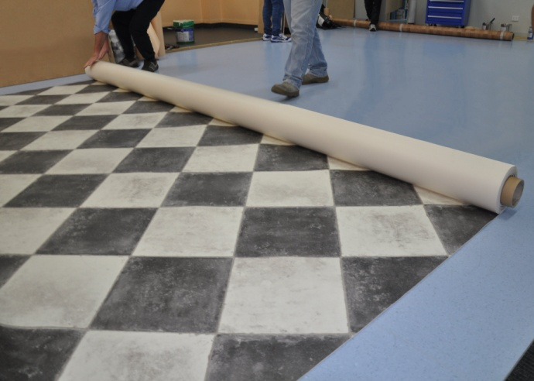
Before you begin an installation, you need to let the floor covering condition to the surrounding temperature and humidity in the room. This process is also called acclimatisation.
AS 1884-2012 says that floor coverings should be conditioned for at least 24 hours, or until the product has achieved an ‘ambient room temperature’ range of between 15° and 28° C.
For more information on the conditioning process, including the procedures you should follow in buildings with air conditioners or heated floors, go to the lesson ‘Conditioning’ in the unit: Preparing floor coverings.

Learning activity

Can you identify one brand name product for each of the three types of lay flat vinyl described above? Also name the manufacturer of the product.
Which of these products have you installed? What type of projects were they used in?

Adhesives
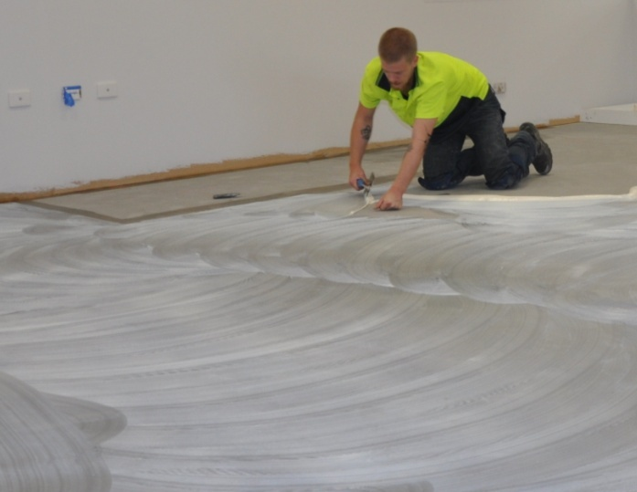
Adhesives are used to stick two surfaces together so they can’t separate easily.
There is a huge range of adhesive products designed for resilient floor coverings.
However many of these are not suitable for lay flat vinyl because they can react with the backing and cause discolouration or damage.
These products include polyurethane, contact and epoxy resin. We'll talk more about these adhesives in the unit: Commercial vinyl.
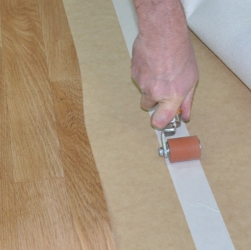
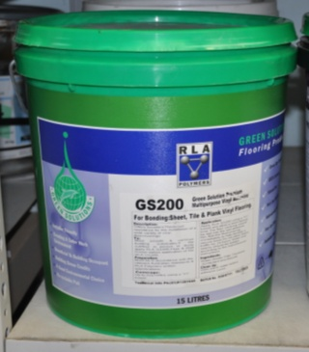
The two main types of products used to stick down lay flat vinyl are acrylic adhesive and double-sided tape.
The methods used to install them are described in Section 4: Laying techniques.

Learning activity

Choose a lay flat vinyl product and get a copy of the manufacturer’s installation instructions.
Then answer the following questions:

- What is the brand name and who is the manufacturer of the flooring?
- What brand of adhesive is recommended for laying the flooring?
- What type of adhesive is it? Briefly describe the product.

Tools and equipment
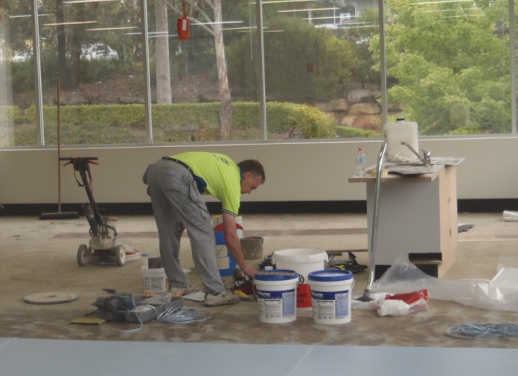
Do you know why ‘a good tradesman never blames his tools’? It’s because he always uses the right tool for the job, and only ever uses tools that are in good condition.
If a particular tool is malfunctioning or getting worn or going blunt – don’t keep using it! If you can’t fix the problem on the spot, put it to one side and either fix it later or replace it.
For every tool to perform properly and not let you down when it’s needed, it has to be treated properly and kept in good working order. This means that you should put fragile tools into their protective cases when you’re not using them, and keep replacement blades and other common wearing parts on hand at all times.
Set out below are the main hand tools used to install lay flat flooring.

Common hand tools
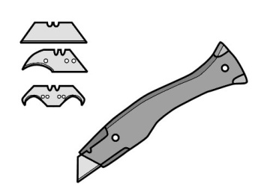 | 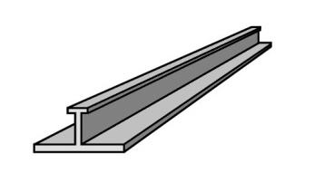 | 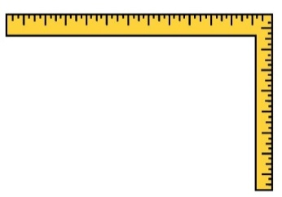
utility knife | straight edge | square
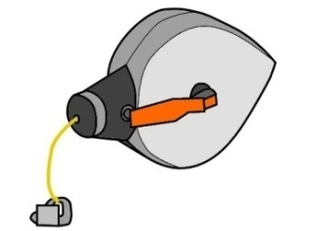 |  | 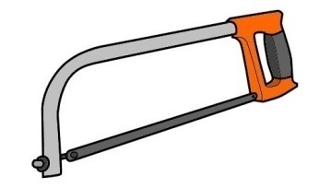
chalk line | tape measure | hacksaw
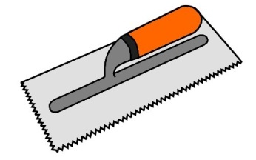 |  | 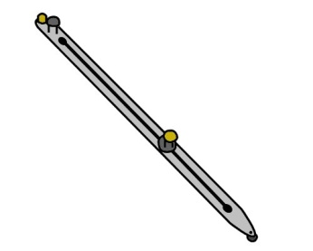
notched trowel | hammer | scribing bar
 | 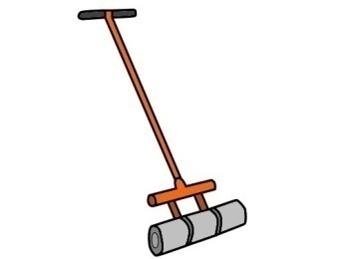 | 
dividers | floor roller | hand roller
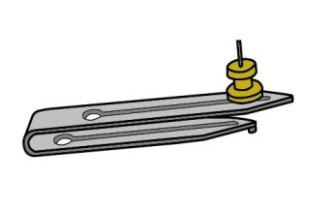 |  | 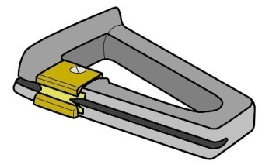
recess scriber | hot air gun | edge trimmer
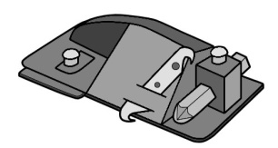 | 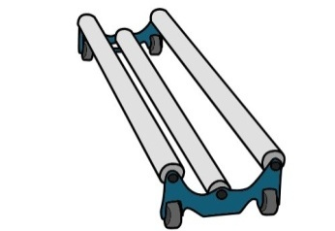 | 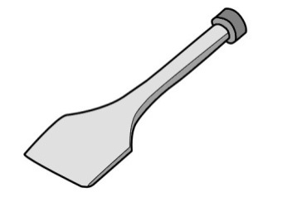
wall trimmer | dolly | stair tool

Learning activity

Choose three cutting tools from the table above.
How you would ensure that you always have a sharp blade to work with for each of these tools? What types of spare blades would you need to carry with you?

Assignment 1
Go to the Workbook for this unit to write your answers to the questions shown below. If you prefer to answer the questions electronically, go to the website version and download the Word document template for this assignment.
___________________________________________________________________________
- How is lay flat vinyl different from other forms of sheet vinyl flooring? That is, why is it called ‘lay flat’?
- Choose two lay flat vinyl products with different compositions (encapsulated glass fibre, rotogravure or inlaid). For each product answer the following questions:
- What is the brand name of the product and who is the manufacturer?
- What is its composition?
- What types of floor is it designed for (domestic, commercial, other)?
- What are the manufacturer’s conditioning instructions prior to it being installed?
- Choose one adhesive product (suitable for lay flat vinyl) that’s marketed as ‘environmentally friendly’ by the manufacturer.
- What is the brand name of the adhesive and who is the manufacturer?
- What features of the product make it environmentally friendly?
- What types of applications is it most suitable for?
- How should you clean up your tools after using it?
- How should you dispose of the waste materials?

Section 2

Preparing for installation

Overview
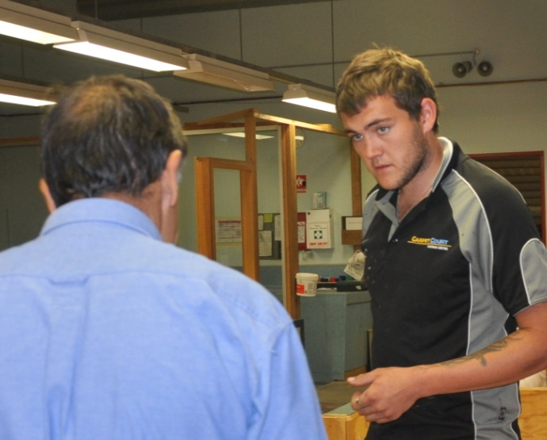
There’s a lot to think about when you carry out an on-site installation.
Sometimes you can get so preoccupied with the specifics of the job that you forget about other important issues.
These include the arrangements that must be made in advance, the documentation you need to take, and the inspections you should carry out before you start the job.
In this section, we’ll talk about these general issues that apply to working on-site and preparing for the installation.

Completing this section

The assignment for this section will test your understanding of the sorts of preparations and site inspections that must be carried out before you can begin an installation.
Have a look at the Assignment on page 27 to see what you’ll need to do to complete it.
There are four lessons in this section:
- Dealing with the client
- Health and safety
- Documentation
- Assessing the subfloor.
These lessons will provide you with background information relevant to the assignment.

Dealing with the client
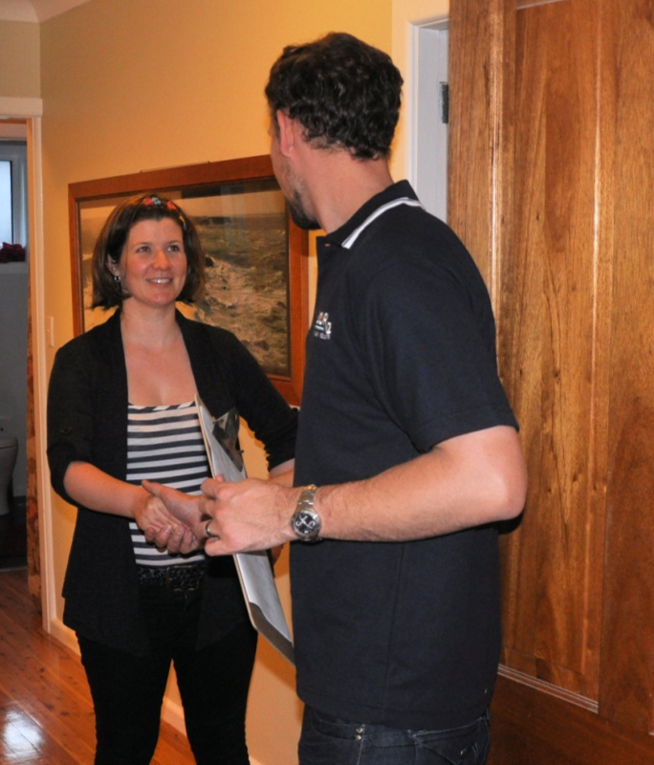
Depending on the size of the project you’re working on, your client might be the owner of the property, or on larger installations, the builder or site manager.
Whatever their role is in the overall project, they need to have the confidence that you’ll do a high quality job and will act professionally at all times.
It’s a very responsible position to be in when the client puts their trust in your abilities. If you repay that trust with an installation that meets their expectations and satisfies the standards, everyone will be happy at the end of the job.
They’ll be happy because they’ll get a finished floor that represents good value for their money. And you’ll be happy because you’ll get paid without any quibbles.
But in addition to these immediate pay-offs, you’ll have left behind an installation that demonstrates your commitment to a quality job. And as every good installer knows – there is no stronger advertisement than a happy customer’s personal recommendation!

Presenting a professional image
Here are some hints on how to present a professional image to the client when you show up on-site to carry out the installation:
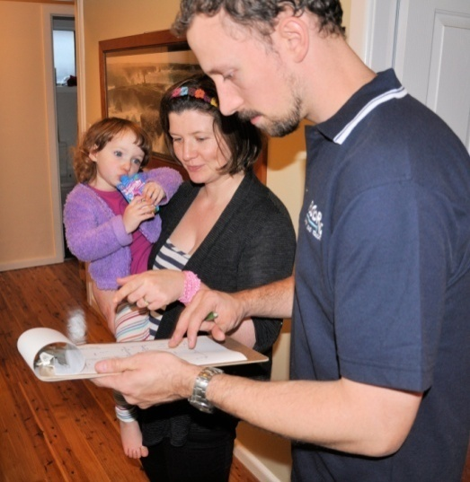
- arrive on time, or if you're running late, phone the client to apologise and tell them what time you expect to be there
- when you arrive, introduce yourself by name and be courteous
- look at the project together and show them a floor covering plan that includes details on seam directions
- answer any questions they might have about specific aspects of the job
- tell them how long you expect to be working on-site
- carry in tools and materials carefully to avoid damaging doors, walls or other items
- be flexible, and try to work in with the client to avoid disruptions or inconvenience.

Making arrangements with the client
If you work for a company with a supervisor or manager who organises the installations, everything should be ready for you when you arrive on-site. But if you’re self-employed or work in a very small team, you may have to talk to the client yourself about any advance arrangements or preparations they are responsible for.
These include:
- making sure the job site is accessible on the date you’ve agreed to do the installation
- making sure no other trade work will be going on that would hold up your progress
- keeping pets and children out of the way and having as few other people on-site as possible.
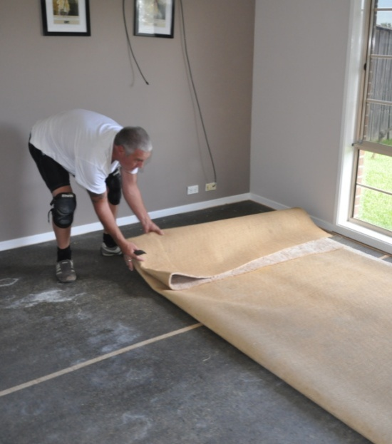
There are some advance arrangements that you need to be particularly careful about, because they’re the sorts of things you could each think the other party is going to organise. These include:
- who will move the furniture, appliances and any other items that are in the way
- who is responsible for disconnecting appliances, especially when an electrician or plumber is required
- who will remove and dispose of existing floor coverings and other fixtures.

Learning activity

The arrangements listed above are just some of the preparations and cross-checks you need to make before you show up on-site to carry out the installation.
Can you think of any others?

Health and safety
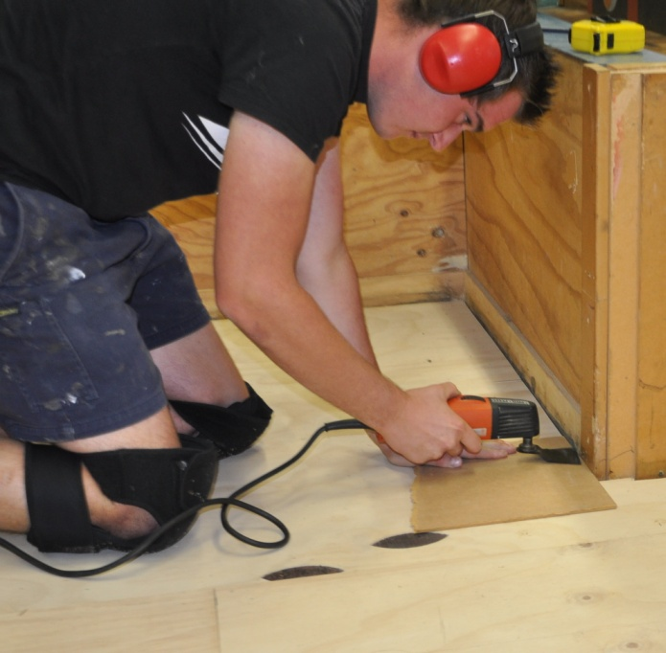
It sometimes seems that there are lots of rules and regulations when it comes to safety on-site.
But the basic formula for staying healthy and avoiding injures is really quite simple:
- use safe work practices at all times
- look for hazards before you start any new job and take actions to control them
- keep the workplace tidy
- maintain a professional attitude and don’t take shortcuts.
Many of the specific safety issues that you need to be aware of when you’re laying a resilient floor are covered in other units in this Flooring Technology resource. Here they are in summary, together with the units they are discussed in:
- Manual handling – including how to lift and carry heavy rolls of flooring – see: Safety at work
- Knee problems – including injuries and chronic conditions caused by working on your knees – see: Safety at work
- Dust and fumes – including dust from subfloor preparations and fumes from primers and adhesives – see: Subfloor coatings and toppings
- Skin contact with hazardous substances – including cement-based products and solvents – see: Subfloor coatings and toppings
- Personal protective equipment – including eye protection, ear protection and other items of PPE needed on-site – see: Safety at work.
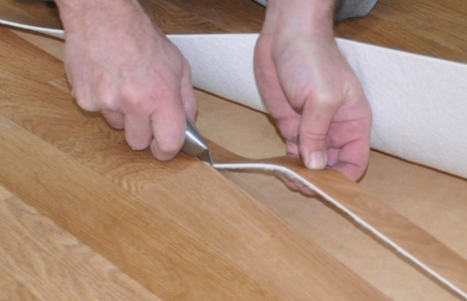
But there is one issue we haven’t discussed yet that particularly applies to resilient floor layers – knife safety.
The most common type of knife you’ll use when laying a resilient floor is a utility knife. Below are the general safety procedures for using a utility knife to cut resilient floor products.

Utility knife safety procedures
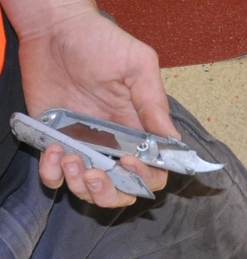
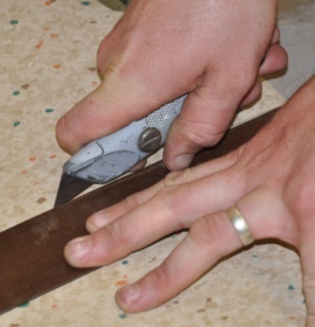
- Use the right blade for the job. There are different blades for different uses, including utility, hook and linoleum blades. Always use the
blade for the task it’s designed for.
- Keep the blade sharp. Change the blade whenever it starts to get blunt. If you need to force it through a cut or it begins to tear the material instead of cutting cleanly, it’s time
to replace the blade.
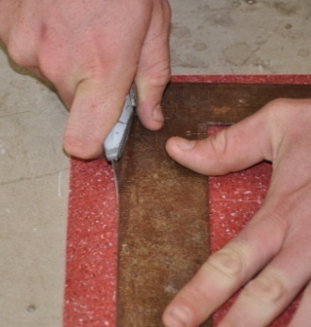
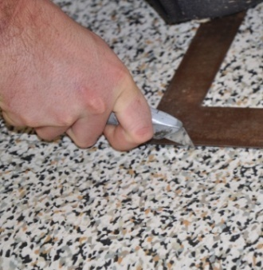
- Pull the knife towards you. A pulling motion is stronger and can be controlled more easily than a pushing force, especially when you’re cutting on a flat surface.
- Keep your free hand clear. If you need to hold the material or a straight edge with your free hand, make sure it is not in the direct line
of the cut.
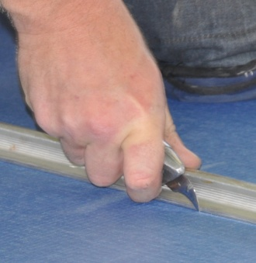
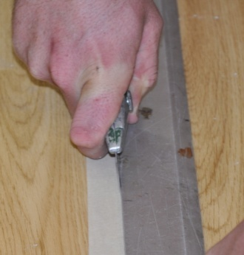
- Use a straight edge with sufficient thickness. If you need to use a straight edge, make sure it is thick enough to guide the blade without letting it ride up over the edge.
- Use several passes on thick material. Cut progressively deeper with each pass, rather than trying to push the knife as deep as possible in a single cut.

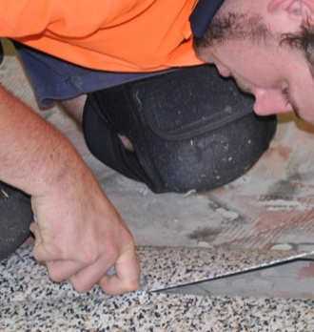
- Don’t over-reach while you’re cutting. Try not to reach further forward than your shoulders, and don’t cut past your hip. If you stay within this area while you’re cutting, you’ll always have maximum control.
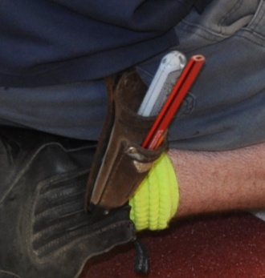
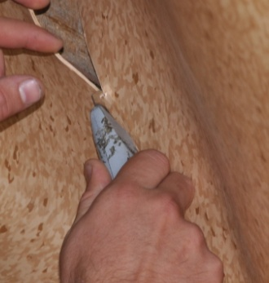
- Don’t bend the blade sideways. Blades are strong when the force is in the direction of the cut, but brittle if they’re twisted at an angle. They are also totally unsuitable for use as a lever, and will snap easily if bent sideways.
- Keep the knife in a scabbard or pouch. When you’ve finished using the knife, make sure you put it away safely. This helps to protect the blade and avoid injuries.

Learning activity

Utility knives come in a variety of brands and models. Popular brands used for cutting lay flat vinyl include Delphin and Shark.
- What brand do you use?
- Are you happy with it?
- If not, what design features could be better? Do you know of any other brands with improved features?

Documentation
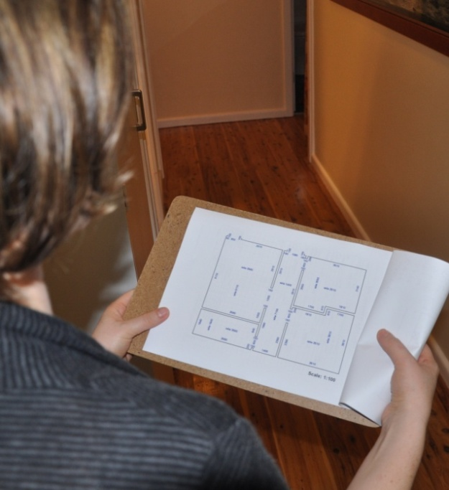
In the unit Planning and costing we talked about the sorts of documents you need to take with you when you go out to the site on installation day.
The main document is the floor covering plan, which sets out the details relating to how the flooring will be installed.
You should always show the client the floor covering plan before you start a new project. This gives them the opportunity to identify any issues that they may not be happy with, or weren’t expecting, before it’s too late to make any changes.
Some companies require the client to formally approve the plan by signing a copy.

Job sheet
It’s normal practice for the installer to be given a job sheet by the contracting company. A lot of the information is the same as in the floor covering plan, but there are also details relating to the specific products used and arrangements that have been made with the client.
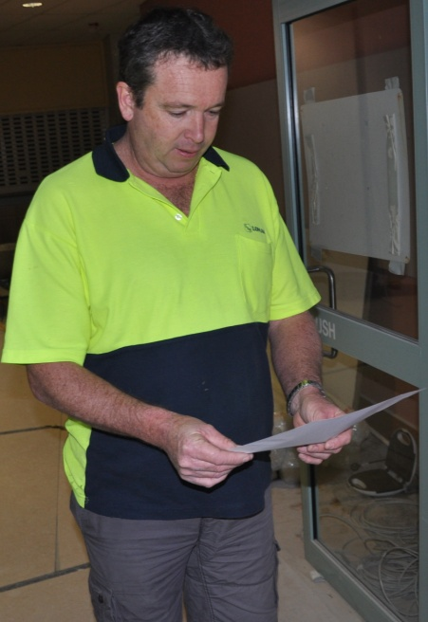
The job sheet should include:
- jobsite address and contact details of the person in charge
- brand names and descriptions of the floor coverings to be laid
- details of other products to be used, including underlay, adhesive and trims
- seam placement and other installation details
- subfloor preparation required
- furniture and appliances to be moved
- unusual site conditions or potential problems.

Warranties and maintenance advice
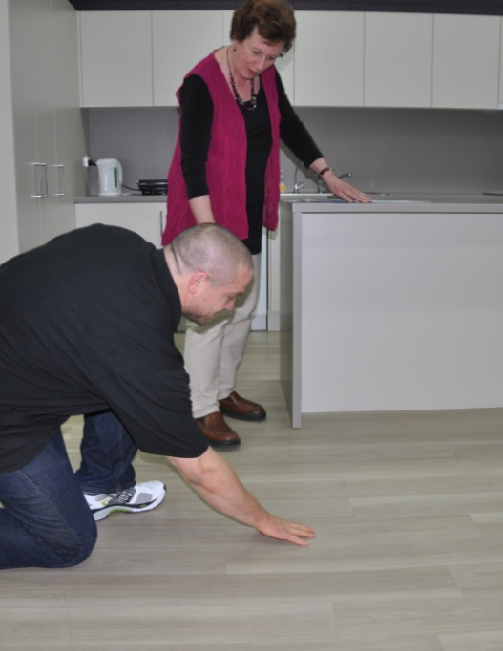
Most flooring installation companies provide their clients with a written warranty as part of the contract documentation.
The warranty sets out the conditions under which the company will come back and fix problems that have occurred due to poor quality workmanship or faulty materials.
Hand in hand with the warranty conditions is the maintenance advice. This includes instructions on how to protect the floor immediately after installation, as well as general care and cleaning advice. It often comes in the form of a brochure produced by the flooring manufacturer.
The reason these two documents go together is because the warranty needs to be clear about who is 'liable' – or legally responsible – for particular types of problems. For example, it is the client's responsibility to follow the manufacturer's advice on how to maintain the floor and keep it in good condition. If they don't follow the advice and the floor suffers some sort of damage as a result, they can't expect the warranty to cover their expenses.
It's important that you make sure the client understands the warranty conditions and maintenance advice. This not only helps them to do the right thing and enjoy the long-lasting performance of their floor, it also helps you to avoid a call back at some time in the future from a disgruntled customer!

Learning activity

What sorts of documents do you take with you to the jobsite?
Name each of the documents and list its purpose.

Assessing the subfloor
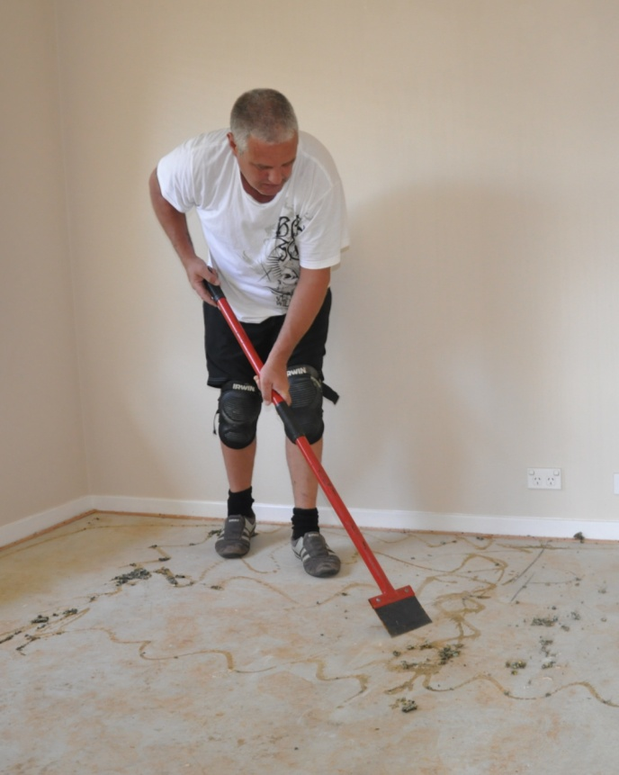
There’s a variety of subfloors you’re likely to encounter when installing resilient floor coverings. We discussed the main subfloor types and typical preparations in the following two Learner guides:
- Inspecting and testing subfloors
- Subfloor coatings and toppings.
So in this lesson we’ll summarise these issues by putting them into a set of questions that you should ask yourself before laying the floor covering.
Remember, as the flooring installer it’s your responsibility to decide whether the subfloor is suitable and has been adequately prepared.
If you’re worried that the substrate isn’t suitable, or that there is an underlying problem that might cause trouble later on, don’t ignore it. Check with your supervisor or manager before going ahead. Everyone will be thankful in the long run, even if it means that there’ll be a delay while the problem is fixed.

Questions to ask yourself

General issues
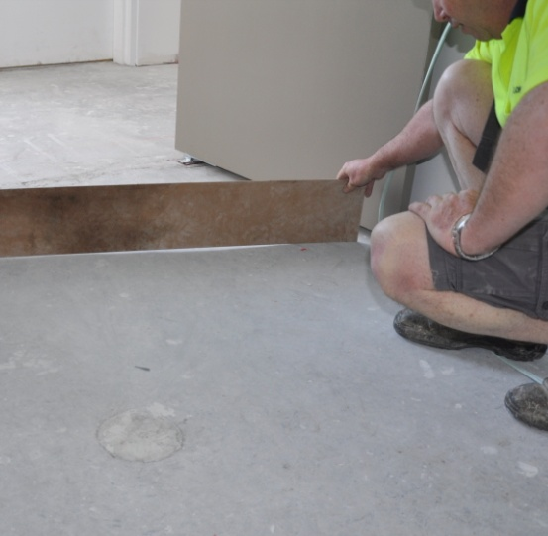
- Is the substrate smooth and flat?
AS 1884-2012 states that the planeness tolerance is 4 mm over a 2 metre length, and the smoothness tolerance is 1 mm over a 150 mm length.
- Is the surface free from dirt, oil, adhesive residues and all other contaminants?
Certain substances can interfere with the strength of the adhesive bond, and in some cases also discolour the vinyl surface.

Concrete subfloors
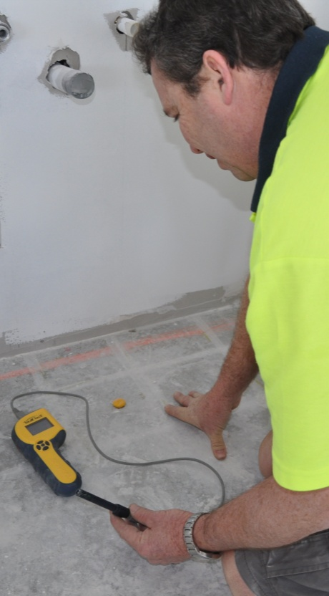
- Are the relative humidity (RH) and alkalinity (pH) levels within the allowable limits?
There are strict limits set for RH and pH, both in the Australian Standards and in the flooring manufacturers’ own installation instructions. The only time you should over-ride these specifications is when an approved moisture barrier is being installed.
- Is the substrate sound and free from loose, powdery or scaly material?
The concrete or underlayment surface must be sound and sufficiently porous to allow the adhesive to bond properly. If it’s not in good condition, the affected layer will need to be removed and replaced with a new underlayment.
- Are there expansion joints in the floor?
Expansion joints need to be in good condition and free from dirt or obstructions. You’ll need to keep them clear and finish them off with approved cover strips.
Don’t get mixed up with relief cuts that have been put into the concrete to stop it from cracking during the curing process. These will be a 5 mm wide saw cut, and can be filled with a suitable compound.
- Have heating elements been installed in the floor?
Flooring manufacturers provide recommended limits for the temperature of the subfloor. Make sure the heating elements will not exceed this temperature, and follow the specific instructions relating to substrate preparation for heated floors.

Wooden subfloors
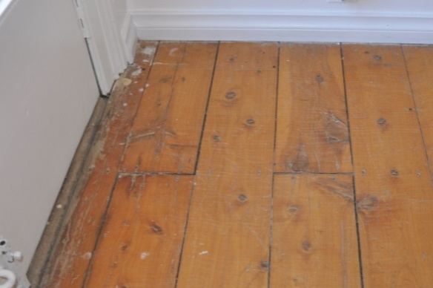
- Is the existing floor properly supported and well secured?
Any structural problems or loose boards should be fixed before the installation begins, especially squeaky floorboards or springiness in the floor surface.

- Are there gaps between boards, protruding nail heads or other surface defects?
Gaps, ridges, cupped boards, protruding nails, and other defects will ‘telegraph’ through to the surface of the floor covering.
In general, structural floors made from plywood and strip flooring need to have a hard underlay placed on top to provide a flat smooth surface.
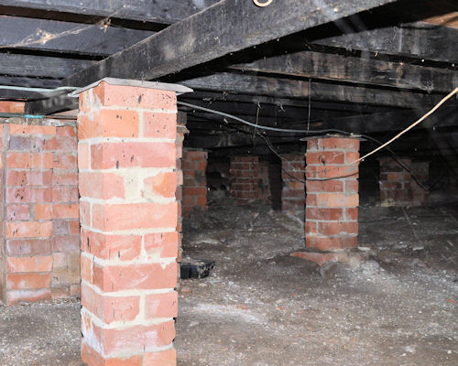
- Is the subfloor ventilation adequate and in compliance with the relevant standards?
Check that the air vents provide sufficient ventilation and that the subfloor cavity meets the minimum requirements for clearance between the floor and the ground.
- Has the moisture content (MC) been checked and is it within the allowable limits?
The moisture content of structural members and floor boards or sheets must all be within the allowable MC range. There must also be no evidence of plumbing or stormwater leaks that might have a long-term effect on the MC.

Old resilient floor coverings
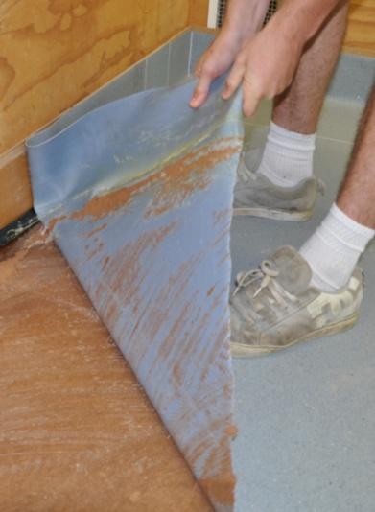
Some flooring installers lay new vinyl on top of old resilient coverings if they’re well bonded to the subfloor. However, AS 1884 does not allow this practice because of the risks involved.
It’s also likely that you’ll void the warranty on any new materials laid if you leave an existing covering underneath.
One of the main reasons for not putting new coverings on top of old is that you can never be sure the bond will stay sound. Sometimes it’s the old adhesive that breaks down and causes a separation with the subfloor.
At other times it can be the new adhesive that doesn’t bond well to the old floor covering, often because of old polish or other ingrained contaminants on the surface.
There are also potential problems with different shrinkage rates between the two coverings, which may result in blistering, cracking or other surface defects. You can also end up with indentation problems in the new covering, because the old flooring has too much cushioning to provide adequate support or has existing grooves in the surface.

Learning activity
One of the problems you may come across in old floors is asbestos-based products. These need to be removed and disposed of in an approved way.
If you know what to look for, you can often recognise these products by their appearance.
The link below will take you to a website page called ‘History and components of asbestos-containing flooring’. It shows many photos of old lino, vinyl and asphalt floor coverings that contain asbestos.
http://inspectapedia.com/interiors/Floor_Tile_History.htm
Have a look at the specific examples of asbestos-based products. Then answer the following questions.
- Have you had to deal with old floor coverings that contained asbestos?
- How did you handle the problem – did you remove the old floor covering first, or cover it with new underlay or flooring?
- What precautions did you take while you were working with the old materials?
If you haven’t been personally involved in dealing with asbestos-based products, ask your supervisor or another installer about their experiences.

Assignment 2
Go to the Workbook for this unit to write your answers to the questions shown below. If you prefer to answer the questions electronically, go to the website version and download the Word document template for this assignment.
___________________________________________________________________________
1. There are many advance arrangements that need to be made with the client prior to installation day, over and above the specific details of the floor covering itself. List six of these arrangements that relate to general on-site conditions and preparations.
2. (a) You are going to install a lay flat vinyl floor in a person’s home. The subfloor has already been prepared. What items of personal protective equipment (PPE) will you need to take?
(b) Now you are going to do the same installation in a large retirement village still under construction. What extra items of PPE should you have with you – that is, what might the site manager want to see before you are allowed on-site?
  - Who takes final responsibility for deciding whether a subfloor is in a suitable condition for a floor covering installation?
  - Name three things you should assess in a concrete subfloor before you begin an installation. For each issue, describe one possible problem that might result if the conditions did not meet the required standards.
  - Name three things you should assess in a timber subfloor before you begin an installation. For each issue, describe one possible problem that might result if the conditions did not meet the required standards.

Section 3

Cutting and fitting

Overview
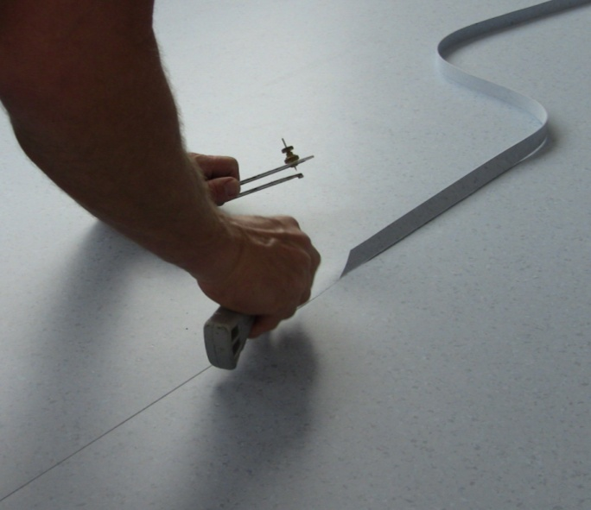
There are some standard installation methods that can be used with all sheet flooring products.
These include the techniques used to mark and scribe material, cut seams and reliefs, match patterns and use templates.
Once you know these methods, you can apply the same principles to fitting cushioned vinyl, commercial vinyl, linoleum and any other sheet materials.
So in this section, we’ll discuss these general techniques for fitting, marking, scribing and cutting.

Completing this section
The assignment for this section will ask you various questions relating to cutting and scribing lay flat vinyl flooring.
Have a look at the Assignment on page 43 to see what you'll need to do to complete it.
There are four lessons in this section:
- Seams and joins
- Freehand cutting
- Direct scribing
- Pattern scribing.
These lessons will provide you with background information relevant to the assignment and the practical demonstration requirements.

Seams and joins
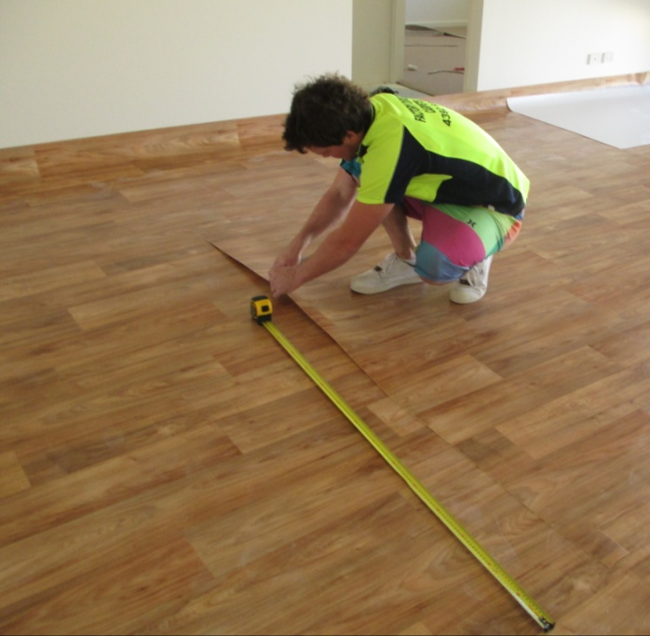
Seams occur in sheet flooring wherever two lengths join side by side. Cross joins occur where two ends meet – that is, where one roll finishes and the next one begins.
It is possible to overlap two sheets where they join and simply cut through both at the same time to form a seam. This is called double cutting.
But it can result in an overly tight seam, which might ‘peak’ where the sheets butt together. It’s also possible that the pattern may not match exactly.
An alternative technique is to trim the factory edge off the first piece to remove any damage and produce a clean ‘true’ edge. You can either do this with an edge trimmer or a straightedge and knife. Then trace cut the second piece using the following procedure.

Trace cutting
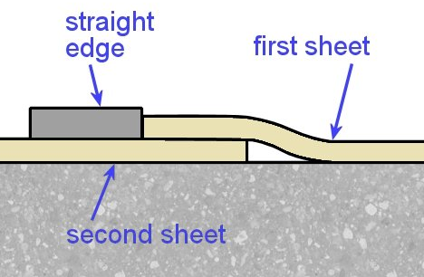
- Cut a true edge along the line of the seam in the first sheet.
- Put the second sheet under the true edge of the first sheet and line up the pattern exactly.
- Push the straightedge up against the seam edge of the first sheet.
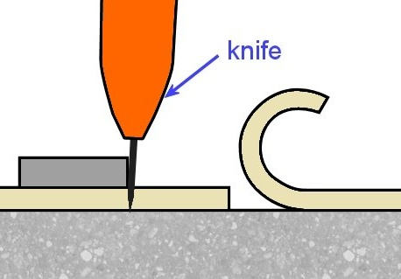
- Hold the straightedge in position and fold back the first sheet.
- Cut the second sheet along the line of the straightedge, holding the knife as vertical as possible.

Batch lots
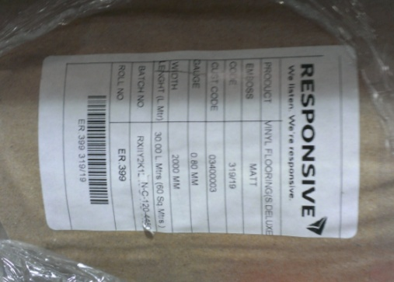
Floor coverings are manufactured in batch lots, also called dye lots. Each roll of material has a batch number on the packaging to indicate which batch of colour dyes was used in that particular manufacturing run. It will also have a roll number.
Where possible, you should try to use flooring with the same batch number and sequential roll numbers when they are being placed side by side. This will help to provide the best match of colours and avoid any inconsistency in shade or intensity.

Using a utility knife
The most common tool used for cutting is the utility knife. Because it’s relatively thin, lay flat vinyl can be cut in a single pass with a straight, concave or hook blade.
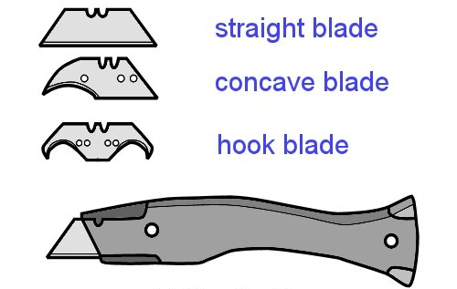
You can use the straight blade for general cutting. The concave blade is better for more precise cutting, such as around door frames.
The hook blade has a flat heel, which stops the cutting edge from coming into contact with the surface underneath. This allows you to cut on a concrete floor or on
top of another resilient sheet.
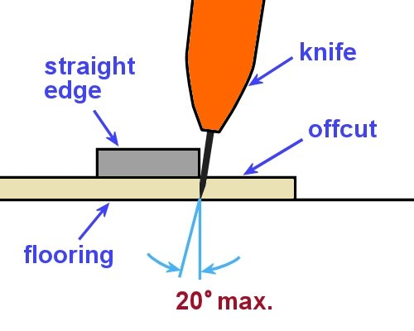
Most people tend to undercut the material slightly when the offcut is on the outside of their cutting hand. This is not a bad thing, because it gives you a sharp edge that butts cleanly against the next sheet or the wall.
But be careful that you don’t undercut too much. If the undercut is more than about
20 degrees from the vertical, the edge might become too weak and break or fold over when it’s butted up.

Learning activity

Have a look for the batch numbers and roll numbers on some rolls of flooring.
Does your company have an inventory system that records these details so they’re not lost when the roll is unpackaged?
Describe the system and how you would go about matching up rolls that have been opened?

Freehand cutting

The idea of freehand cutting is to put a slightly oversized piece of material in place on the floor and then cut and fit it in position.
The procedure is as follows.
- Pre-cut the piece outside the room in an area where you can lay it out full sized.
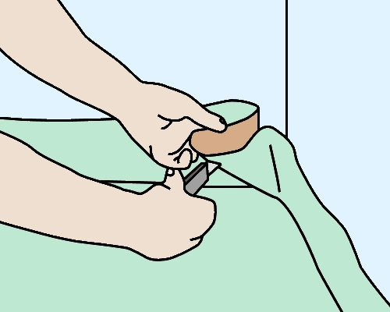
Leave about 50 to 100 mm over-length at each end for re-trimming.
- Carry the piece into the room and lay it in place on the floor.
If the piece is large, roll it up or ‘tube’ it first, with the face on the inside.
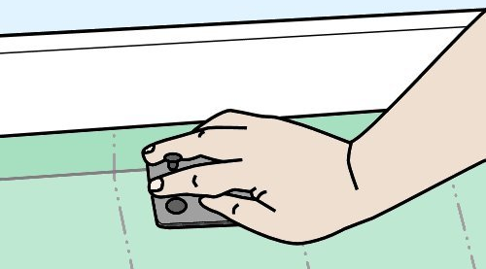
- Make relief cuts at the junction between the floor and walls, so that the material lays flat without tearing.
(See below for the four basic relief cuts.)
- Trim the edges with a knife or wall trimmer so they fit tightly to the walls.

Relief cuts
There are four basic relief cuts. They are designed to allow the material to be pushed down flat on the floor at the junctions with walls and other objects.

Curved or irregular-shaped wall
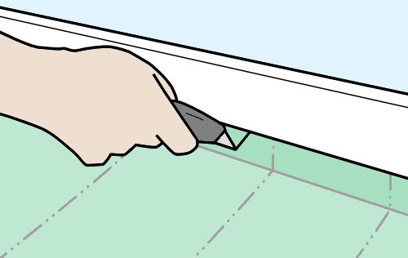
Put a vertical cut in the material where it flashes up against the wall.
Keep the side of the knife against the wall to guide the cut and to avoid marking the wall.
Make sure the cut isn’t too deep, so it doesn’t show in the finished job.

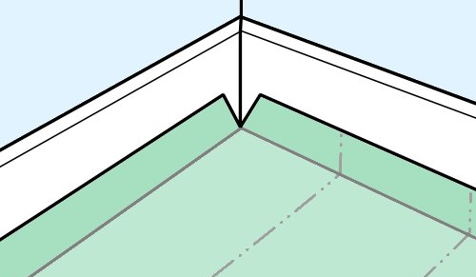
Inside corner
Cut diagonally across the corner of the material from both sides. Push the material into the inside corner to check whether the cut is deep enough.
Be careful not to cut too deep – it’s best to cut in steps and check the fit after each cut.


Outside corner
Hold the material in position at the outside corner. Cut downwards towards the floor, following the line of the corner.
Trim the material at the floor and wall juncture to avoid tearing it as you push it down flat.

Three sides of an object
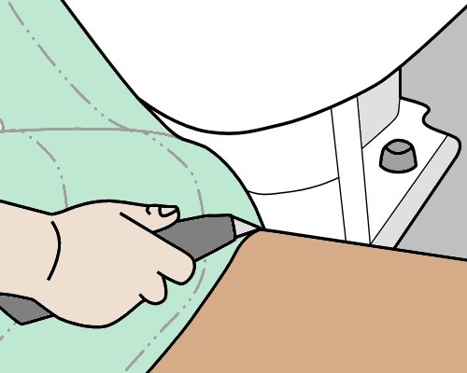
Flash the material up around the front of the object and push it in around the junction of the floor and object. Slit the material almost to the floor. Use a small crosscut at the bottom of the slit to stop the cut from tearing into the material.
Work the material down to the floor, cutting it flat to the floor wherever there are buckles or pressure points.

Other tricks

Door jambs and architraves
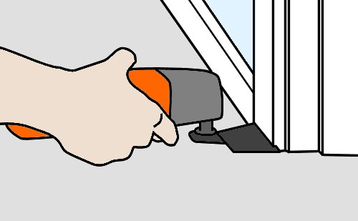
Where possible, undercut the door jambs and architraves to the thickness of the flooring material so it will fit underneath. Use a jamb saw or multi tool to cut the timber.
If the jambs and architraves can’t be undercut, fit the material by putting in relief cuts as you push it down.

Strip measuring
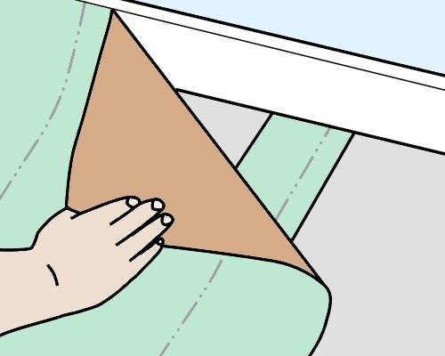
This method of measuring is useful when the wall is straight but hard to reach with the knife.
Flash the material up the wall and then pull it back. Put a piece of scrap material with a squared end under the material and push it hard against the wall.
Pull both pieces back together and mark the underside of the material at the end of the scrap piece. Do this several times along the
wall.
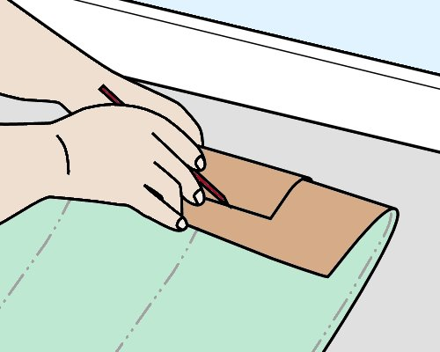
Remove the scrap and fold the piece back so you can draw a continuous line along the marks with a straightedge.
Don’t forget to make an allowance for the curve of the material – the scrap piece will have slid back slightly due to the curvature.
Cut the material from the underside, being careful not to cut right through to the material underneath.

Learning activity

There are various tools that can be used to undercut a door jamb and architrave. You can use a jamb saw or multi tool, or in some cases even a handsaw and chisel.
The link below will take you to a YouTube video clip called: ‘Jamb saw and Dremmel multimax’.
http://www.youtube.com/watch?v=Jzq8Uq5cadU
- Have you used power tools like these to undercut an architrave?
- If so, what type of tool did you use and what was its brand name?

Direct scribing
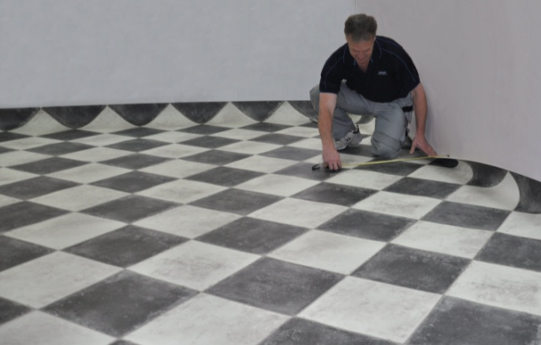
Direct scribing is used in areas where you need to install more than one piece of material. The most common technique is the three-wall scribe.
The procedure is described below. Once you’ve read through this process, go to the web link shown in the learning activity to see a video clip of a floor layer demonstrating the technique.
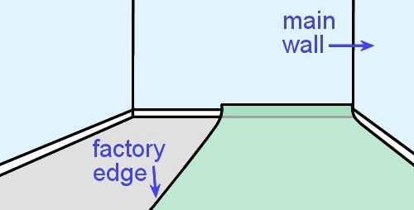
- Place the material in the room with both ends flashed up the wall and the long side as close to the ‘main wall’ as possible. The main wall is the one that runs the full length of the piece. It is always scribed first.
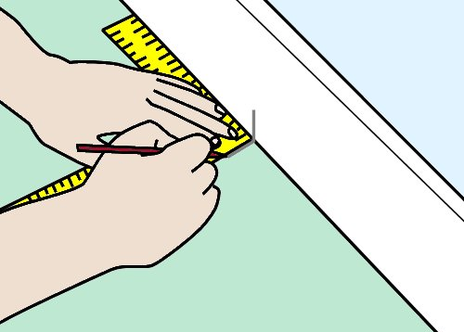
- Mark a cross line on the wall (or skirting) and the material for alignment purposes. These two lines will be matched up later once you’ve cut the piece.
- Pull the sheet back from the wall by about 100 mm, making sure it stays parallel to the wall. Check that the distance is the same at both ends.

- Use dividers or a bar scriber to scribe the outline of the main wall onto the material. Set the scriber so it marks about 10 to
20 mm in from the edge of the sheet. Make sure you hold the scriber at right angles to the sheet while you’re marking the line.

- Cut along the scribed line with a knife. Then move the piece back into place against the main wall and line up the pencil marks.

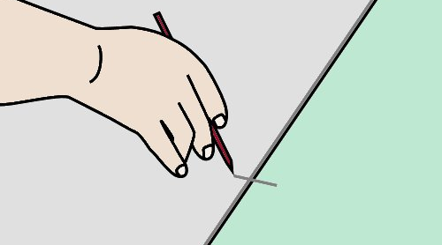
- Trim the ‘factory edge’ off the other side to produce a clean straight edge. Draw a guide line on the subfloor with your pencil held firmly while it follows the edge of the sheet.
Then put a cross line from the edge of the material to the subfloor.
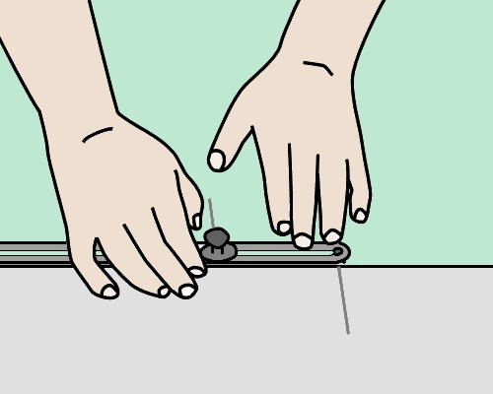
- Pull the piece away from the end wall until it lies flat on the floor. Make sure the edge stays aligned with the long line you’ve drawn on the subfloor.
- Set the bar scriber to the difference between the two cross lines (one on the subfloor, the other on the material). Scribe the end of the piece to the end wall. Cut along the scribed line.
- Carry out the same scribing and cutting procedure at the other end.

Pipes

To scribe a wall and pipe at the same time, first mark the position of the pipe with two offset lines running square from the wall.
Use the same scribe setting as you’ve used for the wall and mark the front of the pipe between the offset lines.

Scribe a circle with the dividers, touching both offset lines and the scribe mark.
Cut a seam into the circle, and cut out the scribe line for the wall and a circle for the pipe.

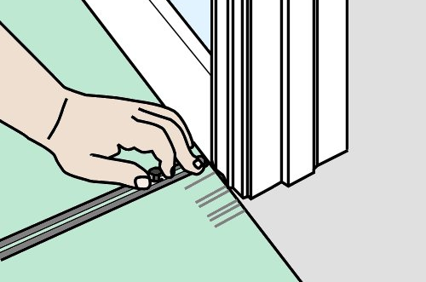
Door trims
Door jambs and architraves can be scribed in the same way. Draw a separate line for each change in direction, at right angles to the wall.
Then use the bar scriber to mark the profile of the architrave.

Pattern matching
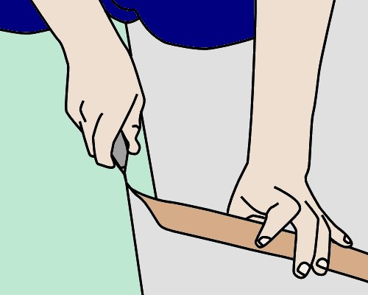
To pattern-match a second piece of material beside the first piece, use the three-wall scribe technique.
Trim off the factory edge of the first piece where the seam will be. Then bring the second piece into the room. Put it in place with its inside edge overlapping the first piece and the other edge against the main wall (running lengthwise).
Make sure the overlap is equal for the entire length of the seam.
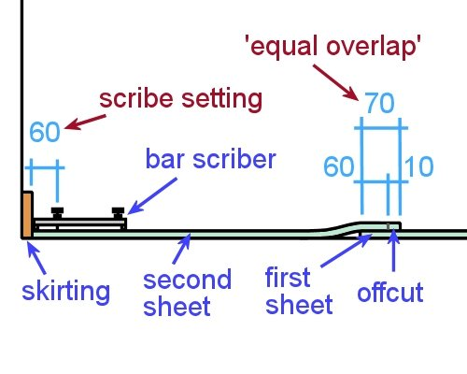
To find the scribe setting for the main wall, subtract the width of the offcut that you’ll trim off the inside factory edge.
For example, if the ‘equal overlap’ at the seam is 70 mm and the offcut is 10 mm, the scribe setting should be 60 mm.
This means that you will still have a 10 mm overlap at the seam when you pull the material back to the wall once it has been cut.

Learning activity

The link below will take you to a set of instruction videos produced by Armstrong Floors. Go to the web page and then select: ‘Vinyl sheet installation video – Part 2’.
http://www.armstrong-aust.com.au/commflrpac/aus/ep/au/vinyl_video_library.html
The video clip provides a demonstration on how to lay two sheets using the direct scribe method. Watch the video, listen to the voice-over narration and then answer the following questions:
- Why does the installer trim off the factory edge from both sheets?
- What sized roller is used to roll out each sheet after it’s been stuck down?
- What tool does the installer use to scribe the seam on the second sheet where it butts up against the first sheet?

Pattern scribing
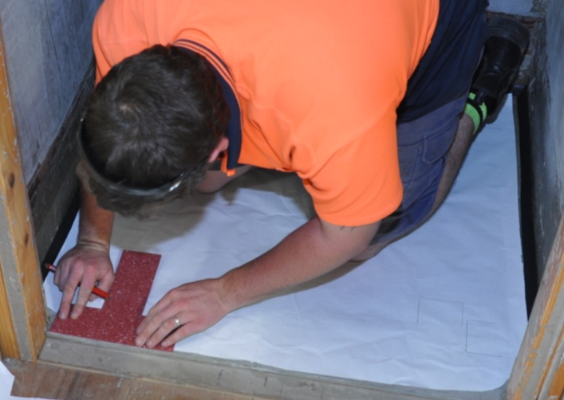
Pattern scribing is used when a shape is complicated or the area is very small.
It involves scribing the outline onto pattern paper and cutting out the template.
This allows the outline to be transferred onto the flooring material so it can be cut to shape in an open area before it’s placed in position on the floor.
The process is as follows.
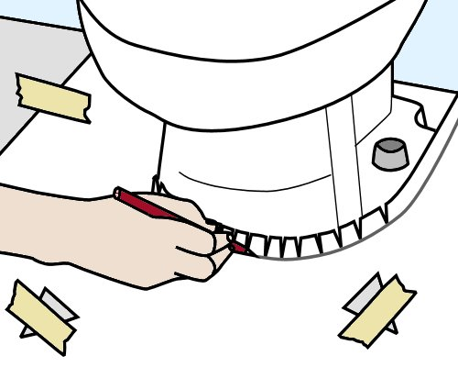
- Lay the paper in position and cut it roughly to shape, to within about 10 mm of all objects and protrusions.
Around a toilet pedestal you can make relief cuts in the paper as you push it down to the floor, and then run a pencil line around the bottom of the cuts, where the pedestal meets the floor.
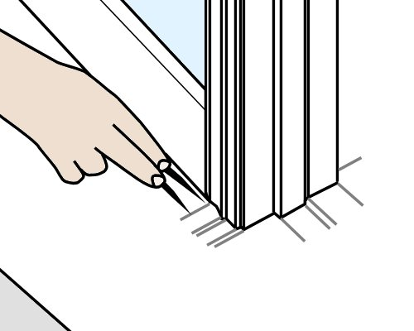
- Secure the paper firmly in position using weights, drawing pins or tape. If you use sticky tape, you should cut small triangular flaps into the template so the tape sticks to the floor through the openings.
- Use a rule and sharp pencil to trace around the object, with the rule pressed firmly against the outline of the object. Alternatively, you can use dividers or a bar scriber to get the same result.
At architraves and other offsets, extend lines out at right angles for each change in direction.

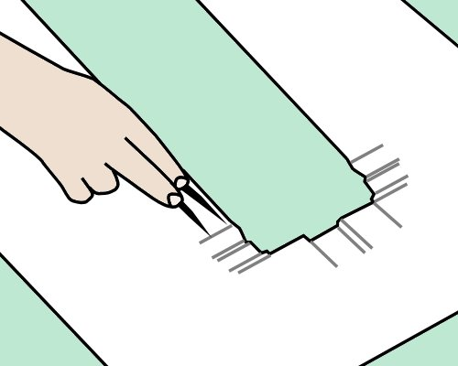
- When all objects in the room have been extended onto the template, take it outside and lay it on top of the floor covering.
Fasten the template to the material with tape so it can’t move.
Extend all of the lines from the template onto the material and cut the material to shape.
- Put the material in position and check the fitting. Then spread the adhesive and stick the material down.

Learning activity

Go to the set of Armstrong Floors instruction videos at:
http://www.armstrong-aust.com.au/commflrpac/aus/ep/au/vinyl_video_library.html
This time, select: ‘Vinyl sheet installation video – Part 4’.
The video clip shows the installer demonstrating how to pattern scribe a difficult area. Watch the video, listen to the voice-over narration and then answer the following questions:
- How does the installer draw guidelines on the pattern around the round object?
- How does he transfer these lines from the pattern onto the vinyl sheet?
- Once he has cut the vinyl sheet and carries it back to the area, how does he ensure that it’s placed exactly in position as he starts to lay it?
- What tool does the installer use to roll the sheet in places where the large roller would be too big?

Assignment 3
Go to the Workbook for this unit to write your answers to the questions shown below. If you prefer to answer the questions electronically, go to the website version and download the Word document template for this assignment.
___________________________________________________________________________
- Describe two methods for fitting sheet vinyl around a door jamb and architrave. In your description, list the tools required for each method.
- How would you go about cutting and fitting a sheet product around the base of a toilet? What items would you need?
- Why do you need to trim off the factory edge of a sheet at the seams? Name two methods for trimming the edges, and state the tools needed for each method.
- How does a wall trimmer work? Describe the adjustments required to make sure the trimmer will cut accurately, and the general process for cutting. If you are describing a particular model, state the name of the model.

Section 4

Laying techniques

Overview
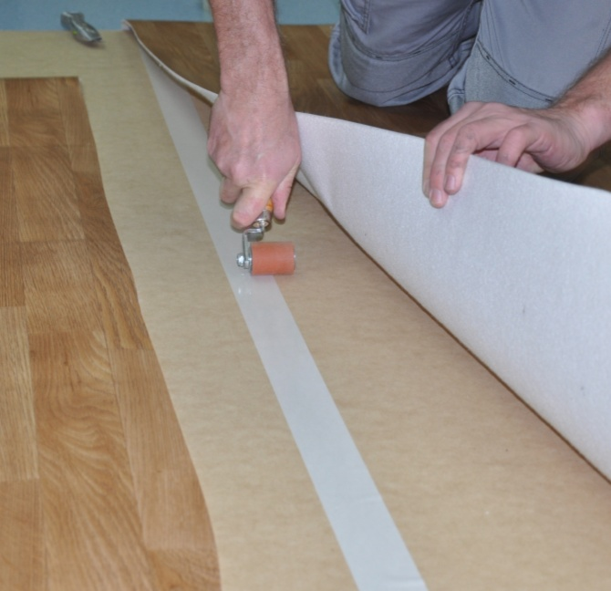
There are two basic methods for installing lay flat vinyl – loose lay and full spread.
When the floor covering is laid without any adhesive underneath, it’s called loose lay. When it is stuck down with adhesive, it’s called full spread.
An alternative to full spread is ‘perimeter stick’ – where the adhesive is only spread around the perimeter of the floor area. However, this is not recommended by some manufacturers because it can cause the material to buckle.
In this section we’ll discuss the loose lay and full spread installation methods. We’ll also cover the techniques used to cold weld seams and joins. And we’ll wrap up with the final inspection and clean-up of the finished job.

Completing this section
The assignment for this section will ask you various questions relating to the processes involved in installing and completing a lay flat flooring project.
Have a look at the Assignment on page 58 to see what you'll need to do to complete it.
There are four lessons in this section:
- Loose lay installation
- Full spread installation
- Cold welding
- Finishing the job.
These lessons will provide you with background information relevant to the assignment and practical demonstration requirements.

Loose lay installation
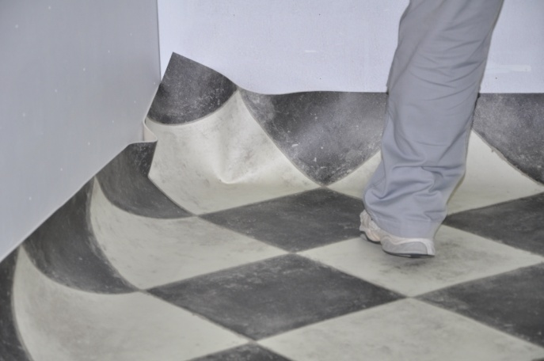
Because there is no adhesive used under a loose laid floor, most manufacturers say that cushioned vinyl should only be loose laid in areas up to 25 m².
However, some of the heavier types of lay flat vinyl can be loose laid on floors up to 40 m². Note that these areas include all connecting rooms.
Loose lay is not suitable for floors that will take heavy traffic, or where there is furniture that may be pushed around. This includes furniture or appliances on roller casters.
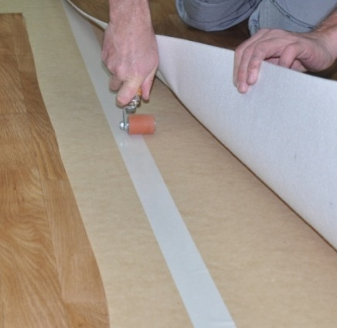
Joins should be cold welded with a chemical seam sealer. To help secure the seam you can also use double-sided tape underneath.
However, this doesn’t mean that you should put tape around the perimeter of the floor. Although some manufacturers allow this ‘perimeter stick’ method of securing the edges, there is a risk that the material may buckle if there is any movement in the covering.
Lay flat vinyl is very stable and won’t shrink or curl over time if it’s laid properly. Nonetheless, in prolonged hot weather it can grow slightly. For this reason, you should leave a gap of about 2 mm around the perimeter of the material so that it can’t buckle up against skirting, cupboards or door frames.
To install loose laid vinyl:
- Lay out the material and allow it to acclimatise to the temperature and humidity of the room. Some installers like to reverse-roll the vinyl to relieve the stresses before laying it out on the floor.
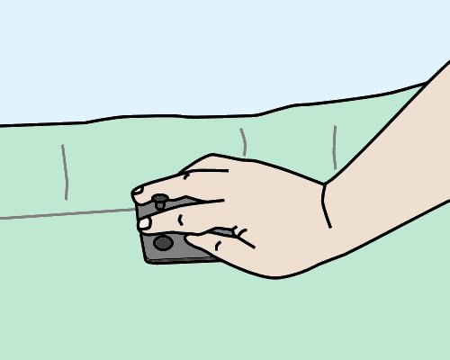
- Cut off all excess material, leaving about 100 mm flashed up the walls for the final trim. V cut all corners to allow it to sit flat on the floor. If you haven’t already reverse-rolled the material, let it relax for about one hour before starting the final trimming.
- Brush the surface with a soft broom to remove any trapped air. Make sure it is sitting flat on the substrate.
- Use a knife or wall trimmer to cut the sheet to size. Cut and fit the sheet lengthwise first. Leave the ends until last, to give the vinyl more time to acclimatise.
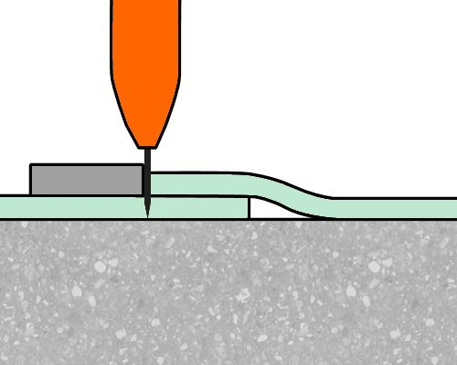
- If more than one sheet is required, fit the
larger sheet first. Overlap the second sheet by about 20 mm, or according to the pattern match required. Try to avoid placing seams in thoroughfares.
- To cut a seam between two sheets, place a straight edge over the overlapping sheets where the cut will go, and hold it firmly in place while you cut as vertically as possible through both sheets.
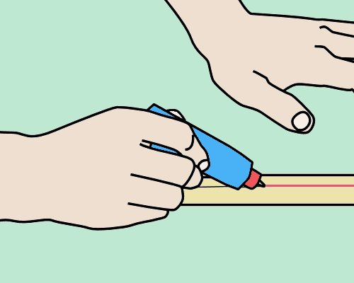
Note that on thicker vinyls you’ll need more than one pass to cut right through both sheets – never force the knife through the material.
- Cold weld the seams with a chemical seam sealer.

Learning activity

Follow the link below to see an installation demonstration produced by Gerflor.
http://www.youtube.com/watch?v=tLLll6OItfU
Watch the video and answer the following questions:
- What tool does the installer use to trim around the walls?
- How does the installer secure the seams? What are the potential risks with using this method around the perimeter of the floor?

Full spread installation
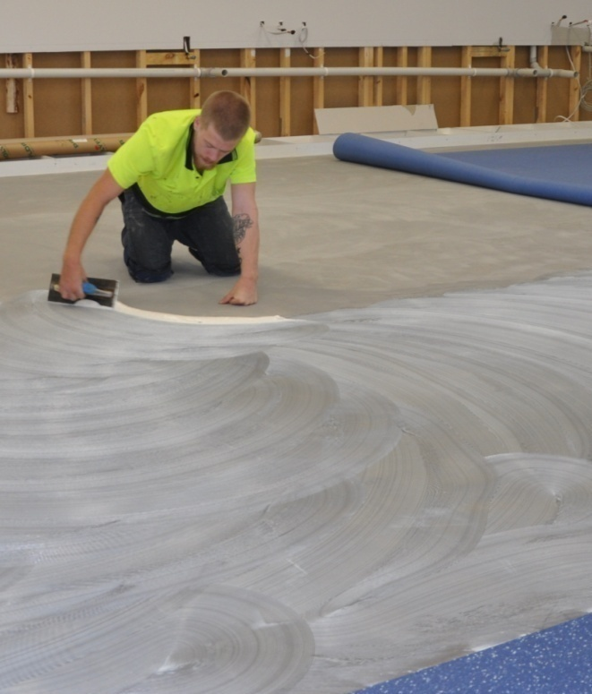
Full spread is also called ‘full stick’, meaning the material is stuck down with adhesive that’s spread right across the floor. Manufacturers generally specify acrylic adhesive for lay flat vinyl flooring.
The installation procedure is as follows:
- Cut and fit the vinyl in the same way as for loose lay.
- Once the vinyl has been fitted, fold it back and apply adhesive to the subfloor.
- Wait for the adhesive to ‘tack up’ and then press the vinyl into position. Broom out any air bubbles.
- Roll the floor thoroughly with a roller, making sure that all trapped air has been removed.
- Cold weld the seams with a suitable seam sealer.

Adhesive ‘open time’
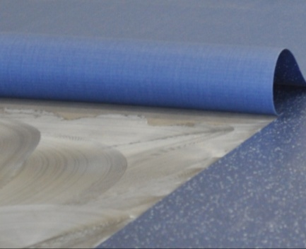
Once an adhesive has been spread on the floor, you need to wait until the open time has elapsed before placing the floor covering in position.
This is also called the tack up time, because the ridges in the adhesive start to ‘skin over’. But don’t wait until it becomes touch dry – for the adhesive to grab it needs to be able to stick to your fingers and pull back when you lift your hand off.
Installers describe this stickiness as ‘having legs’.
Having said that, you should also make sure that the flooring isn’t placed into the adhesive too soon. Wet adhesive gives off gasses, and if it isn’t allowed sufficient time to tack up, the gasses can get trapped under the floor covering and cause bubbles under the surface.

Adhesive ‘working time’
When the adhesive is ready for the flooring to be placed on top, the working time begins. This is the time you have available to lay the material and complete all cutting and fitting.
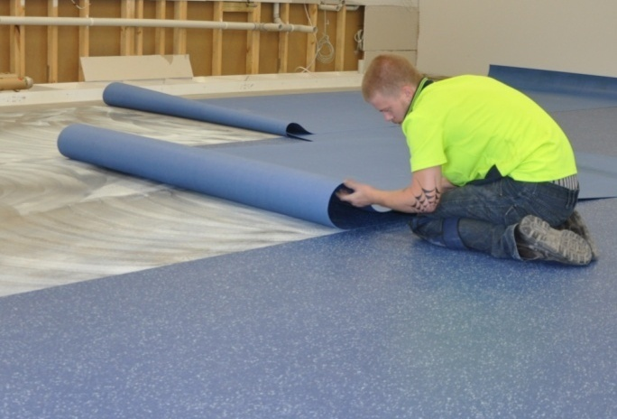
If you place flooring into the adhesive after the working time has passed, the flooring won’t bond properly.
Note that the open time and working time of an adhesive will vary depending on the temperature, humidity and porosity of the surface. High temperatures, low humidity and porous surfaces will all reduce these times.
For very porous surfaces, such as wood-based underlays, manufacturers generally specify that a primer be applied first with a brush. This helps to avoid the problem of late placement, where the adhesive has already set and will no longer bond to the flooring covering.
Manufacturers often combine the open time and working time and specify a working open time for their adhesives. The duration begins when the adhesive is spread and continues through to the time when you should no longer place the flooring into the adhesive. It particularly applies to adhesives that skin over almost immediately.

Notched trowels
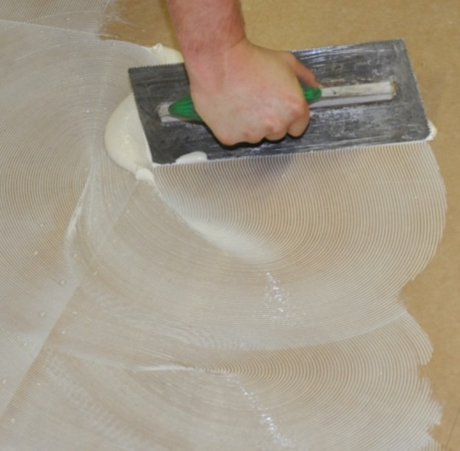
Most adhesives are designed to be spread on the floor with a notched trowel. These trowels have square or V shaped notches cut into one or both sides of the blade. Their purpose is to control the amount of adhesive that’s spread on the substrate.
Trowels are designed to be held at a 60° angle to the floor while you’re spreading. If the angle is too flat, the ridges in the adhesive will be too low, so there won’t be enough to ooze out and fill the spaces when the floor covering is pushed down on top.
Manufacturers sometimes specify different trowel notchings for particular flooring and adhesive products. It’s important to follow these specifications, because if you don’t, you’ll end up applying either too much or too little adhesive.
Applying too much adhesive can result in the ridges showing through the floor covering surface, or ‘bleeding’ at the joints. Applying too little will mean that there is less adhesive available for a firm bond, as well as a reduced working time for placement.

The photo at left shows what can happen if the adhesive isn’t spread evenly.
Large gaps are sometimes called ‘windows of opportunity’ – because they create the opportunity for a very bad outcome when the material doesn’t stick properly!
Over time, the notches in the trowel will gradually wear down and reduce the depths, especially when you’re working on cement-based substrates. So whenever the trowel starts to show signs of wear, it should be replaced. Alternatively, you can reshape the notches using a triangular file.
For more details on the sorts of problems that can occur with adhesives and a troubleshooting table on problems and their causes, see the lesson ‘Problems with adhesives’ in the unit: Commercial vinyl.

Rollers
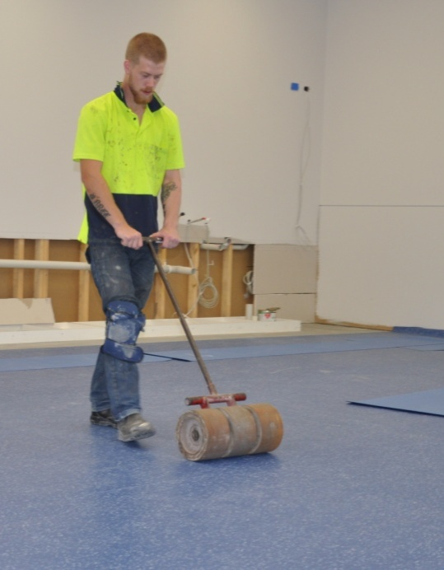
Once the floor covering has been placed in position and fitted, it needs to be pushed firmly into the adhesive. You should do this with a heavy floor roller, running lengthwise and then across the floor.
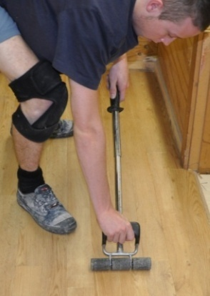
In areas that can’t be reached with a floor roller, use a hand roller.
Be sure to roll the edges
and seams properly, because these are the areas where adhesive failures tend to start.

Learning activity

The term ‘open time’ is sometimes used as a shorthand way to say ‘working open time’ – that is, the total time you have available to lay the flooring once the adhesive has been spread.
Because the term has these slight variations in meaning, some manufacturers refer to the time you should wait between spreading the adhesive and laying the material as ‘set-up time’ or ‘tack-up time’.
Get two drums or containers of adhesive from different manufacturers and have a look at the labels. Answer the following questions for each adhesive:
- What is the brand name, and who is the manufacturer?
- What term is used for set-up (or ‘open’) time, and what is the duration?
- What term is used for working time, and what is the duration?

Cold welding
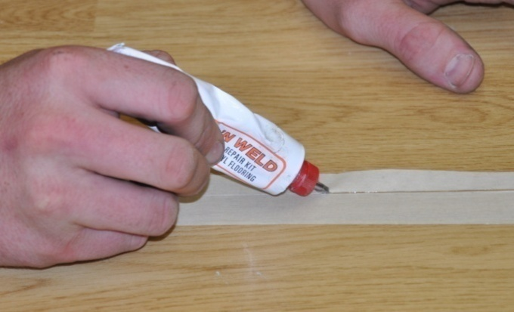
Cold welding is also called chemical welding, because it uses a solvent to fuse the two sides of a seam together.
The process is applied widely to carpets and PVC products in all sorts of applications – but in resilient floors it’s generally only used with cushioned vinyl that isn’t suitable for heat welding.
You should always wait until the following day after installation before cold welding the seams. This allows the adhesive to set and gives the moisture from the adhesive time to evaporate. Some manufacturers recommend a full 24 hours before cold welding.
Set out below is the general procedure for seam sealing with a PVC cold welding liquid. Typically, this product comes in a tube and is applied through a steel needle attached to the tube’s nozzle. However, there are variations on this technique, so you should always follow the specific instructions provided by the manufacturer.

General procedure
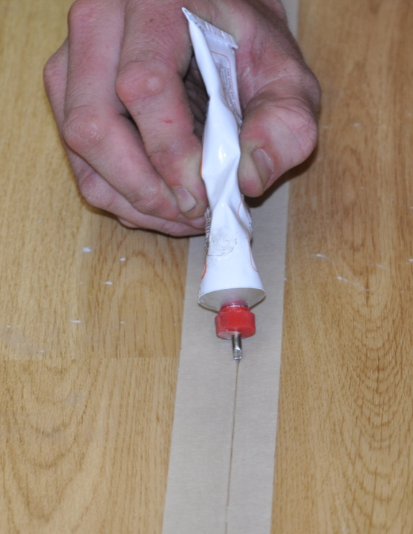
- Place masking tape over the seam and press it down firmly.
- Cut through the masking tape over the join between the two sheets using a straight knife.
- Press the needle of the tube firmly into the seam and pull the tube along the join.
Control the flow of liquid so that a 5 mm wide glue line appears on top of the masking tape.
- Wait about 10 minutes for the glue to bond and then pull the masking tape off.

Learning activity
The link below will take you to a video clip produced by Johnsonite Flooring on how to do a cold weld.
http://www.youtube.com/watch?v=3i8ngxa-GII
Watch the video and then answer the following questions:
- What tool does the installer use to press the masking tape down firmly onto the flooring?
- What angle does he hold the tube at while he is applying the cold weld liquid?

Finishing the job
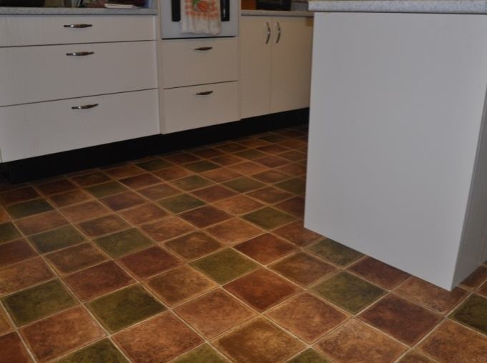
Once you’ve completed the installation you should carefully check the finished floor to make sure everything looks right.
If you do find any problems, fix them straight away – don't wait for complaints or call backs from the client.
In particular, look for:
- loose edges or seams
- adhesive on the surface
- trapped air bubbles or buckles in the flooring.
Doing a final inspection of your work is also an excellent way of evaluating your installation techniques and learning where you can improve your skills.

Protecting the new floor
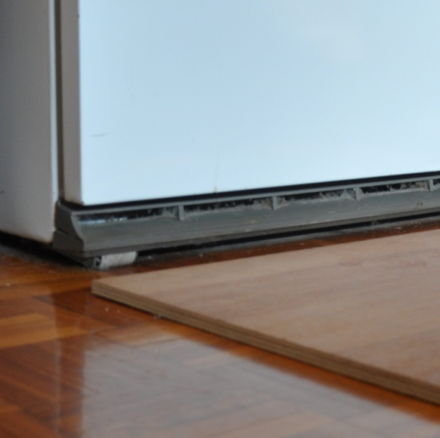
On projects where it’s your job to move heavy appliances back into position, use plywood panels or other board products as protection underneath the appliance.
Slide the first board under the object as you lift it off the floor one side at a time. Then put another board beside the first one and push the object over the boards.
Don’t roll or drag the object directly across the new flooring material.
If you’re leaving the client to move the appliances themselves, give them instructions on how to do it properly so they don’t put a tear or buckle in the floor covering. Even objects on wheels or casters need to be pushed across wood panels, because if the adhesive isn’t fully cured they’ll leave grooves in the floor surface.
Commercial floors should be protected from rolling loads for at least 72 hours after the installation is finished.

Housekeeping
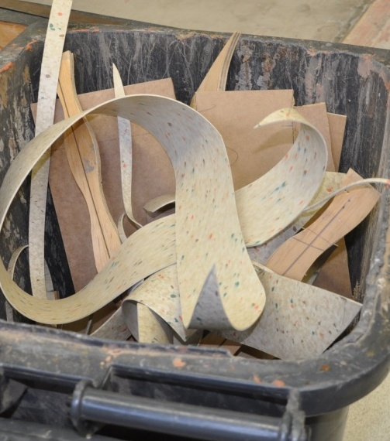
Clients appreciate tidy tradespeople – especially if you’re working in their home. Take all your rubbish and materials with you, except for left-over pieces of floor covering that might be useful to the client for future repairs.
Be particularly careful with hazardous products that need to be disposed of in an approved way.
Don’t put materials or rubbish in doorways or other access ways, because they’ll probably get knocked over and end up being a trip hazard. Keep everything well stacked and out of everyone’s way.

Learning activity

We’ve said that you need to take particular care with hazardous products when you’re cleaning up at the end of the job and disposing of left-overs.
- What sorts of products do these include?
- How should you dispose of hazardous products?

Assignment 4
Go to the Workbook for this unit to write your answers to the questions shown below. If you prefer to answer the questions electronically, go to the website version and download the Word document template for this assignment.
________________________________________________________________
- Loose lay installation:
(a) What types of floors or rooms are most suitable for a loose lay installation?
(b) What types of floors or rooms are not suitable?
(c) How big should the gap be around the perimeter of the floor?
(d) What is the purpose of the gap around the perimeter?
(e) What are the risks with using double-sided tape to secure seams and joins?
2. Full spread installation:
(a) What is the difference between ‘open time’ and ‘working time’ in an adhesive?
(b) How can you tell when an adhesive has ‘tacked up’?
(c) What is the purpose of the notches in a notched trowel?
(d) Why does the floor need to be rolled after it’s laid into the adhesive?
3. Name three potential problems you should look out for when you’re inspecting a flooring installation that’s just been completed. For each one, state what you could do to rectify the problem if it had occurred.

Practical demonstrations
Your trainer may ask you to keep a log book or diary of the work you do on-the-job that relates to the practical components of this unit. This will help them to determine when you’ve had sufficient hands-on practice in these tasks to undertake the assessment events.
When you’re ready to be assessed, your assessor will ask you to complete a range of practical demonstrations, including:
- installations of lay flat vinyl in several connecting rooms – including pattern matching at seams and cross joins – using free-hand, template and scribing methods
- installations of lay flat vinyl in a single room with a link up – including pattern matching at seams and cross joins – using free-hand, template and scribing methods.
The types of floor covering you may use include:
- encapsulated glass fibre
- inlaid vinyl
- rotogravure vinyl.
As part of the demonstrations, you will be asked to use of the following tools:
- utility knife, spatula knife and wall trimmer
- straight edge, square, chalk and chalk-line, tape measure, scribing bar and dividers
- hammer, rubber mallet and hacksaw
- roller and paint brush
- notched trowel
- trolley.
In addition to assessing your ability to physically install lay flat vinyl, your assessor will also be checking that you can:
- follow all work, health and safety requirements and environmental care procedures
- correctly interpret company documents and work instructions
- complete work records
- communicate and work effectively with other workers in the area
- prevent damage to goods, equipment and products
- work productively and produce a high quality job
- clean up, recycle and dispose of waste products correctly
- modify activities and techniques used to suit different sites and working conditions.
Make sure you talk to your trainer or supervisor about any of the details you don’t understand, or aren’t ready to demonstrate, before the assessment events are organised. This will give you time to get the hang of the tasks you’ll need to perform, so that you’ll feel more confident when the time comes to be assessed.

